HTML:

HTML Attributes

* All HTML elements can have **attributes**
* Attributes provide **additional information** about elements
* Attributes are always specified in **the start tag**
* Attributes usually come in name/value pairs like: **name="value"**

|  |  |
| --- | --- |
| [<p>](https://www.w3schools.com/tags/tag_p.asp) | Defines a paragraph |
| [<hr>](https://www.w3schools.com/tags/tag_hr.asp) | Defines a thematic change in the content |
| [<br>](https://www.w3schools.com/tags/tag_br.asp) | Inserts a single line break |
| [<pre>](https://www.w3schools.com/tags/tag_pre.asp) | Defines pre-formatted text |

* Use the style attribute for styling HTML elements
* Use background-color for background color
* Use color for text colors
* Use font-family for text fonts
* Use font-size for text sizes
* Use text-align for text alignment
* HTML Text Formatting Elements

|  |  |
| --- | --- |
| **Tag** | **Description** |
| [<b>](https://www.w3schools.com/tags/tag_b.asp) | Defines bold text |
| [<em>](https://www.w3schools.com/tags/tag_em.asp) | Defines emphasized text |
| [<i>](https://www.w3schools.com/tags/tag_i.asp) | Defines a part of text in an alternate voice or mood |
| [<small>](https://www.w3schools.com/tags/tag_small.asp) | Defines smaller text |
| [<strong>](https://www.w3schools.com/tags/tag_strong.asp) | Defines important text |
| [<sub>](https://www.w3schools.com/tags/tag_sub.asp) | Defines subscripted text |
| [<sup>](https://www.w3schools.com/tags/tag_sup.asp) | Defines superscripted text |
| [<ins>](https://www.w3schools.com/tags/tag_ins.asp) | Defines inserted text |
| [<del>](https://www.w3schools.com/tags/tag_del.asp) | Defines deleted text |
| [<mark>](https://www.w3schools.com/tags/tag_mark.asp) | Defines marked/highlighted text |

<!DOCTYPE html>

<html>

<body bgcolor="red" text="green">

<h2>The style Attribute</h2>

<p>The style attribute is used to add styles to an element, such as color:</p>

<p >This is a red<br> paragraph.</p>

<p title="I'm a tooltip">This is a paragraph.</p>

<pre>abc

def

ghi jkl

</pre>

<!DOCTYPE html>

<html>

<body>

<h1>Heading 1</h1>

<h2>Heading 2</h2>

<h3>Heading 3</h3>

<h4>Heading 4</h4>

<hr>

<h5>Heading 5</h5>

<h6>Heading 6</h6>

<p>I am normal</p>

<p><b>This text is bold.</b></p>

<strong>This text is important!</strong>

<small>This is some smaller text.</small>

<em>This text is emphasized</em>

<i>This text is italic</i>

<p>Do not forget to buy <mark>milk</mark> today.</p>

<p>My favorite color is <del>blue</del> red.</p>

<p>My favorite color is <del>blue</del> red.</p>

<p style="color:violet;">I am red</p>

<p style="color:blue;">I am blue</p>

<p style="font-size:50px;">I am big</p>

<h1 style="background-color:powderblue;">This is a heading</h1>

<p style="font-family:courier;">This is a paragraph.</p>

<h1 style="font-size:300%;">This is a heading</h1>

<h1 style="font-size:100px;">This is a heading</h1>

</body>

</html>

</body>

</html>

## HTML <q> for Short Quotations

The HTML <q> tag defines a short quotation.

Browsers normally insert quotation marks around the quotation.

### **Example**

<p>WWF's goal is to: <q>Build a future where people live in harmony with nature.</q></p>

## HTML <abbr> for Abbreviations

The HTML <abbr> tag defines an abbreviation or an acronym, like "HTML", "CSS", "Mr.", "Dr.", "ASAP", "ATM".

Marking abbreviations can give useful information to browsers, translation systems and search-engines.

**Tip:** Use the global title attribute to show the description for the abbreviation/acronym when you mouse over the element.

### **Example**

<p>The <abbr title="World Health Organization">WHO</abbr> was founded in 1948.</p>

## HTML <blockquote> for Quotations

The HTML <blockquote> element defines a section that is quoted from another source.

Browsers usually indent <blockquote> elements.

### **Example**

<p>Here is a quote from WWF's website:</p>  
<blockquote cite="http://www.worldwildlife.org/who/index.html">  
For 60 years, WWF has worked to help people and nature thrive. As the world's leading conservation organization, WWF works in nearly 100 countries. At every level, we collaborate with people around the world to develop and deliver innovative solutions that protect communities, wildlife, and the places in which they live.  
</blockquote>

<blockquote cite="http://www.worldwildlife.org/who/index.html">

For 60 years, WWF has worked to help people and nature thrive. As the world's leading conservation organization, WWF works in nearly 100 countries. At every level, we collaborate with people around the world to develop and deliver innovative solutions that protect communities, wildlife, and the places in which they live.

</blockquote>

<p>The HTML address element defines contact information (author/owner) of a document or article.</p>

<address>

Written by John Doe.<br>

Visit us at:<br>

Example.com<br>

Box 564, Disneyland<br>

USA

</address>

<p><cite>The Scream</cite> by Edvard Munch. Painted in 1893.</p>

## RGB Color Values

In HTML, a color can be specified as an RGB value, using this formula:

**rgb(red, green, blue)**

Each parameter (red, green, and blue) defines the intensity of the color with a value between 0 and 255.

This means that there are 256 x 256 x 256 = 16777216 possible colors!

For example, rgb(255, 0, 0) is displayed as red, because red is set to its highest value (255), and the other two (green and blue) are set to 0.

Another example, rgb(0, 255, 0) is displayed as green, because green is set to its highest value (255), and the other two (red and blue) are set to 0.

To display black, set all color parameters to 0, like this: rgb(0, 0, 0).

To display white, set all color parameters to 255, like this: rgb(255, 255, 255).

## RGBA Color Values

RGBA color values are an extension of RGB color values with an Alpha channel - which specifies the opacity for a color.

**rgba(red, green, blue, alpha)**

The alpha parameter is a number between 0.0 (fully transparent) and 1.0 (not transparent at all):

## HEX Color Values

In HTML, a color can be specified using a hexadecimal value in the form:

**#rrggbb**

Where rr (red), gg (green) and bb (blue) are hexadecimal values between 00 and ff (same as decimal 0-255).

For example, #ff0000 is displayed as red, because red is set to its highest value (ff), and the other two (green and blue) are set to 00.

Another example, #00ff00 is displayed as green, because green is set to its highest value (ff), and the other two (red and blue) are set to 00.

To display black, set all color parameters to 00, like this: #000000.

To display white, set all color parameters to ff, like this: #ffffff.

## HSL Color Values

In HTML, a color can be specified using hue, saturation, and lightness (HSL) in the form:

**hsl(hue, saturation, lightness)**

Hue is a degree on the color wheel from 0 to 360. 0 is red, 120 is green, and 240 is blue.

Saturation is a percentage value. 0% means a shade of gray, and 100% is the full color.

Lightness is also a percentage value. 0% is black, and 100% is white.

HTML Links - The target Attribute

By default, the linked page will be displayed in the current browser window. To change this, you must specify another target for the link.

The target attribute specifies where to open the linked document.

The target attribute can have one of the following values:

* _self - Default. Opens the document in the same window/tab as it was clicked
* _blank - Opens the document in a new window or tab
* _parent - Opens the document in the parent frame
* _top - Opens the document in the full body of the window
* <style>  
  a:link {  
    color: green;  
    background-color: transparent;  
    text-decoration: none;  
  }  
    
  a:visited {  
    color: pink;  
    background-color: transparent;  
    text-decoration: none;  
  }  
    
  a:hover {  
    color: red;  
    background-color: transparent;  
    text-decoration: underline;  
  }  
    
  a:active {  
    color: yellow;  
    background-color: transparent;  
    text-decoration: underline;  
  }  
  </style>

<!DOCTYPE html>

<html>

<head>

<style>

p {

border: 2px solid powderblue;

border-width:20px 30px 20px 30px;

padding: 10px;

margin: 50px;

}

</style>

</head>

<body>

<h1>This is a heading</h1>

<p>This is a paragraph.</p>

<p>This is a paragraph.</p>

<p>This is a paragraph.</p>

<a href="https://www.w3schools.com/" target="_blank">Visit W3Schools!</a>

</body>

</html>

## The HTML <picture> Element

The HTML <picture> element gives web developers more flexibility in specifying image resources.

The <picture> element contains one or more <source> elements, each referring to different images through the srcset attribute. This way the browser can choose the image that best fits the current view and/or device.

Each <source> element has a media attribute that defines when the image is the most suitable.

### **Example**

Show different images for different screen sizes:

<picture>  
  <source media="(min-width: 650px)" srcset="img_food.jpg">  
  <source media="(min-width: 465px)" srcset="img_car.jpg">  
  <img src="img_girl.jpg">  
</picture>

Fevicons:

 <link rel="icon" type="image/x-icon" href="/images/favicon.ico">

border: 1px solid black;  
  border-collapse: collapse;

border-style:

* dotted
* dashed
* solid
* double

border-color: #96D4D4;

**tr:nth-child(even) {**

**background-color: rgba(150, 212, 212, 0.4);**

**}**

**th:nth-child(even),td:nth-child(even) {**

**background-color: rgba(150, 212, 212, 0.4);**

**}**

Ordered HTML List - The Type Attribute

The type attribute of the <ol> tag, defines the type of the list item marker:

|  |  |
| --- | --- |
| **Type** | **Description** |
| type="1" | The list items will be numbered with numbers (default) |
| type="A" | The list items will be numbered with uppercase letters |
| type="a" | The list items will be numbered with lowercase letters |
| type="I" | The list items will be numbered with uppercase roman numbers |
| type="i" | The list items will be numbered with lowercase roman numbers |

**Iframe:**

An HTML iframe is used to display a web page within a web page.

<iframe src="*url*" title="description"></iframe>

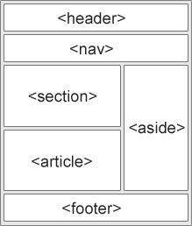

<audio controls autoplay muted>  
  <source src="horse.ogg" type="audio/ogg">  
  <source src="horse.mp3" type="audio/mpeg">  
Your browser does not support the audio element.  
</audio>

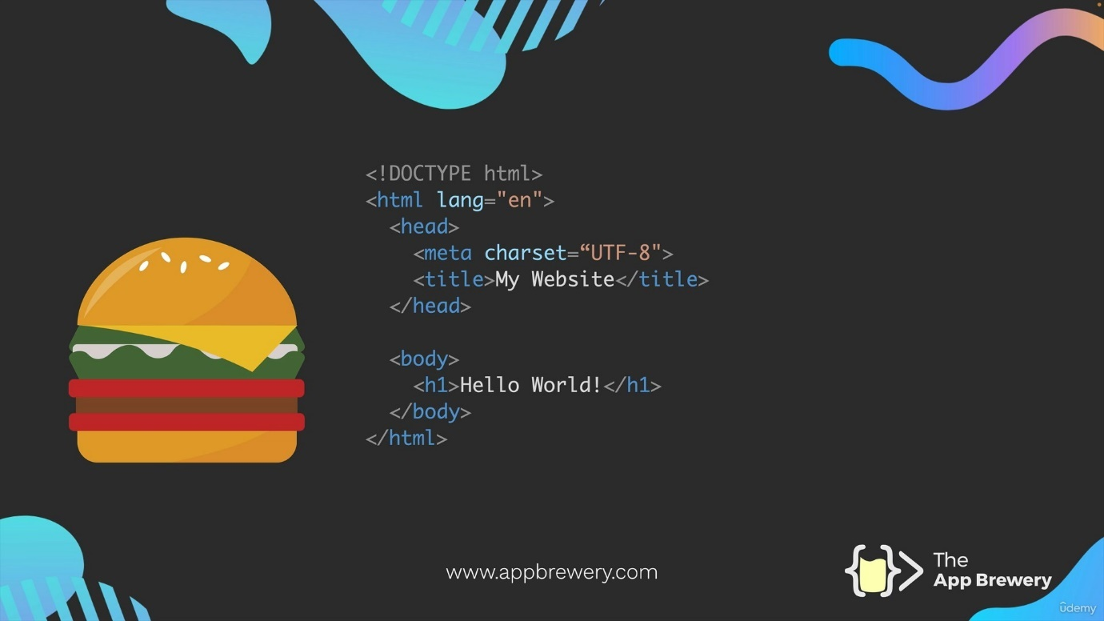

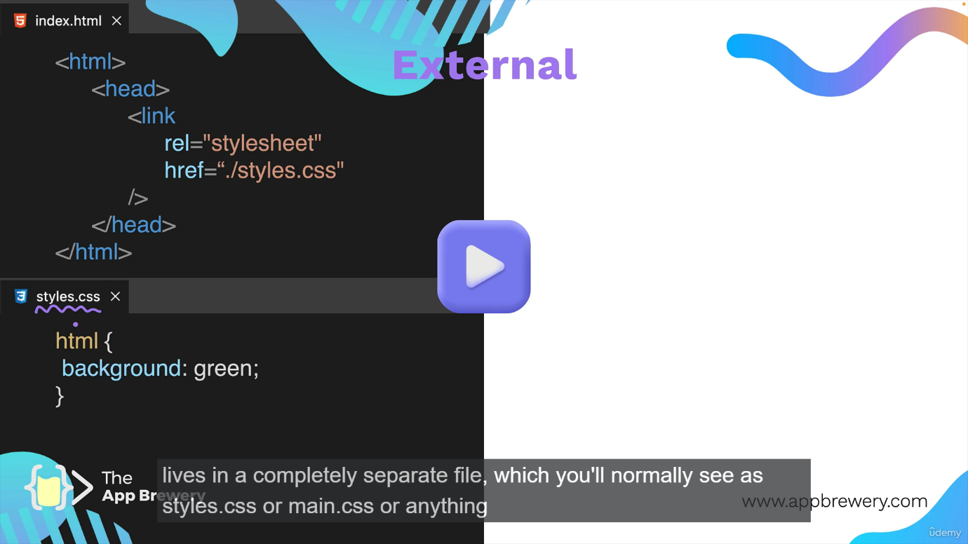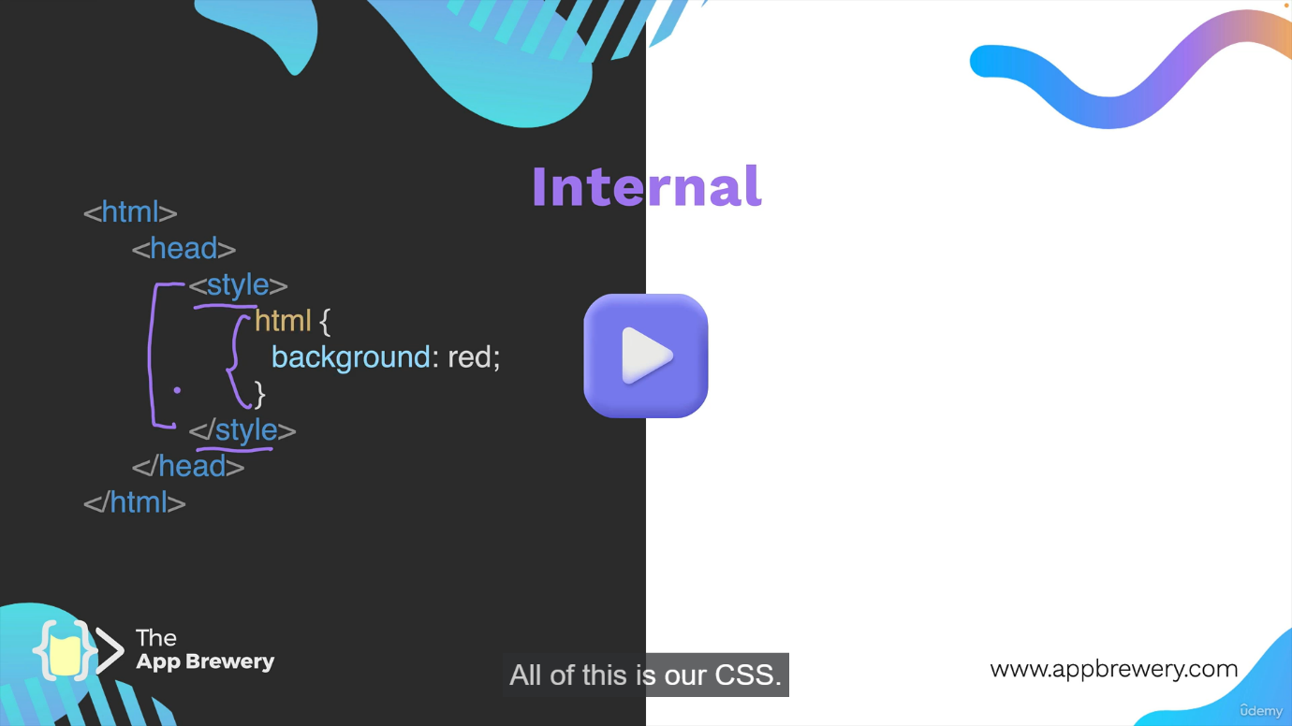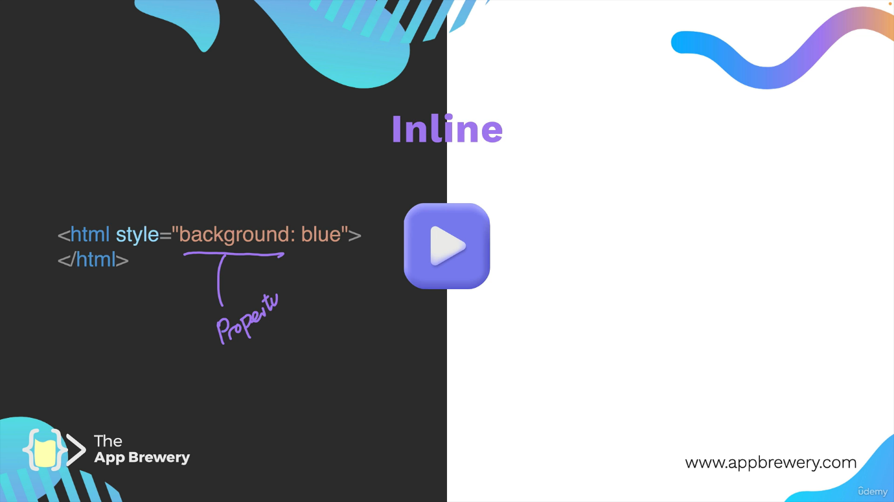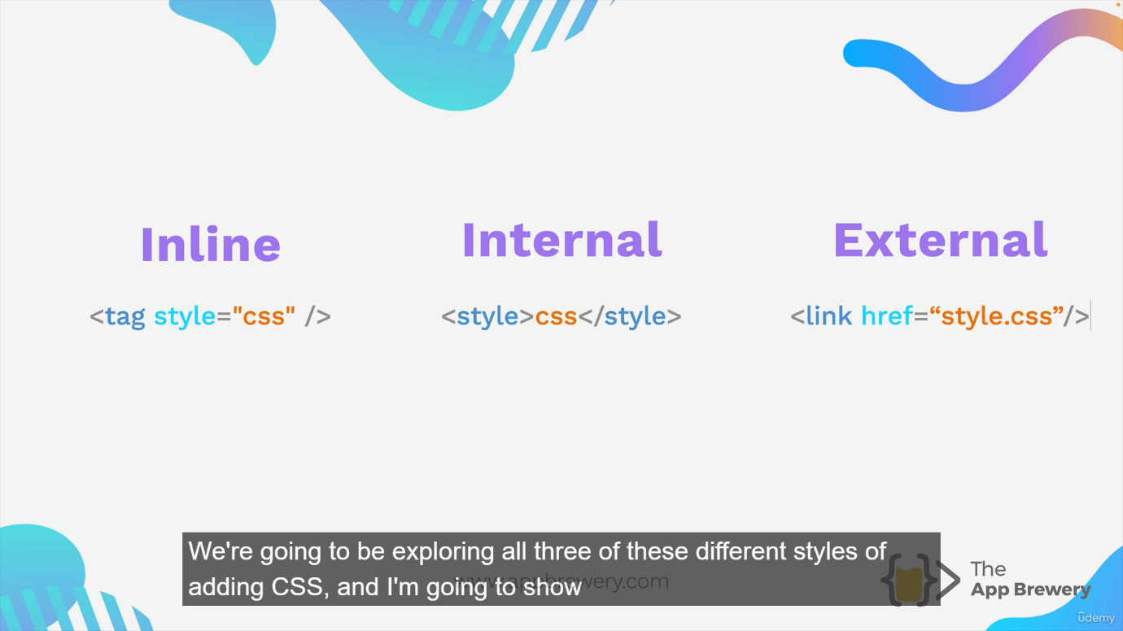

Selectors:

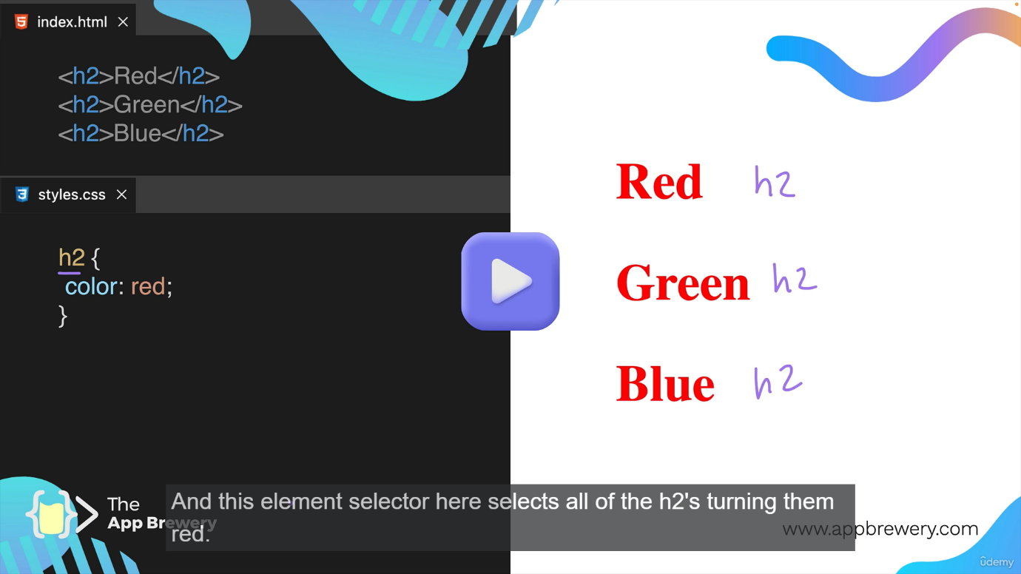

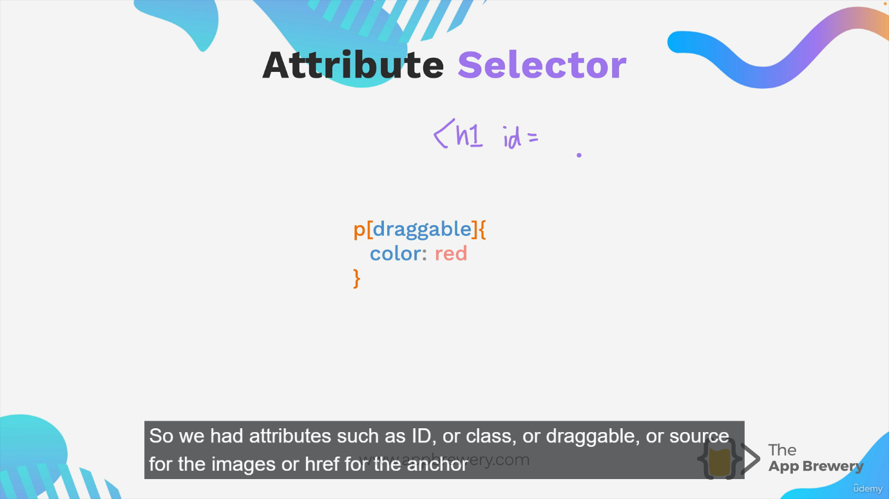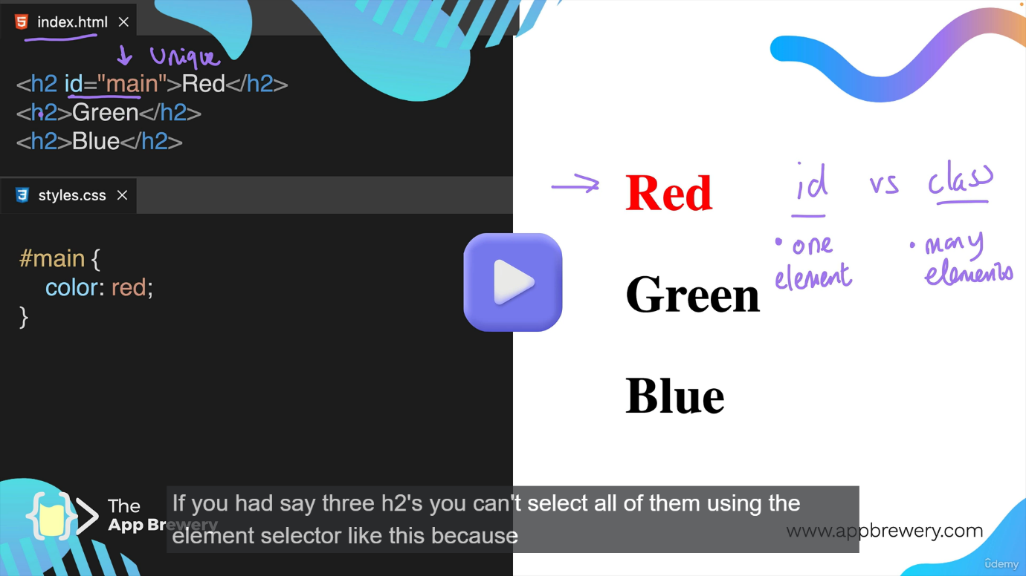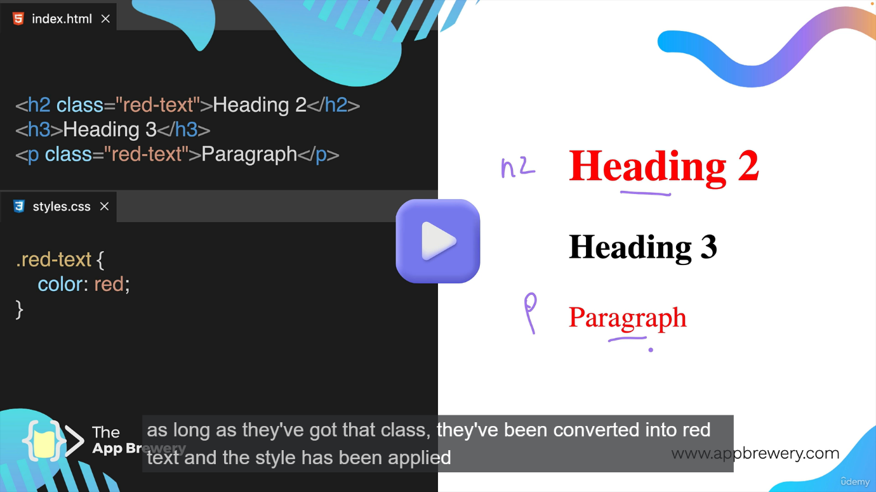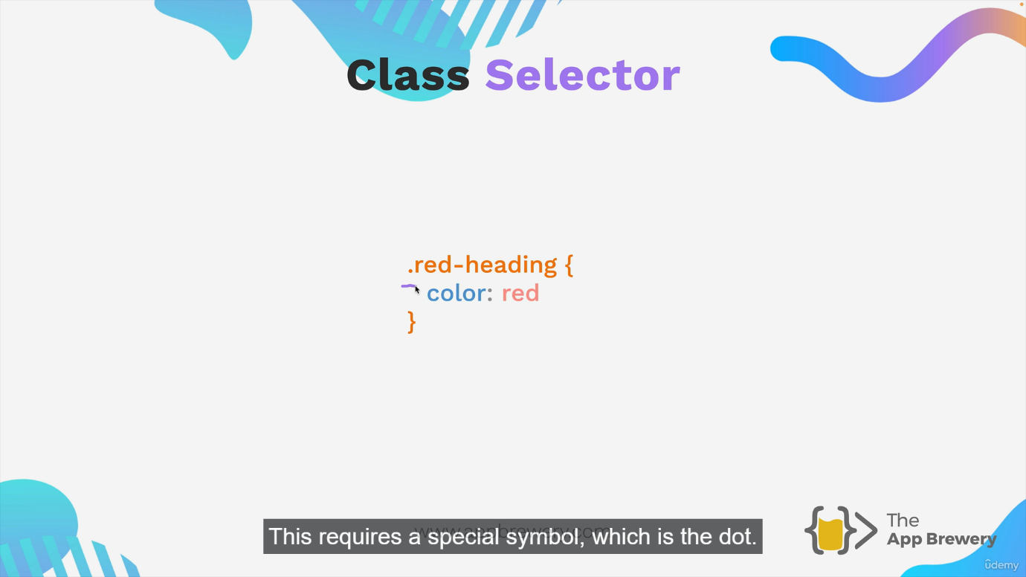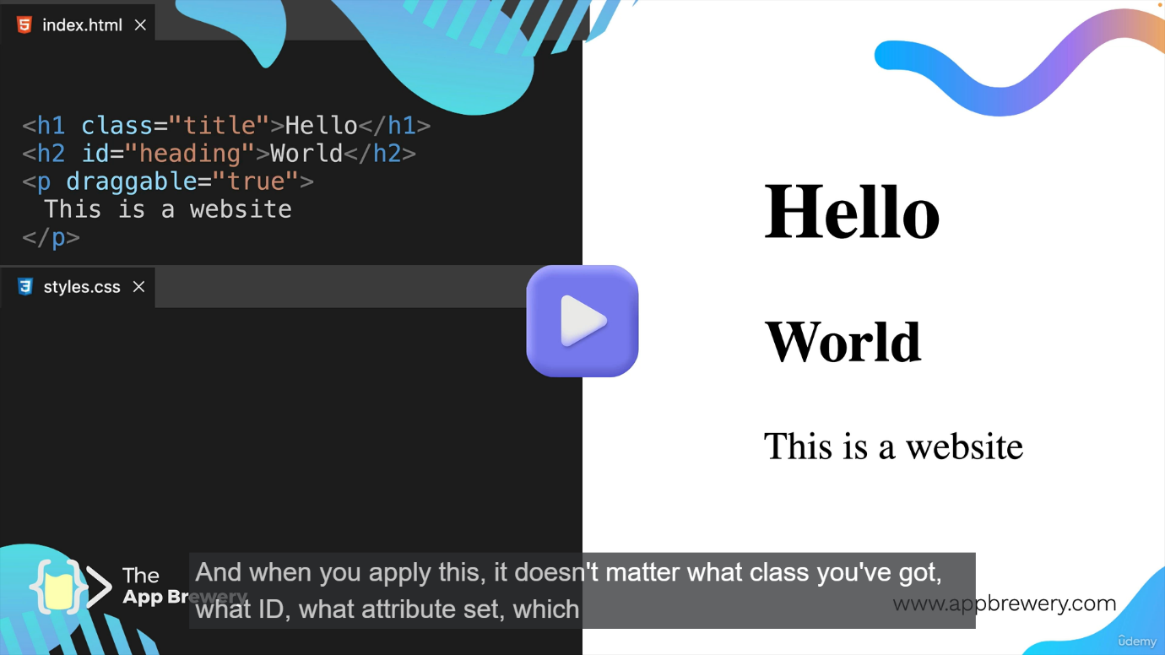

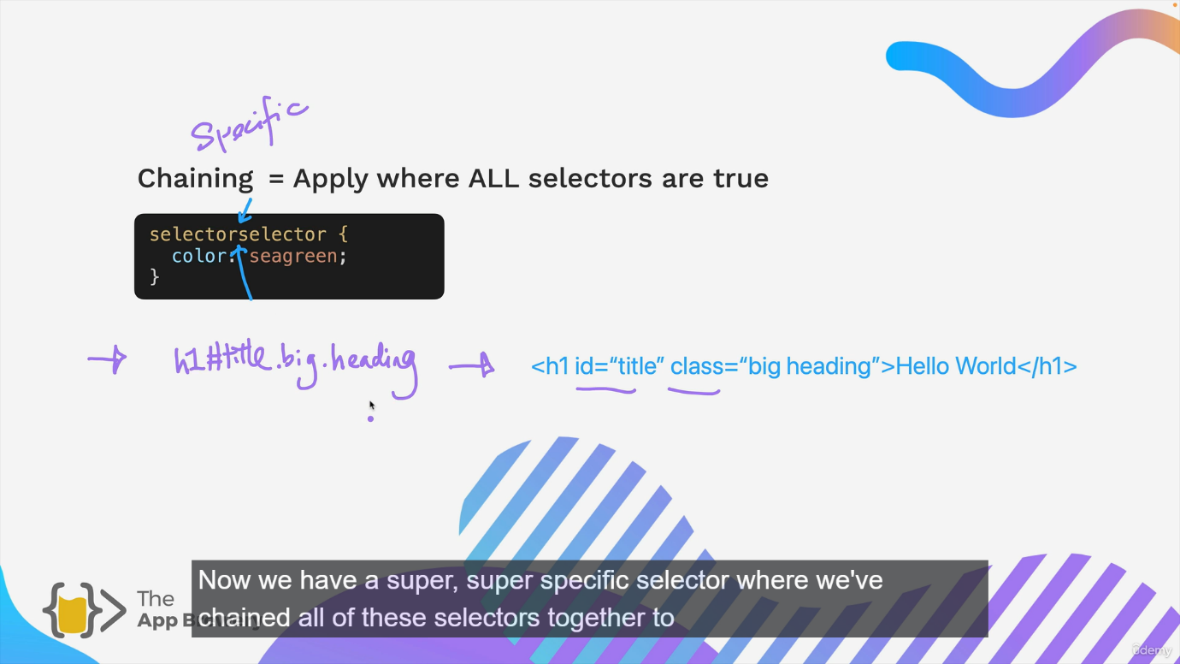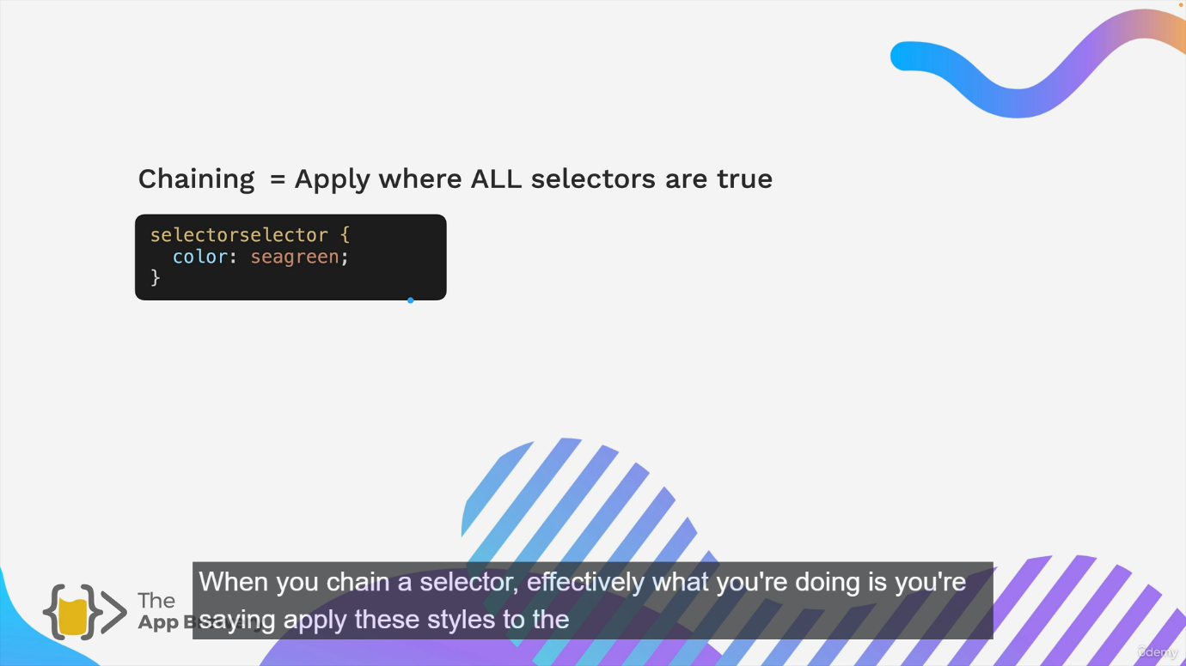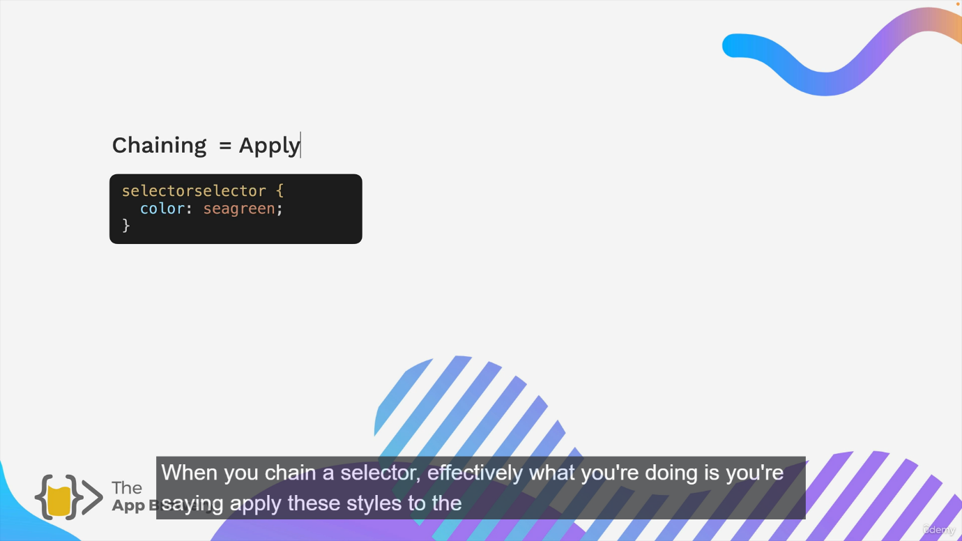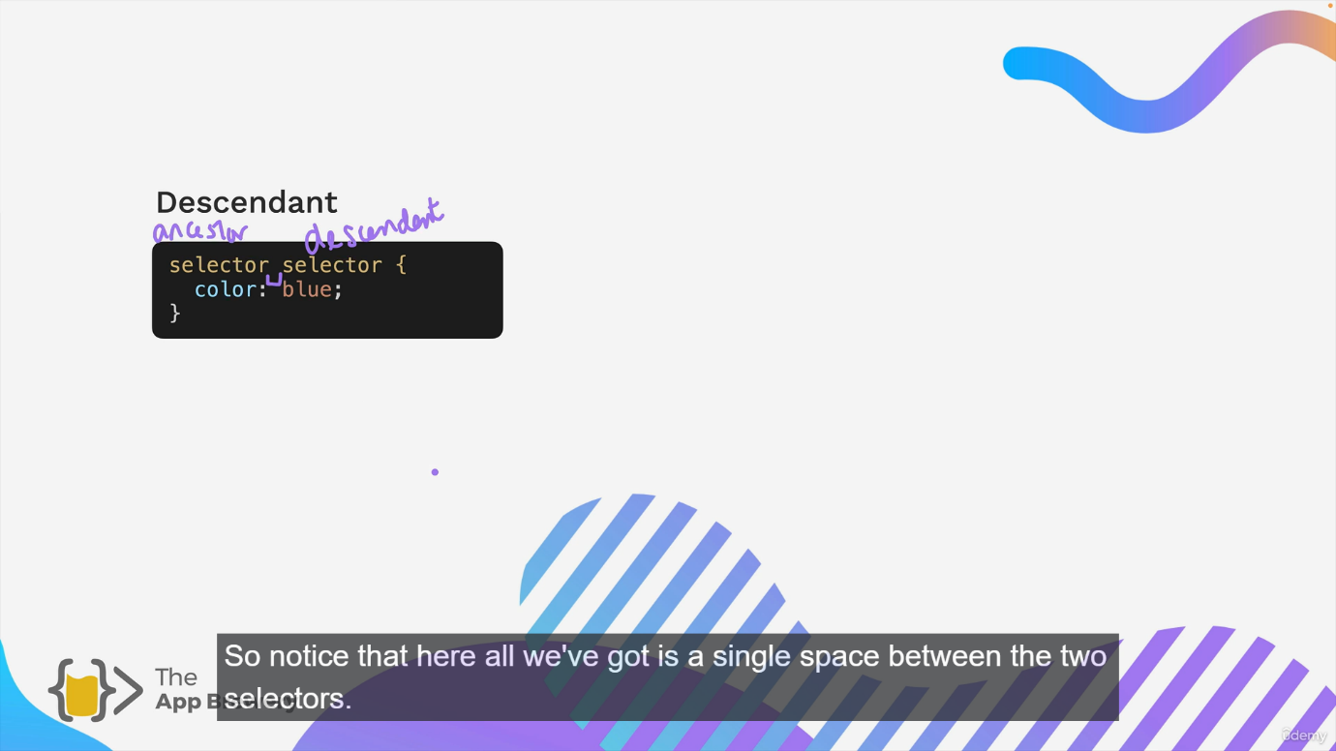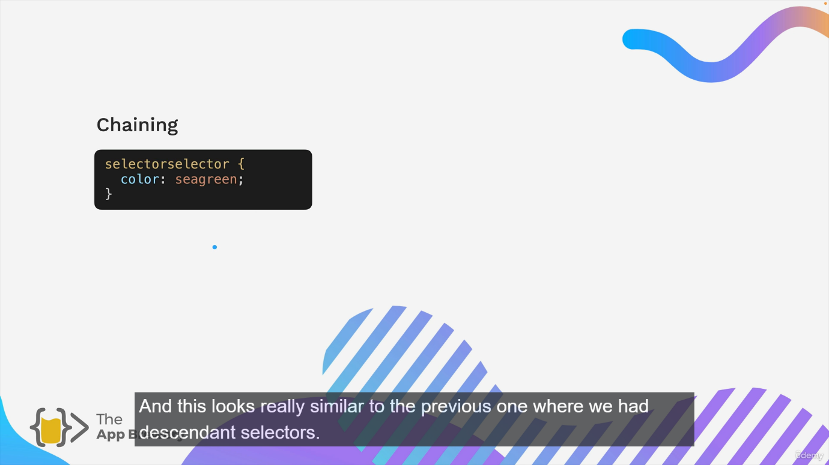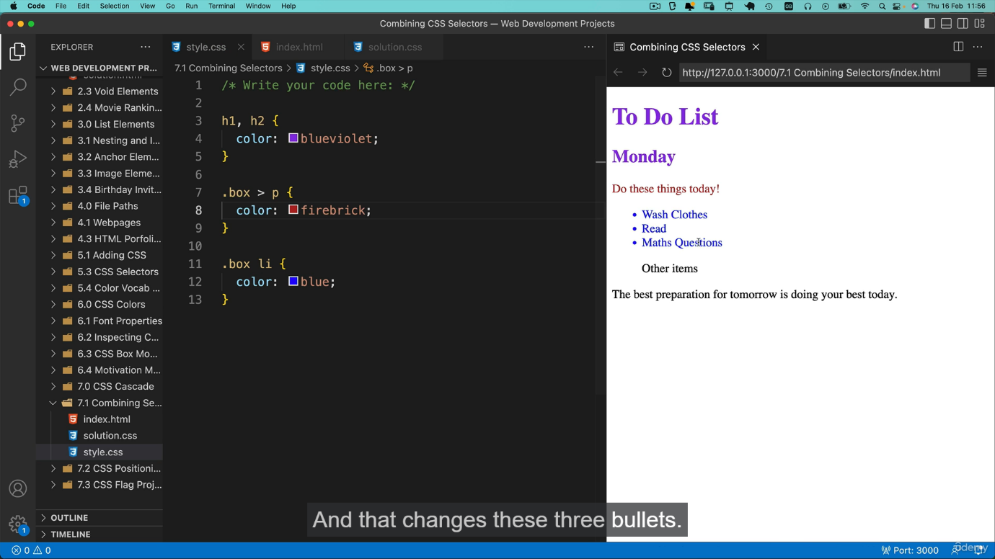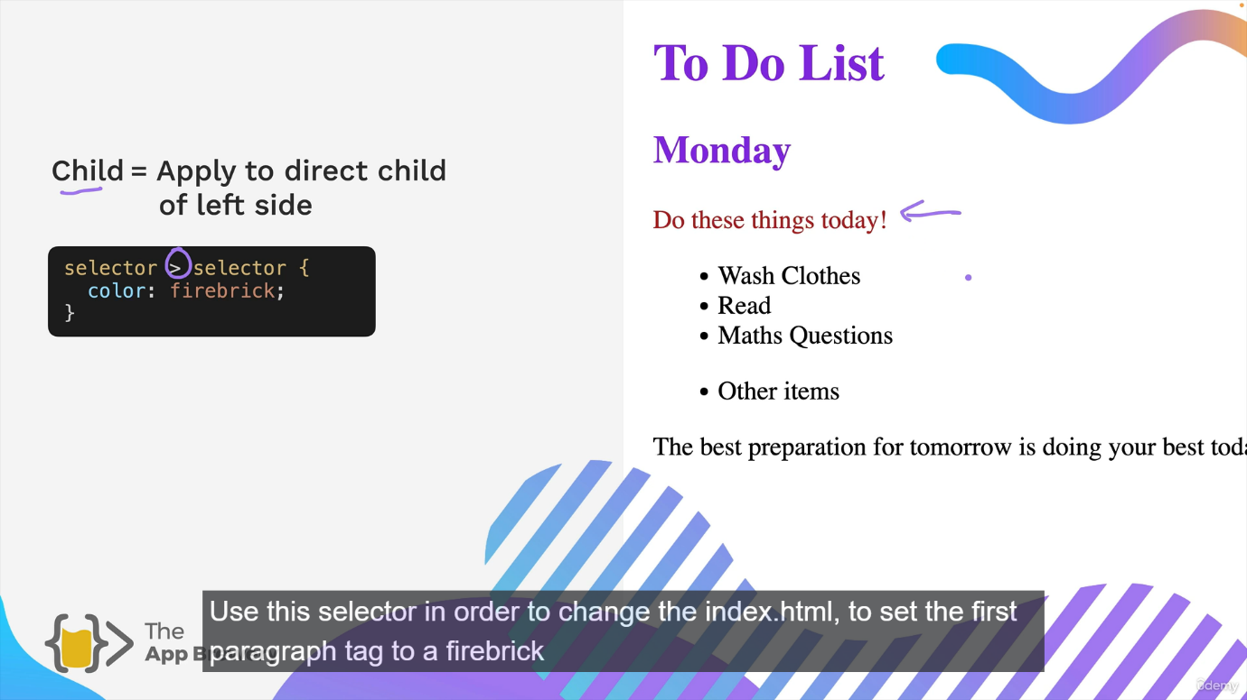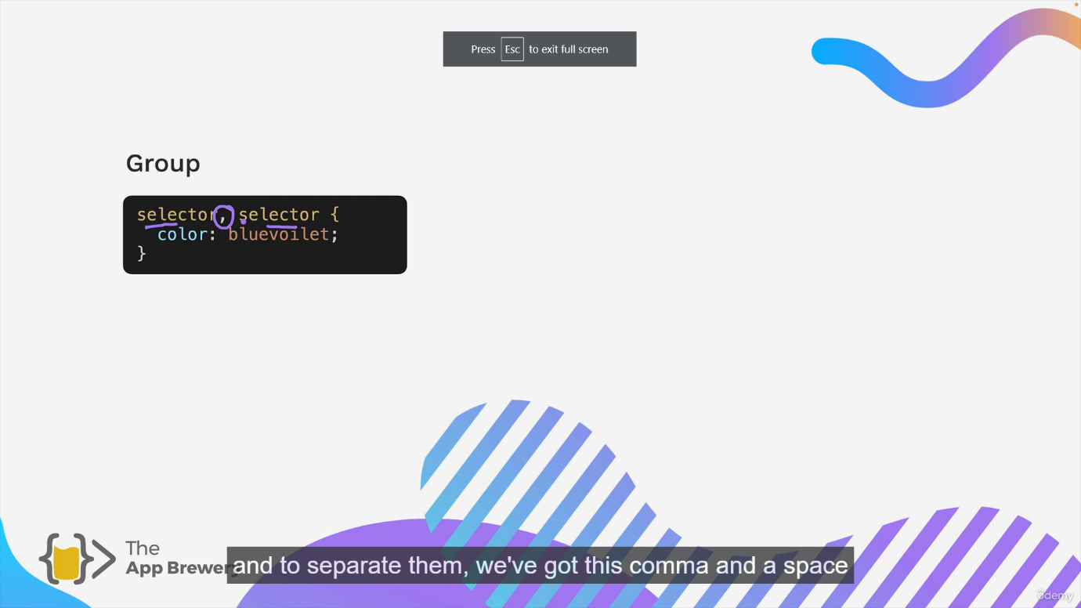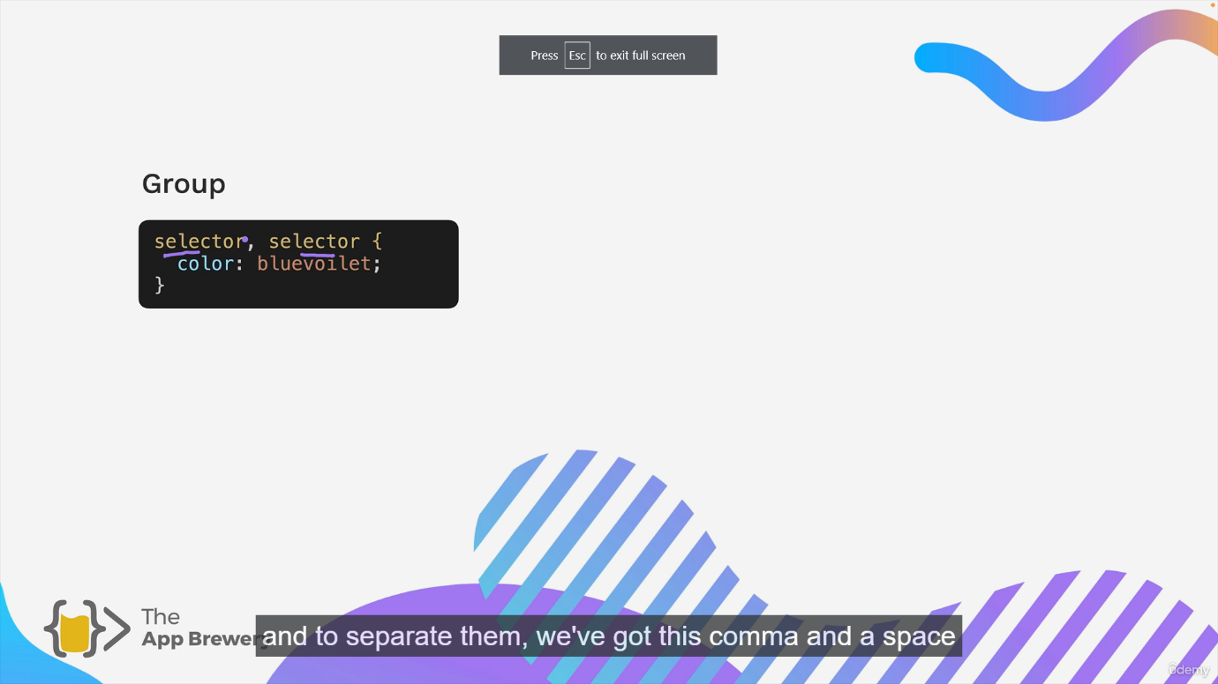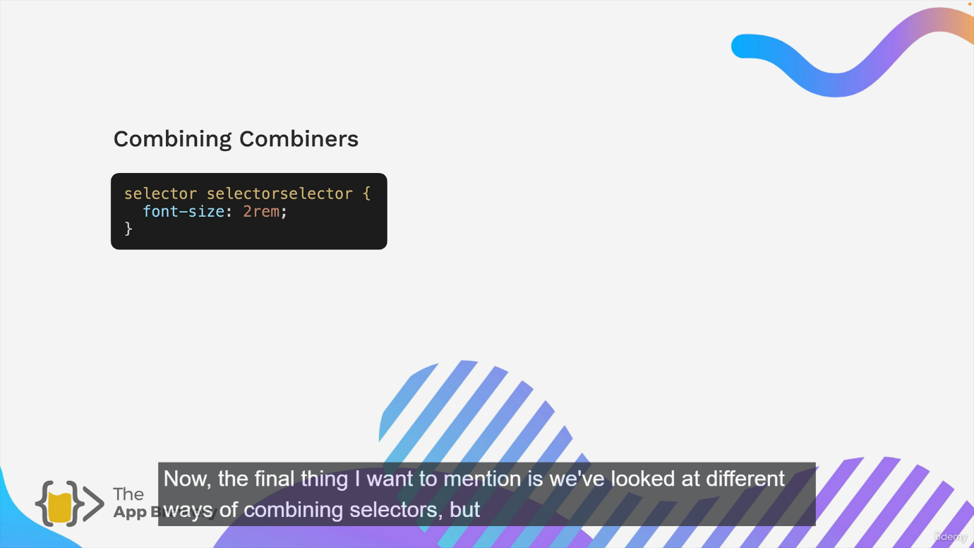

**Position:**

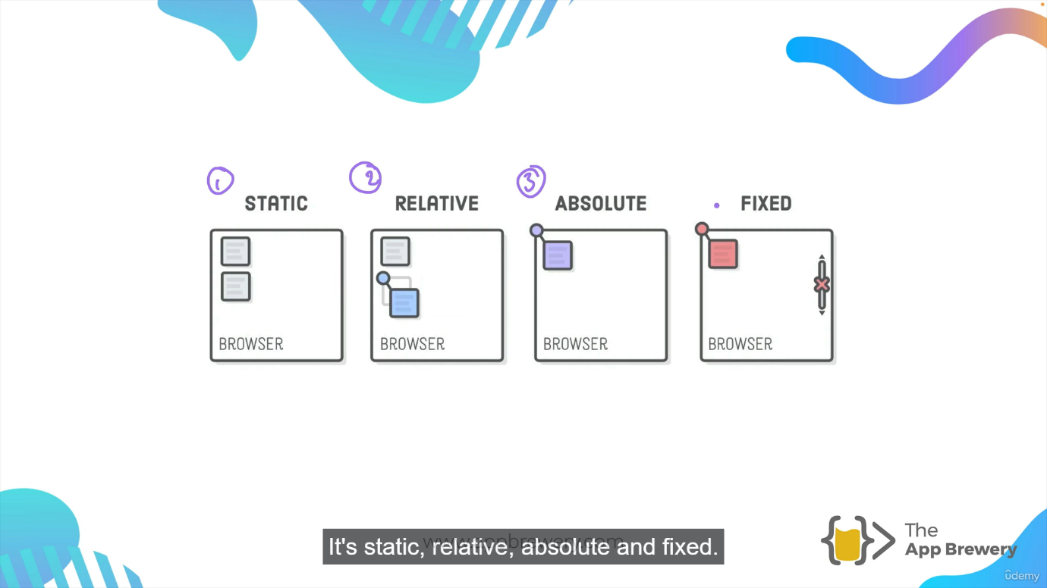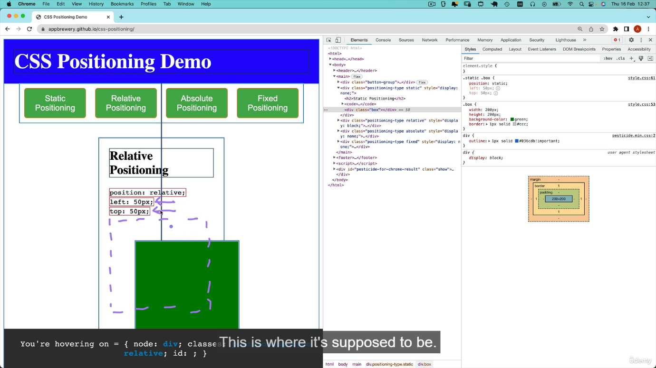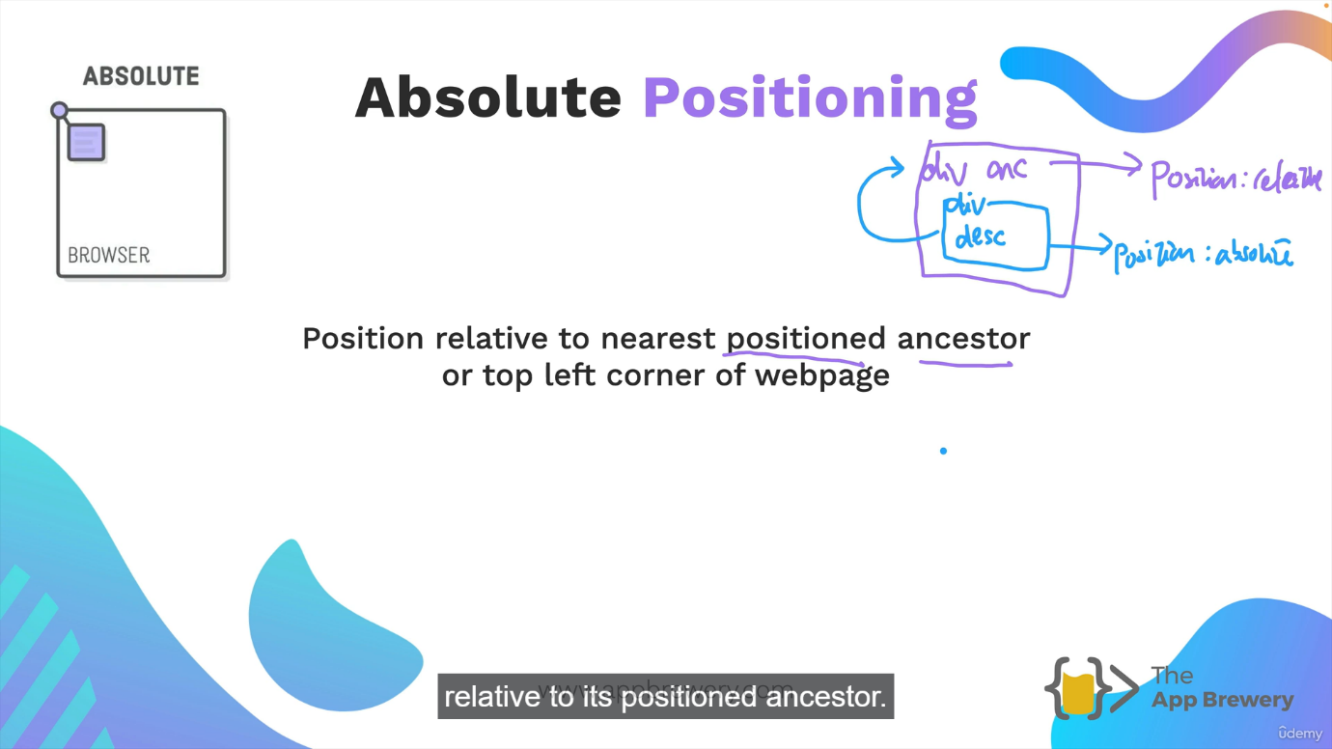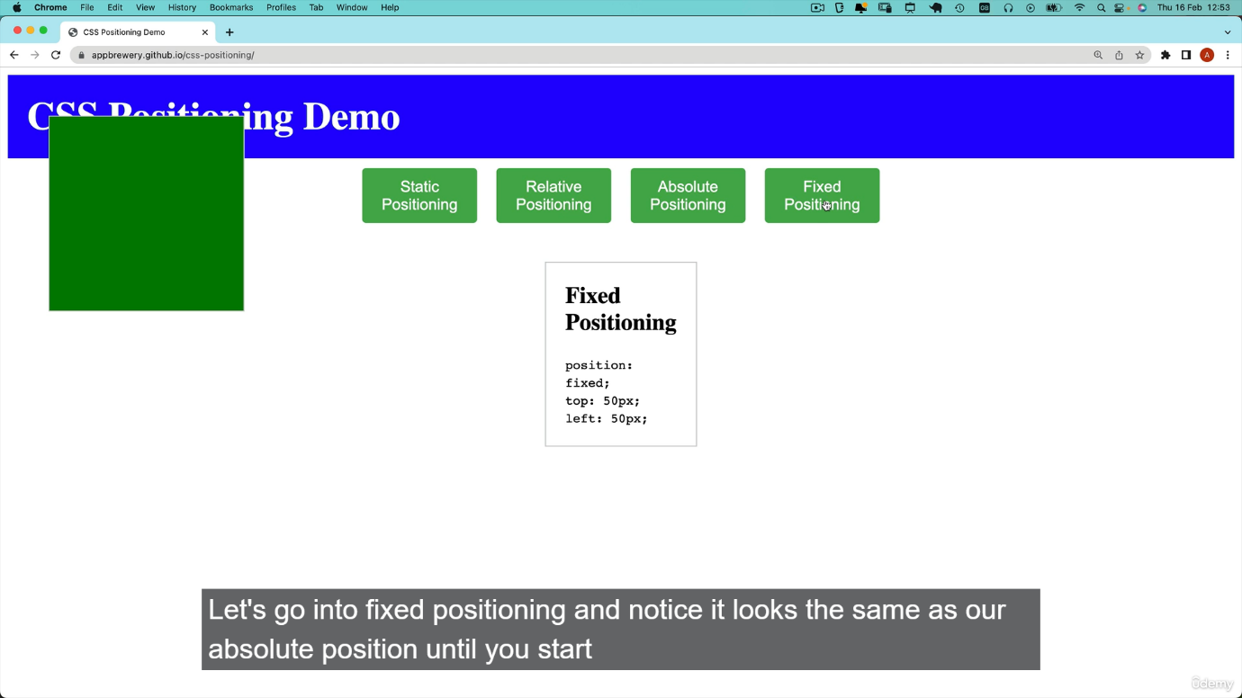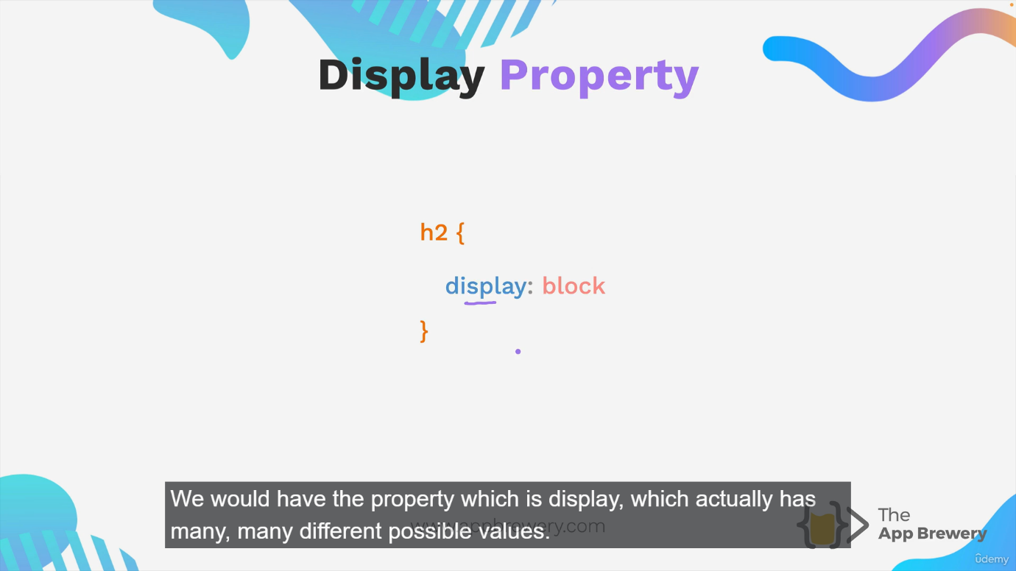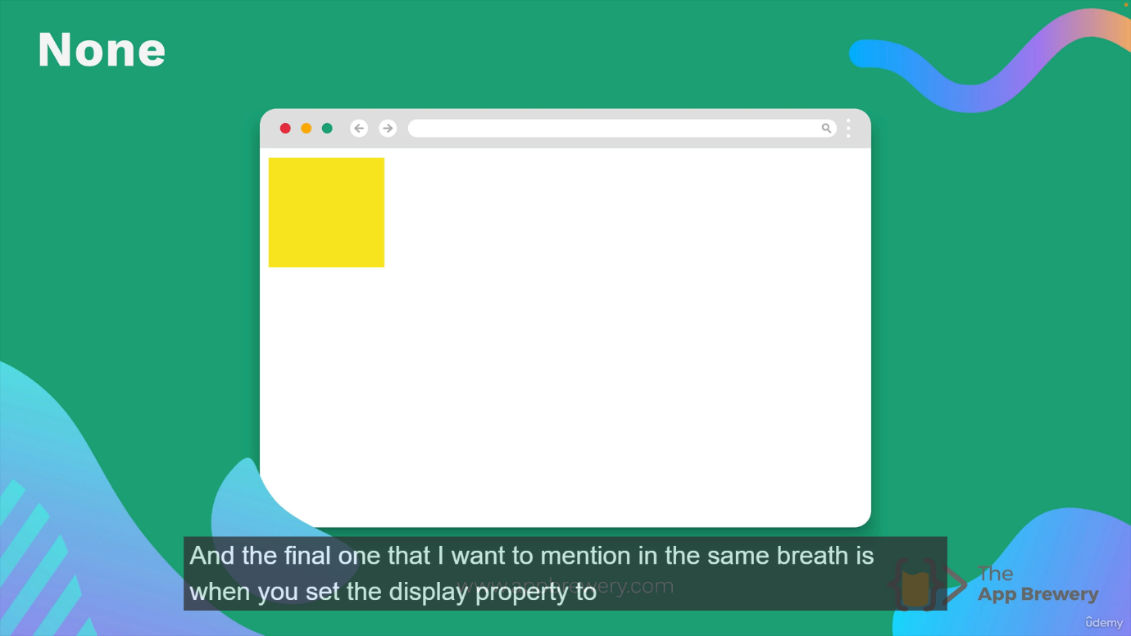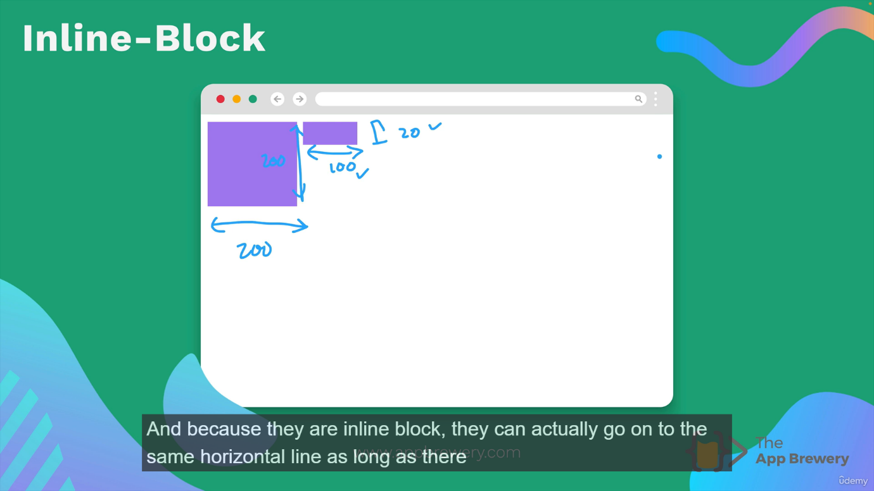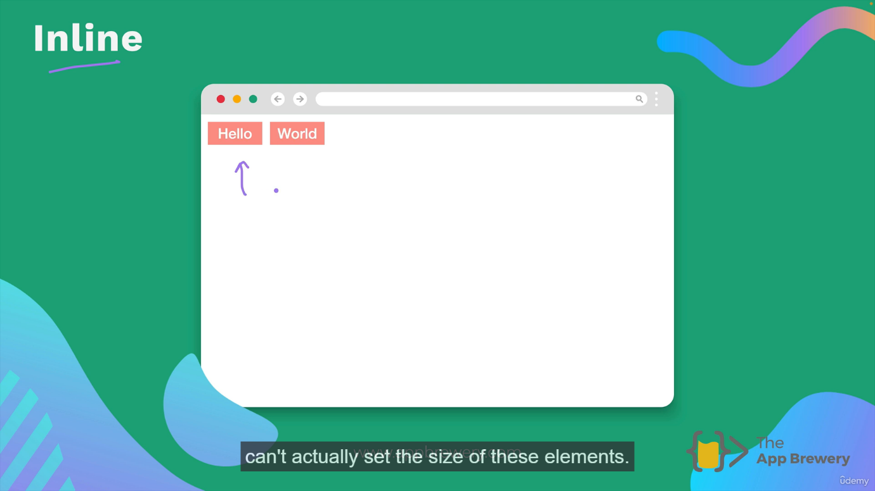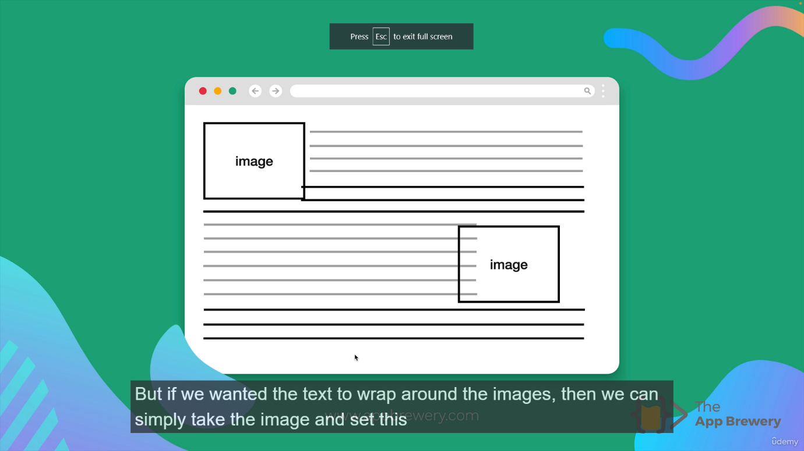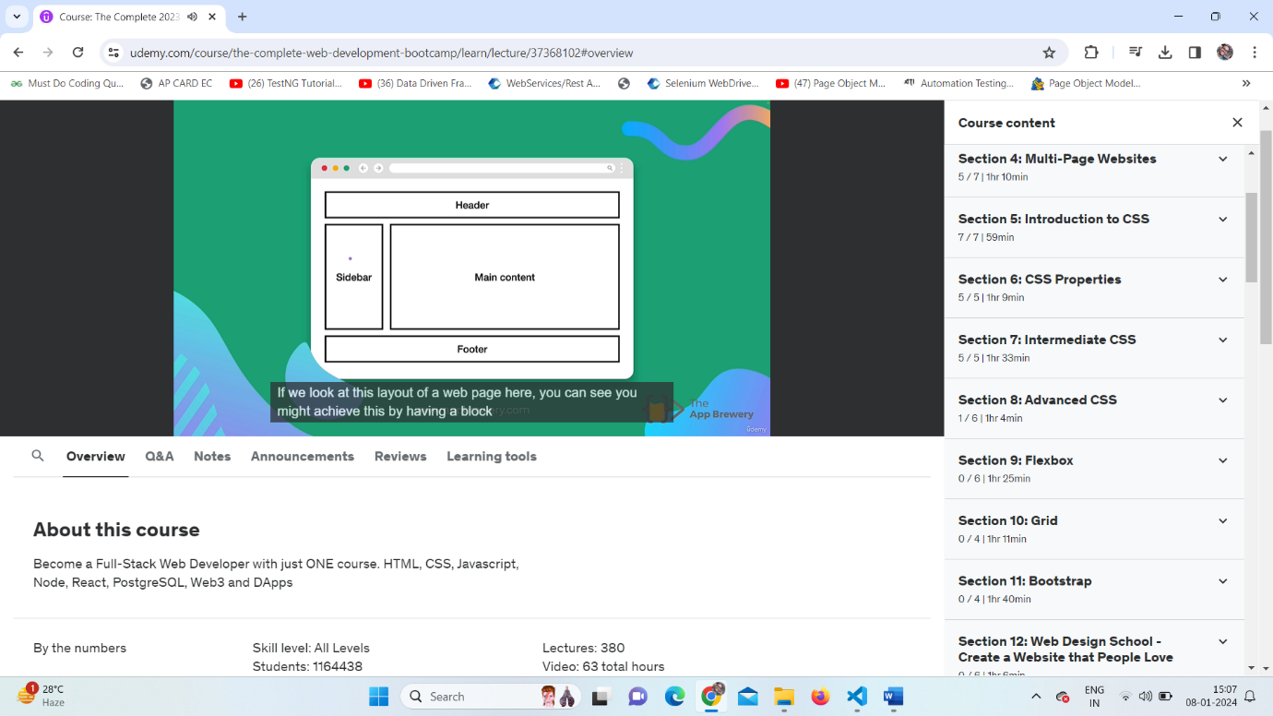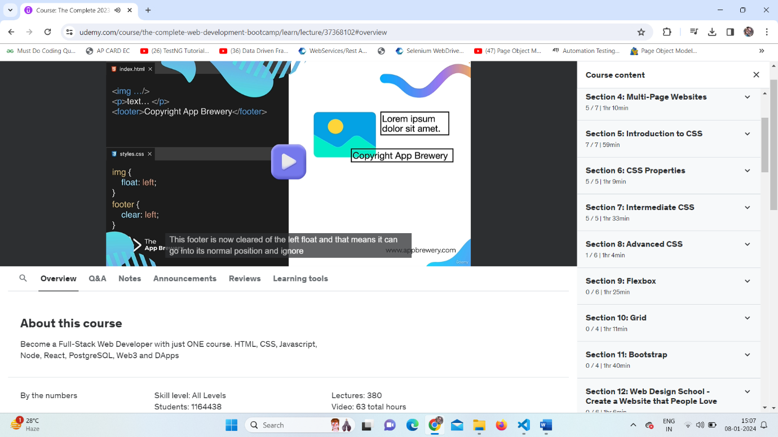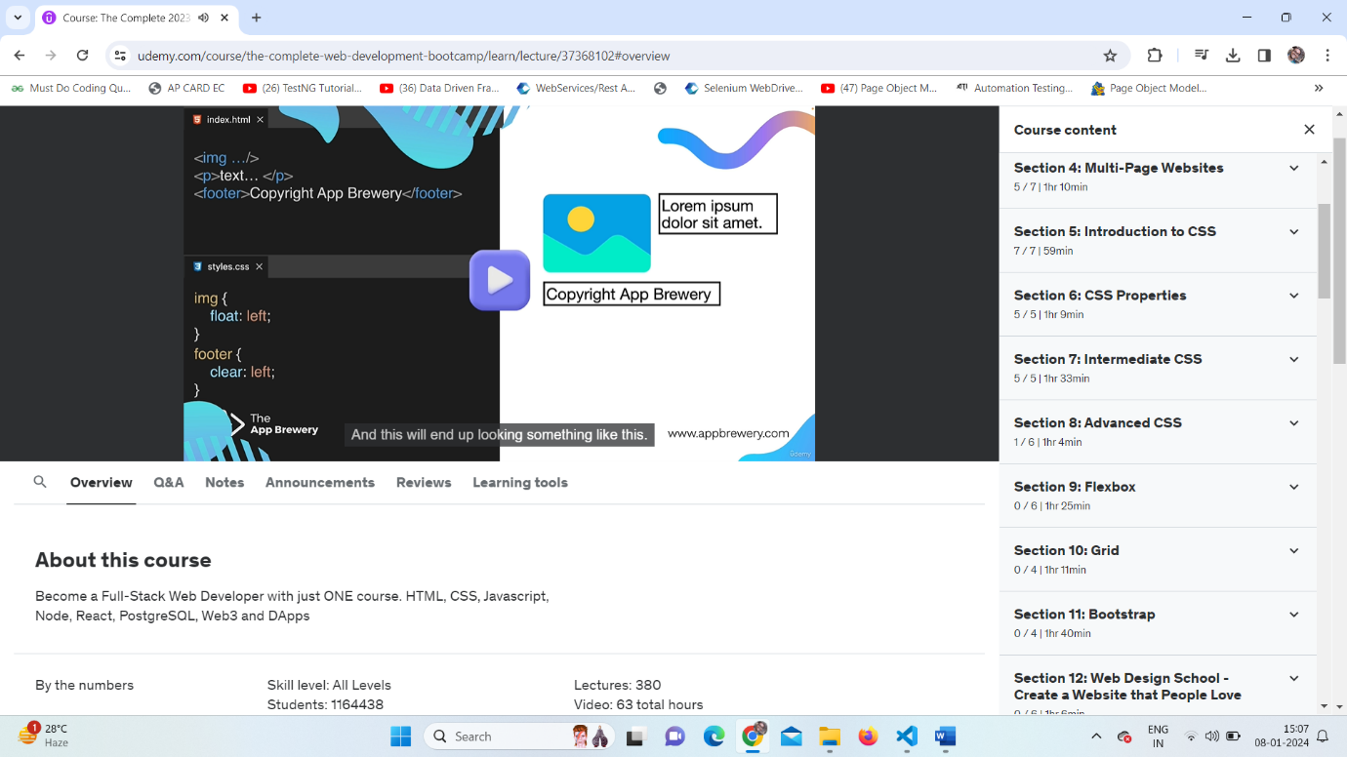

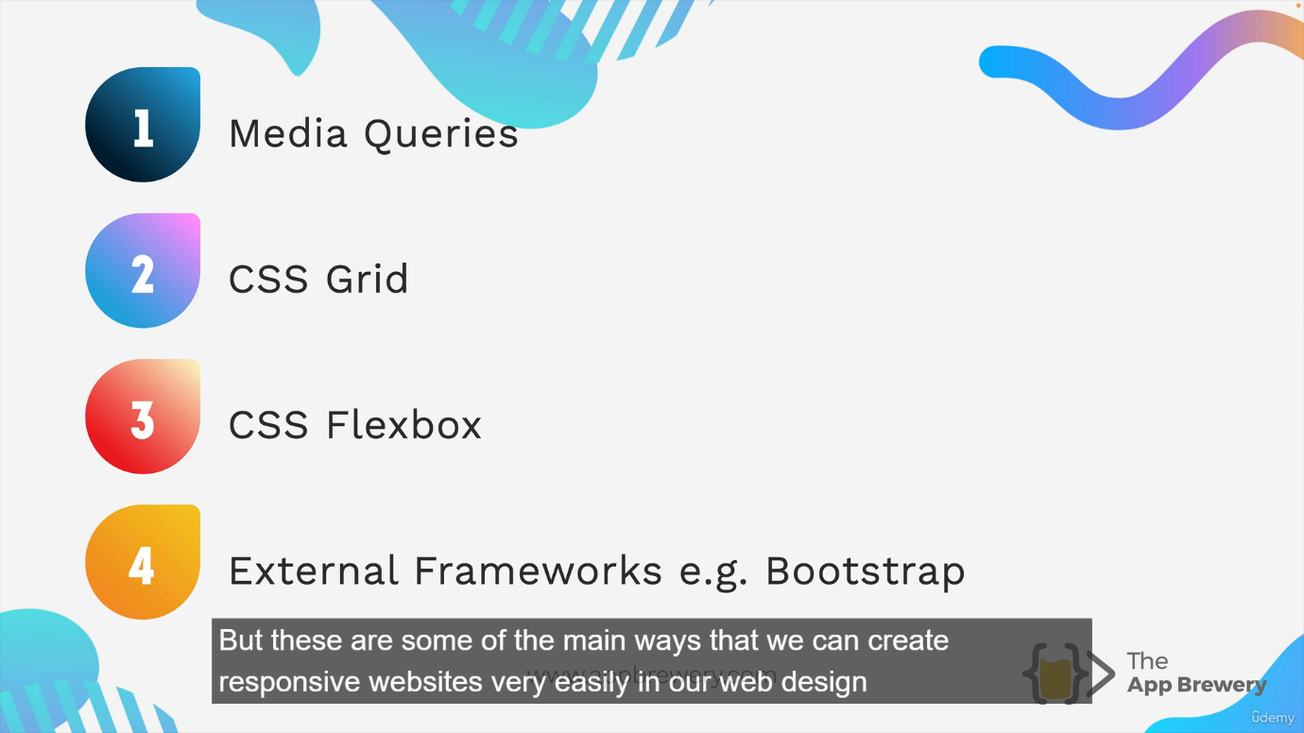

**Css Media:**

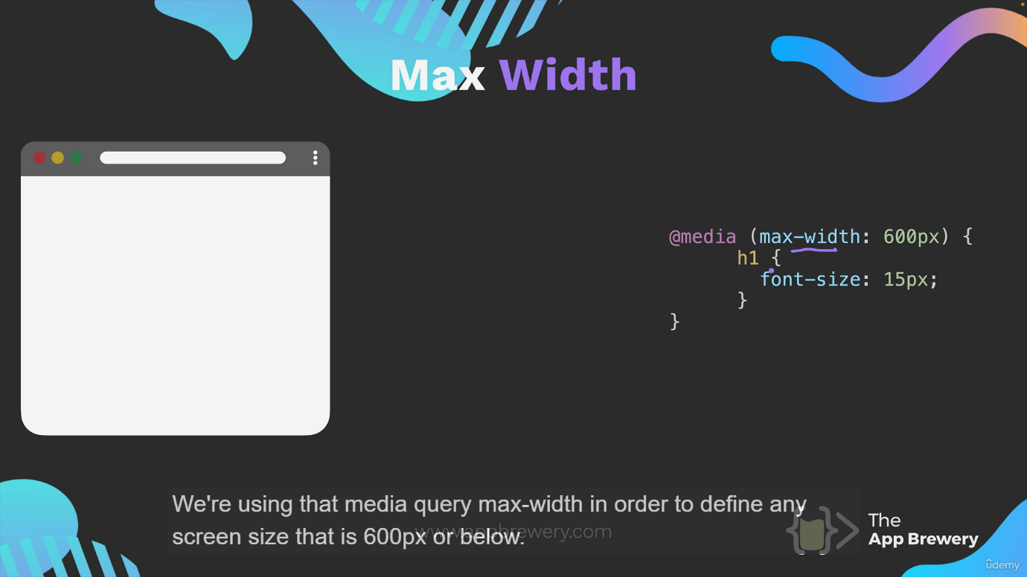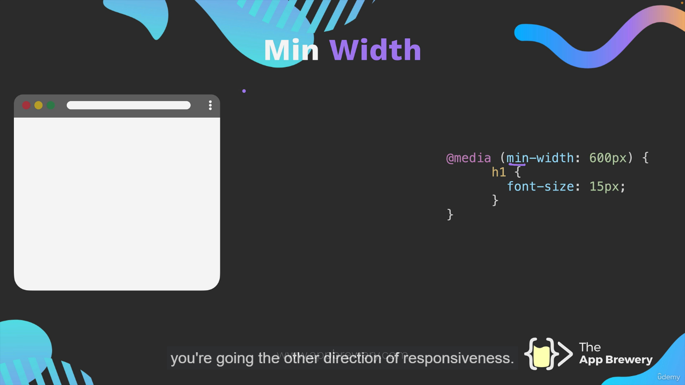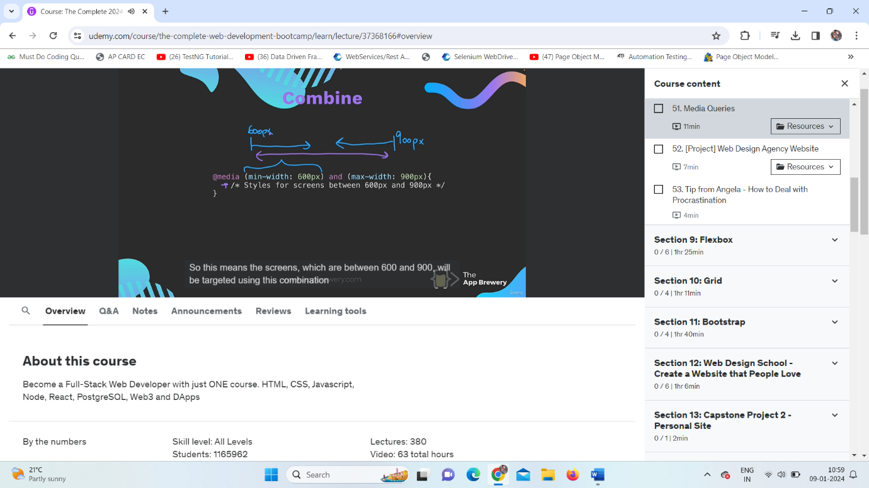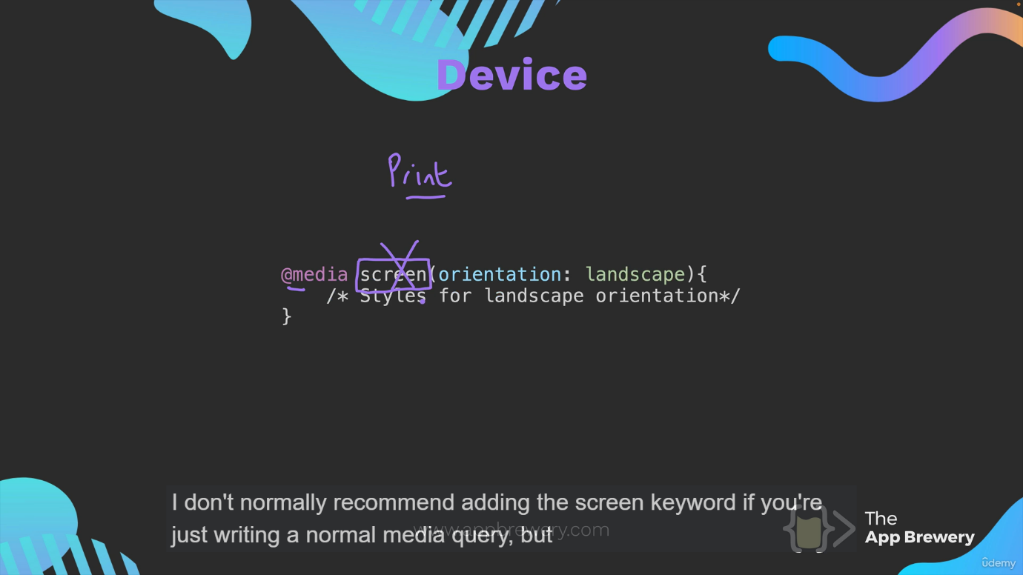

**Css flex box:**

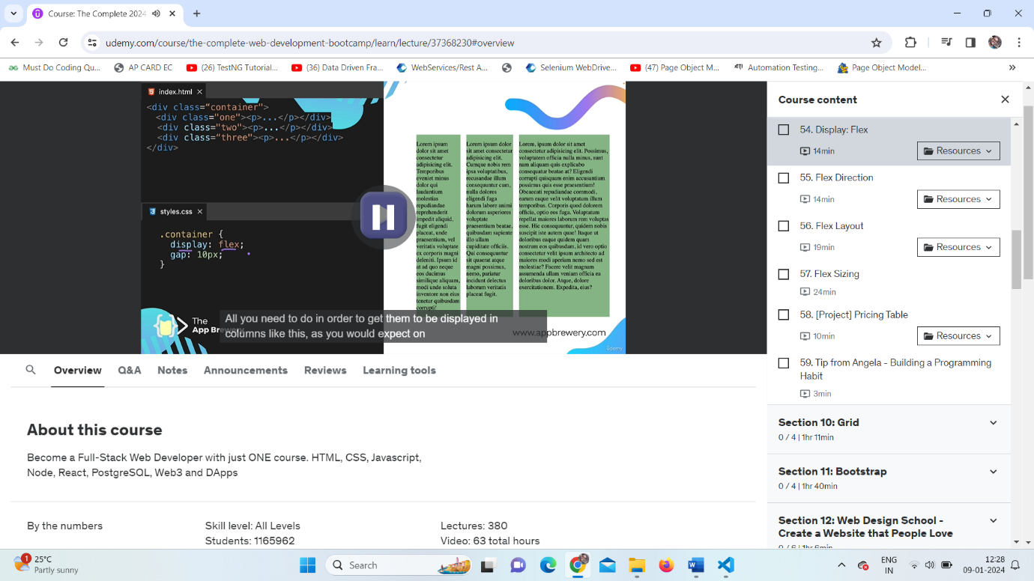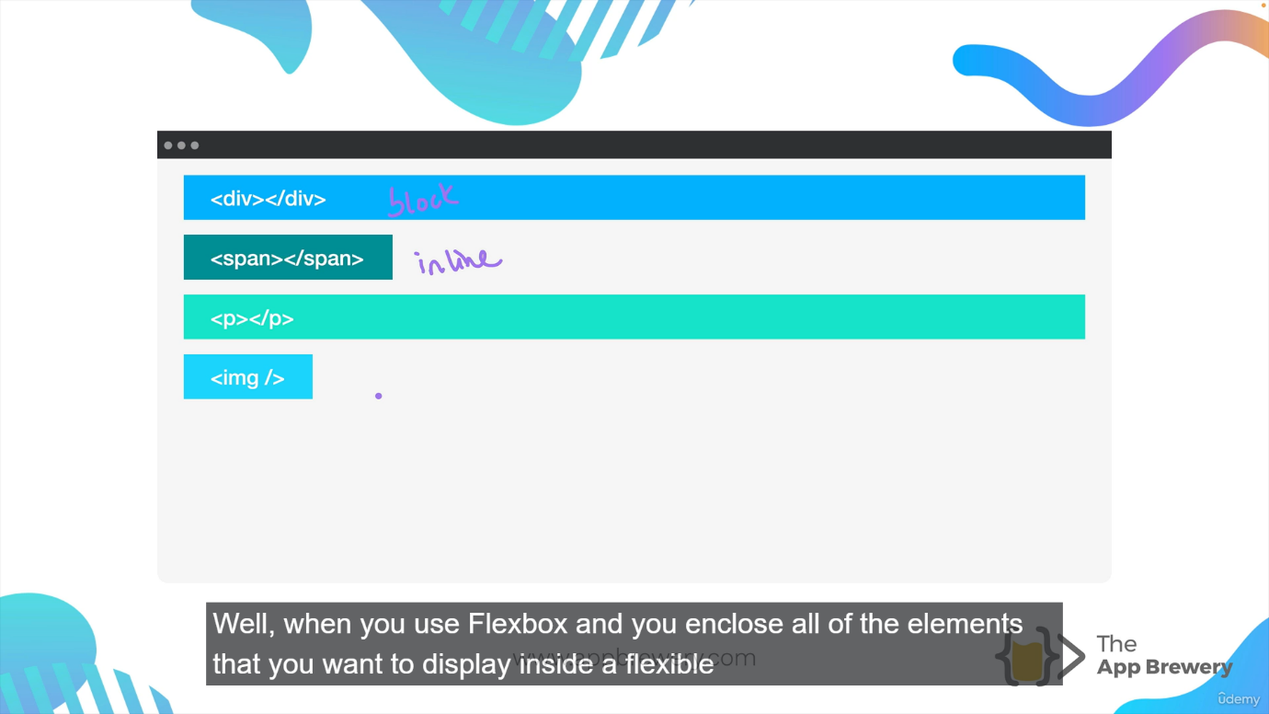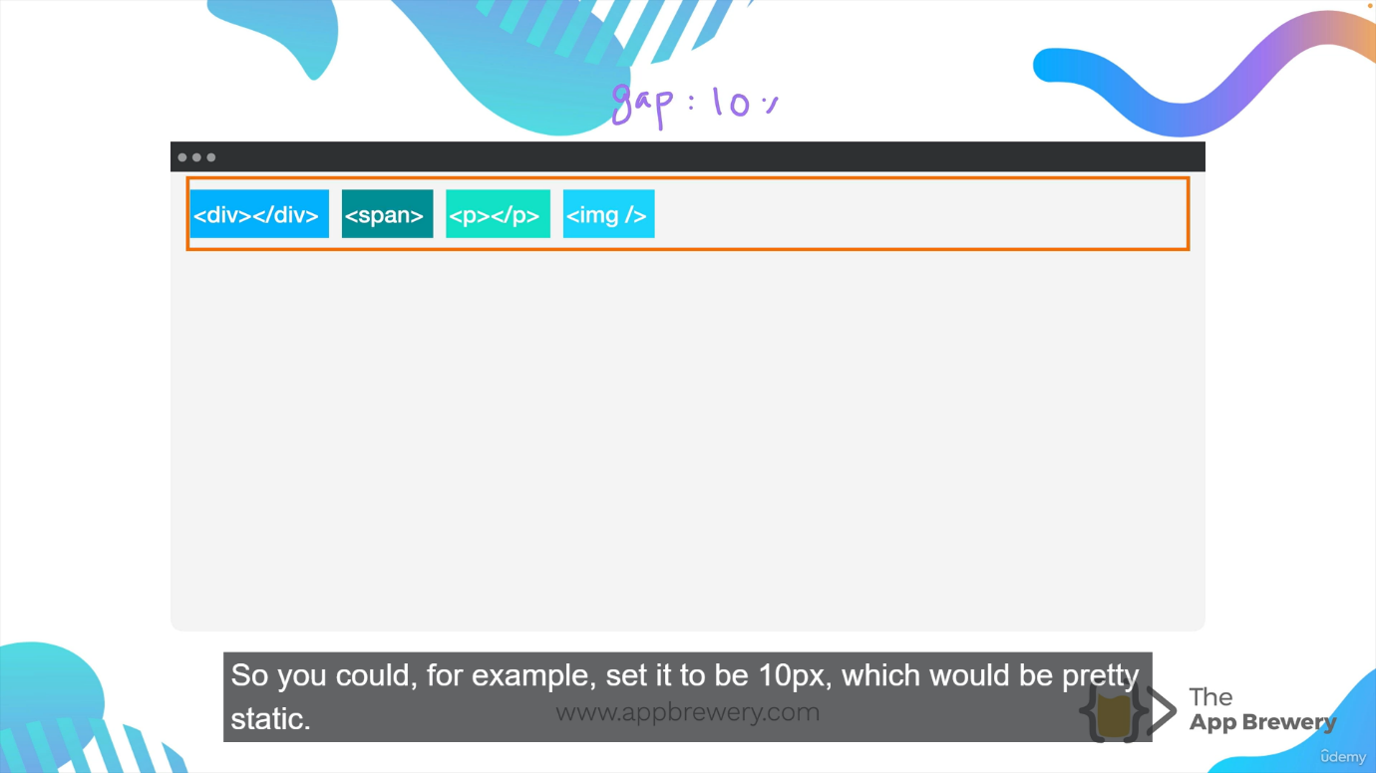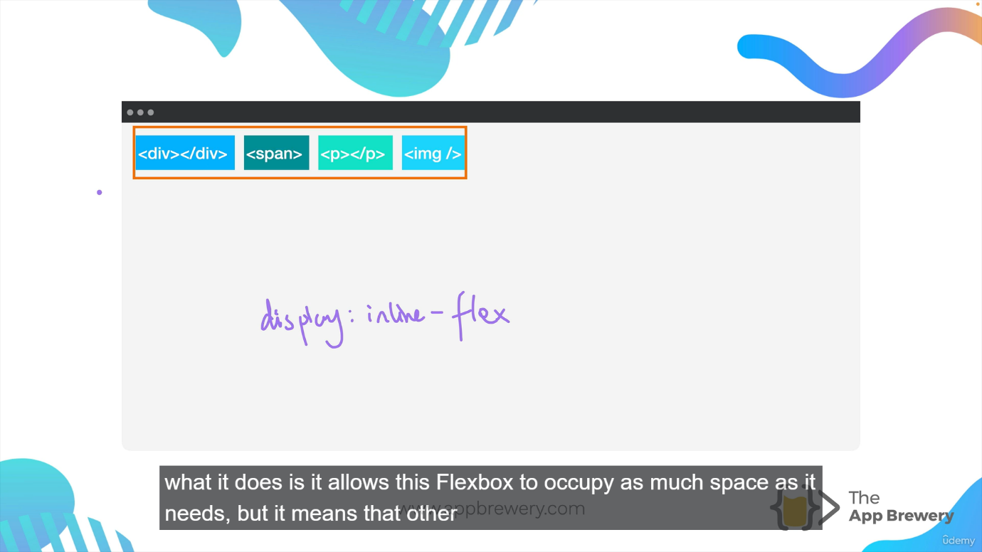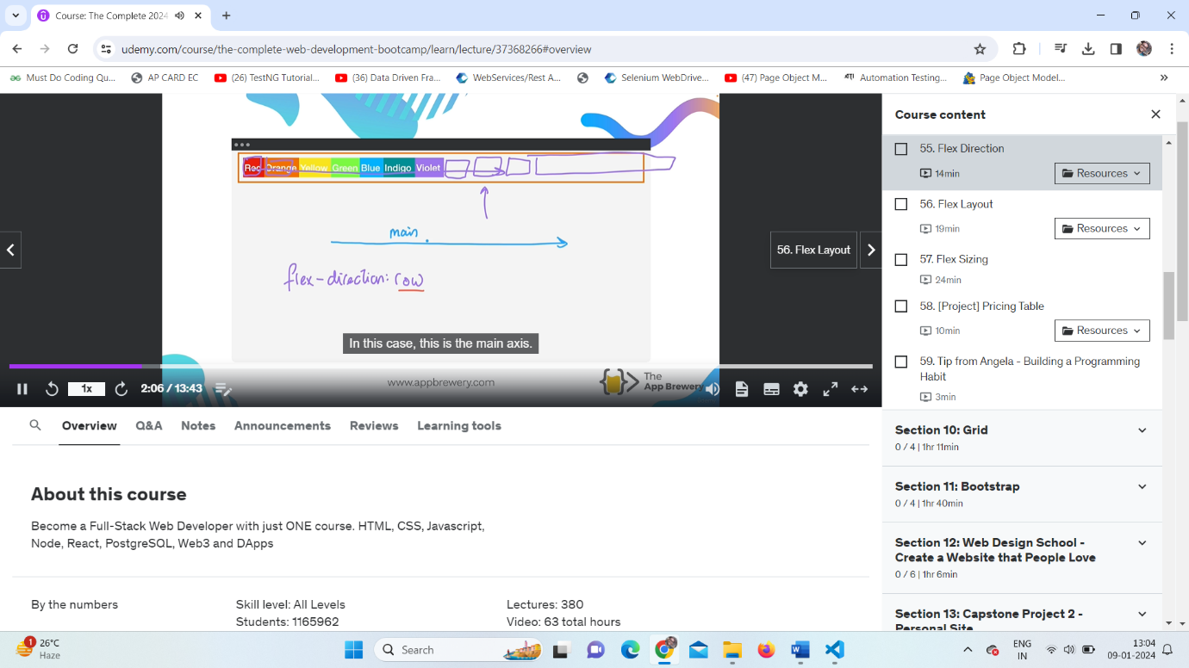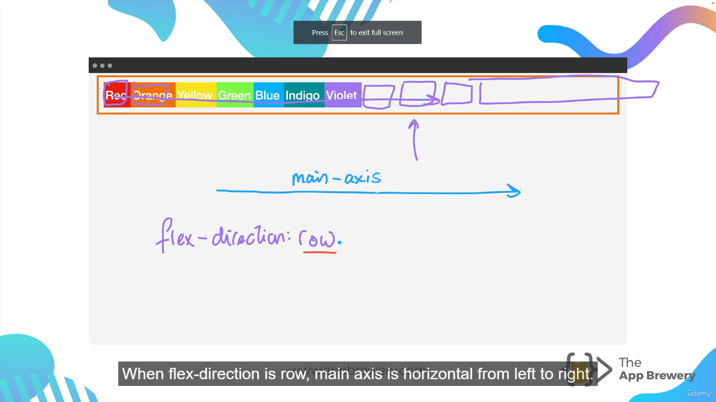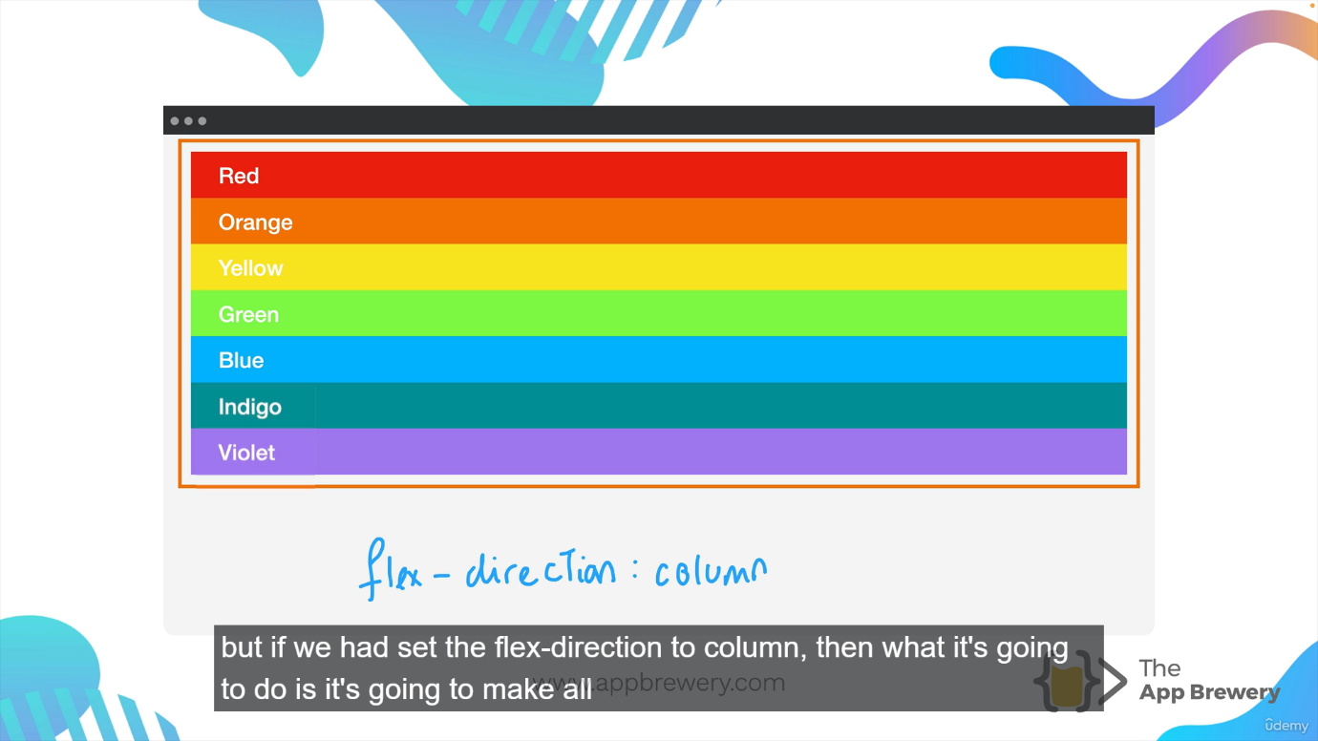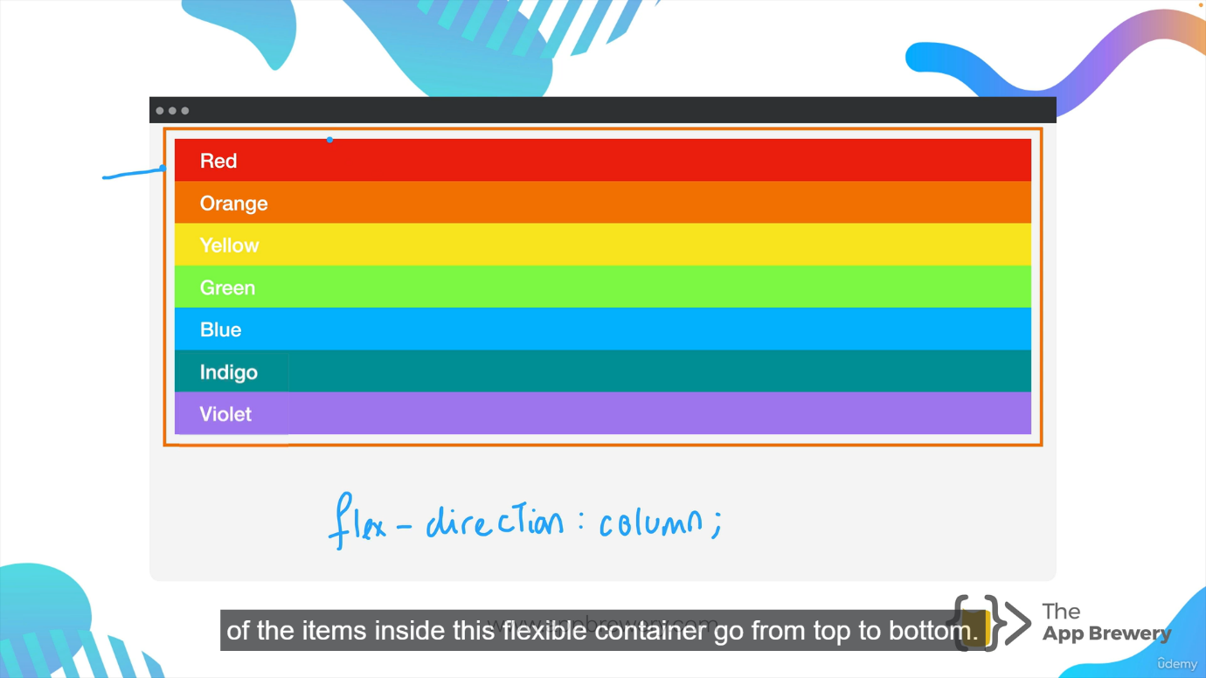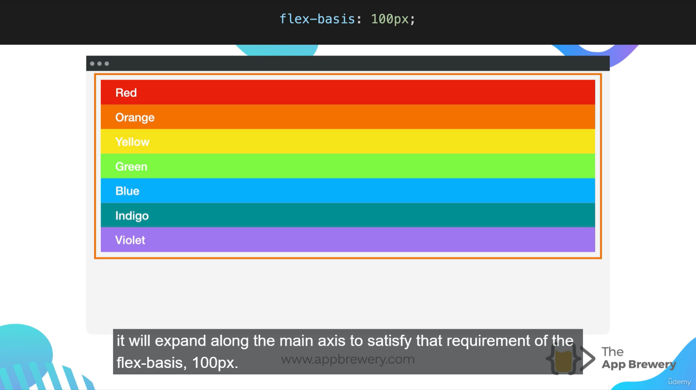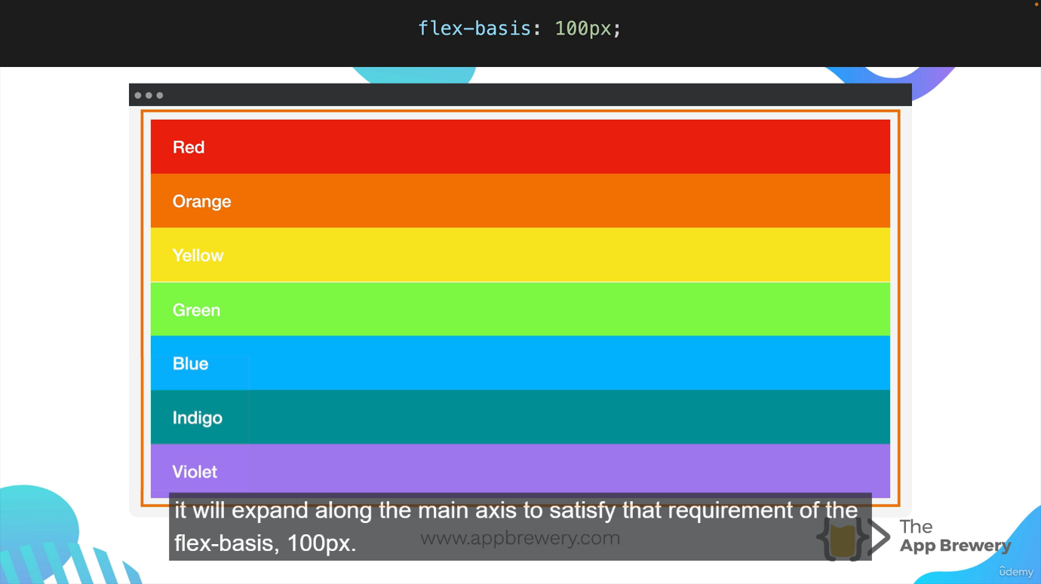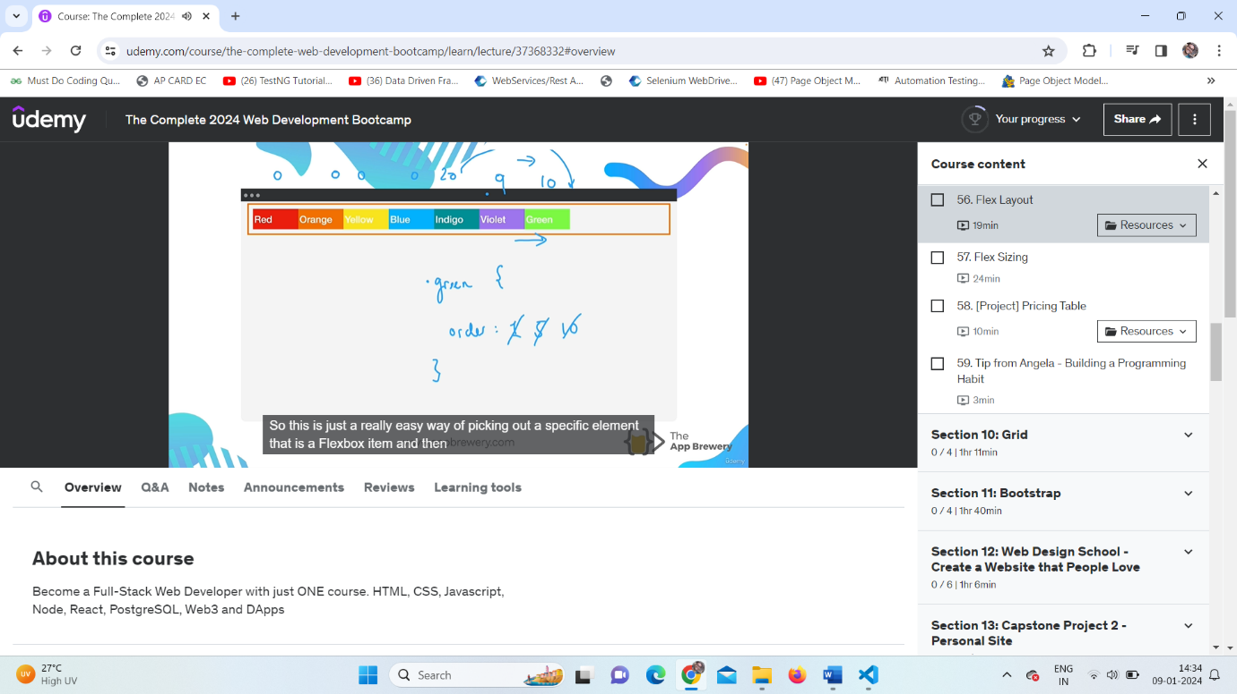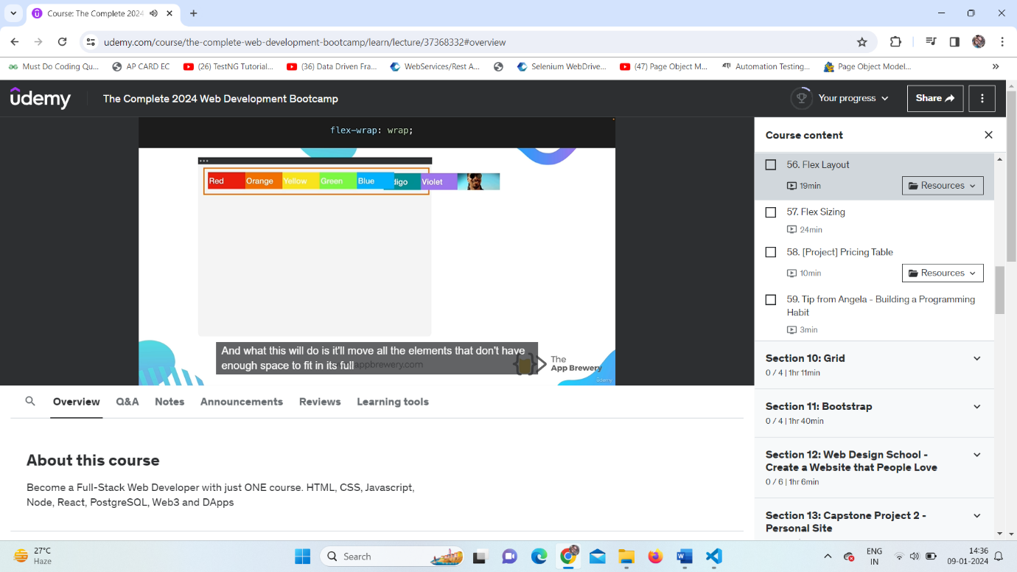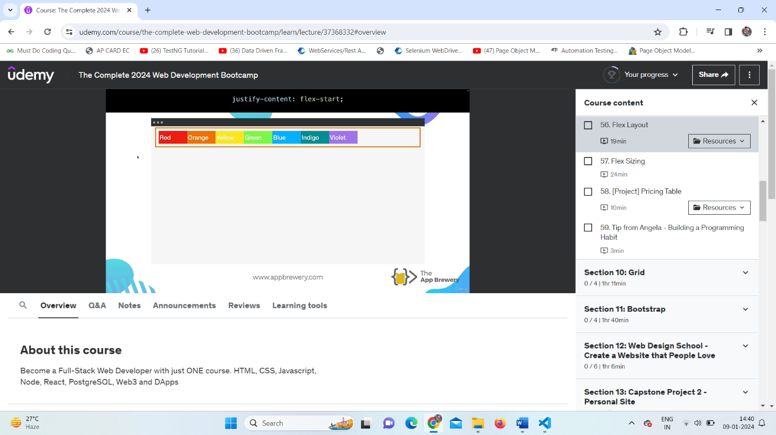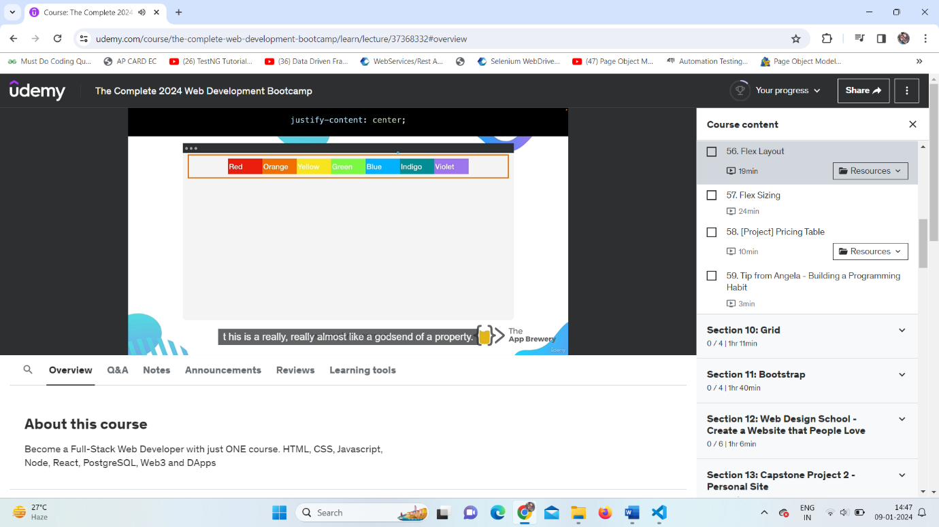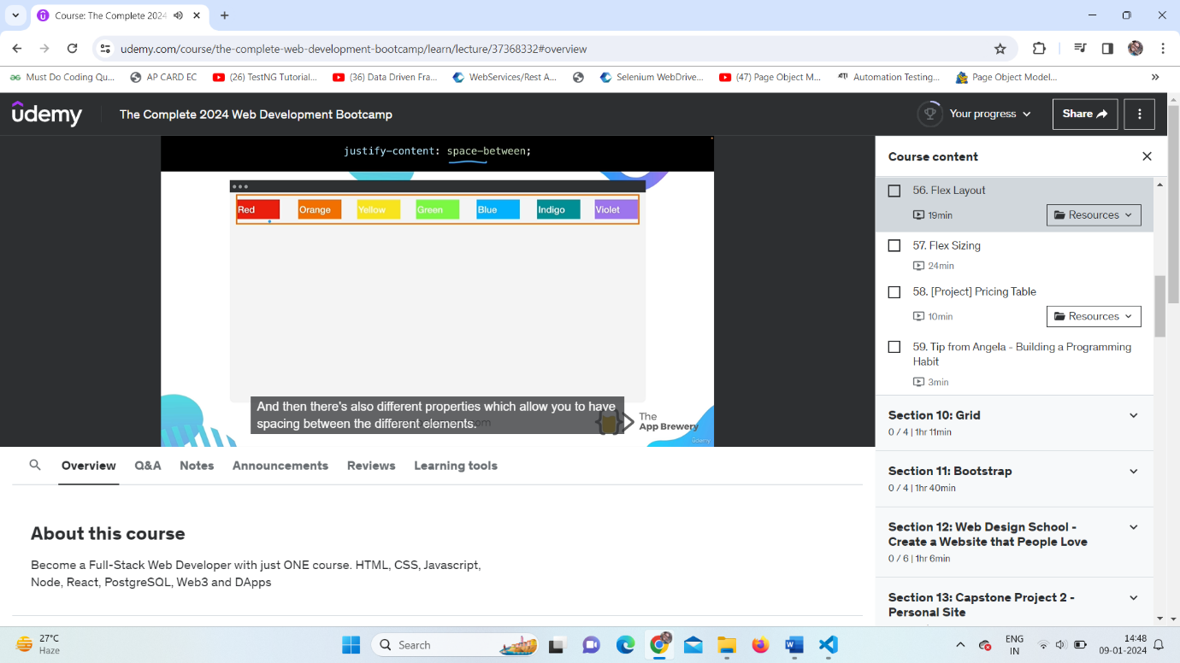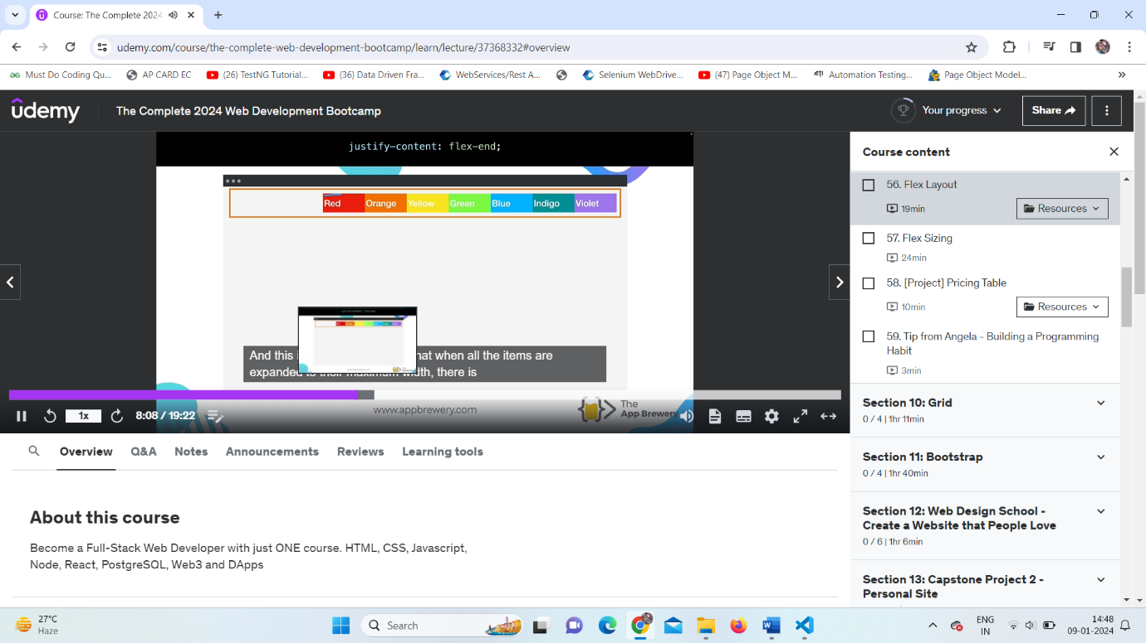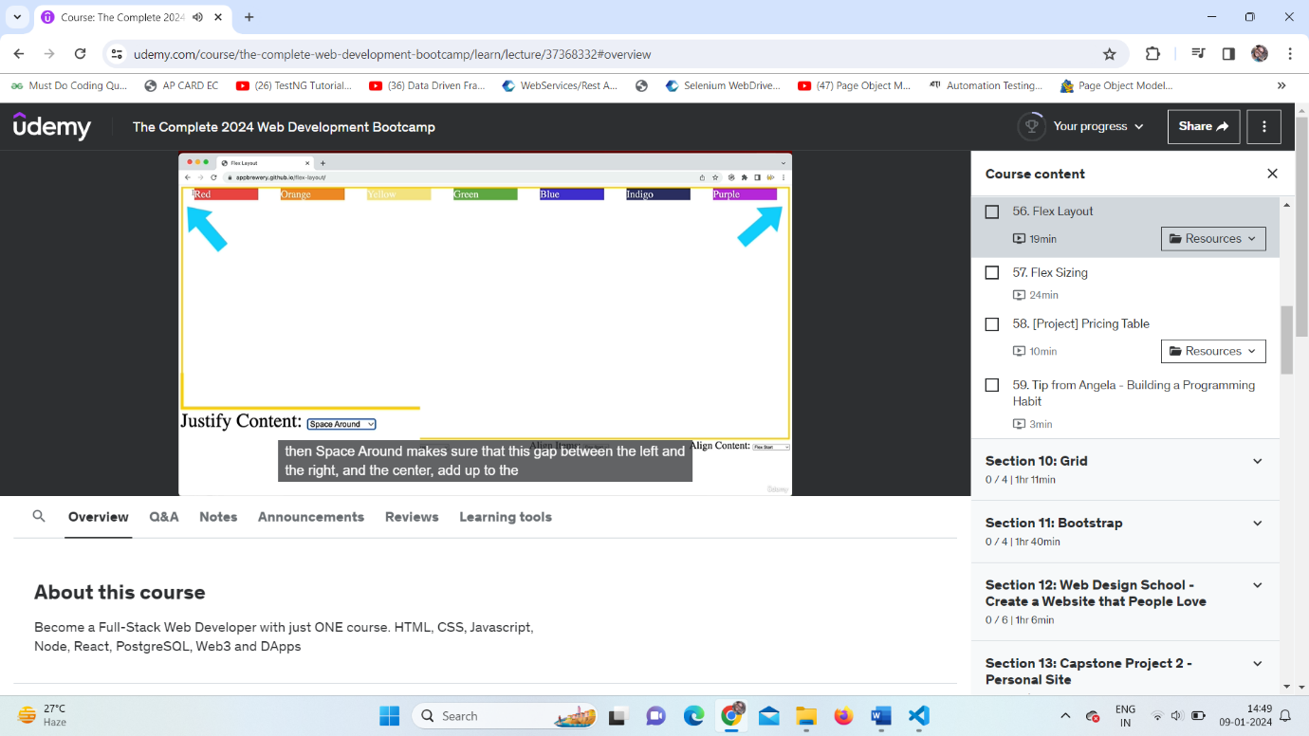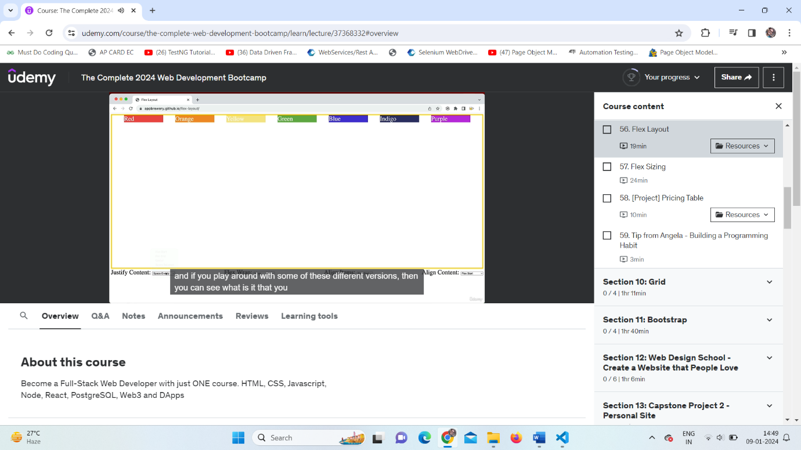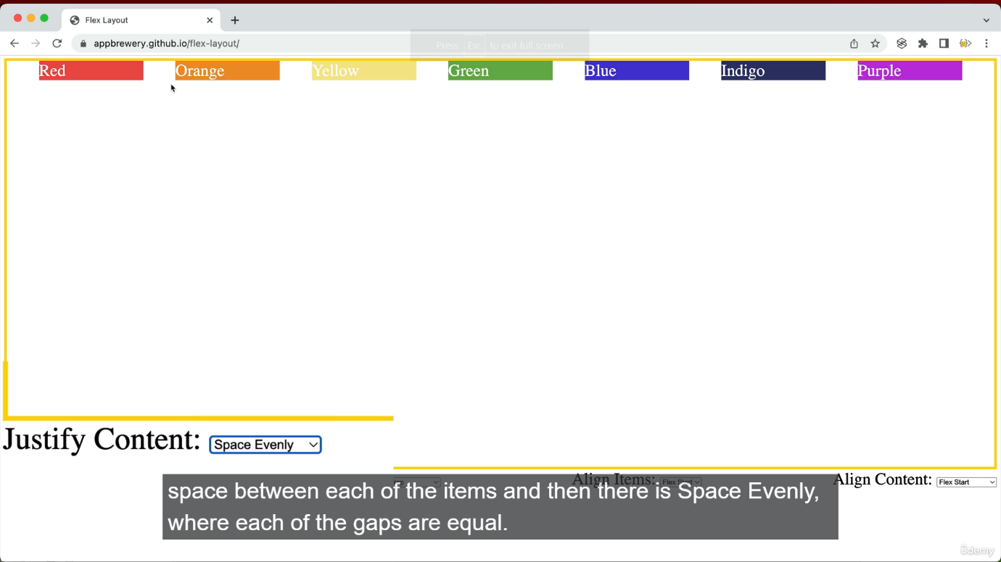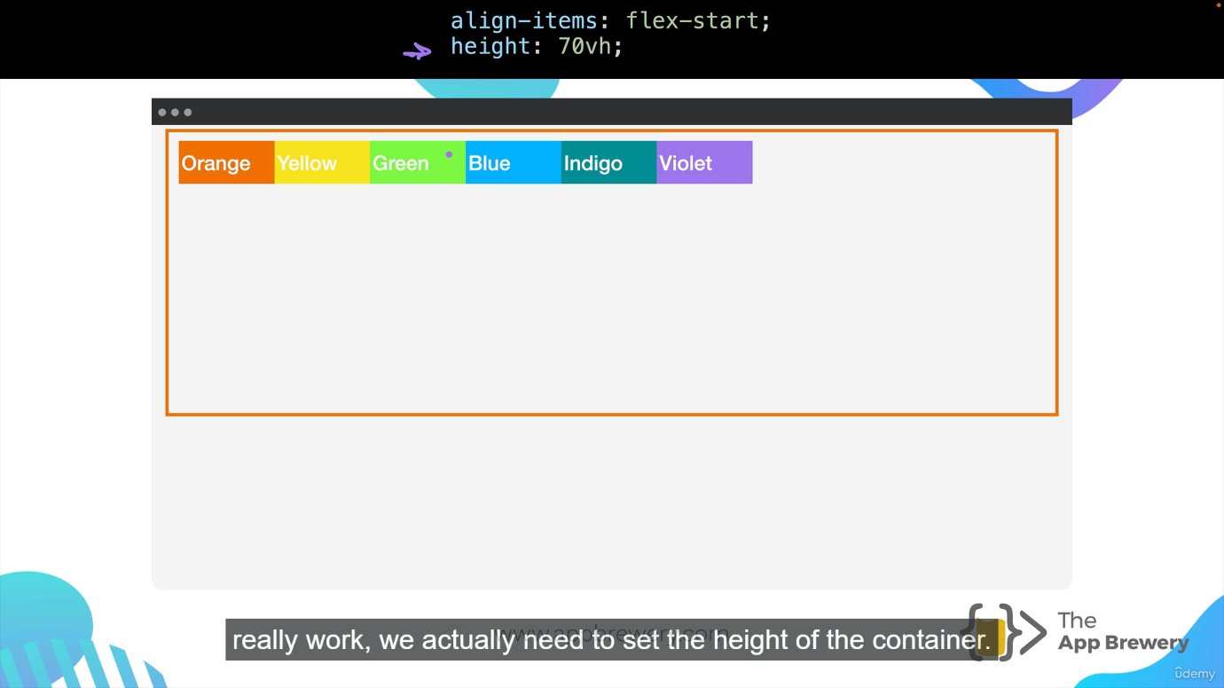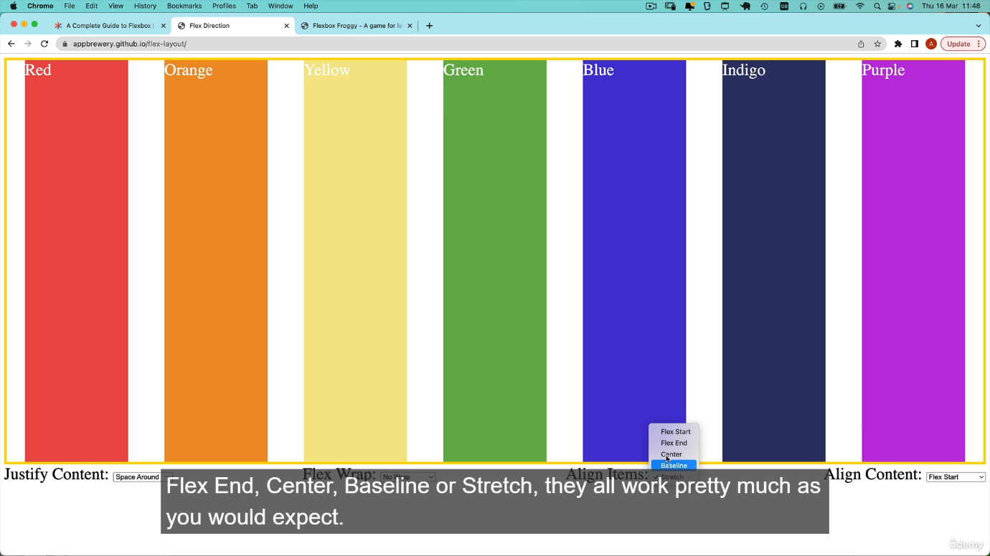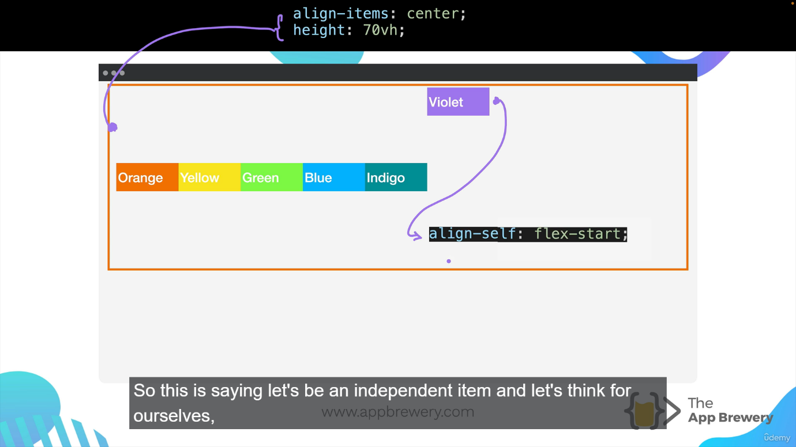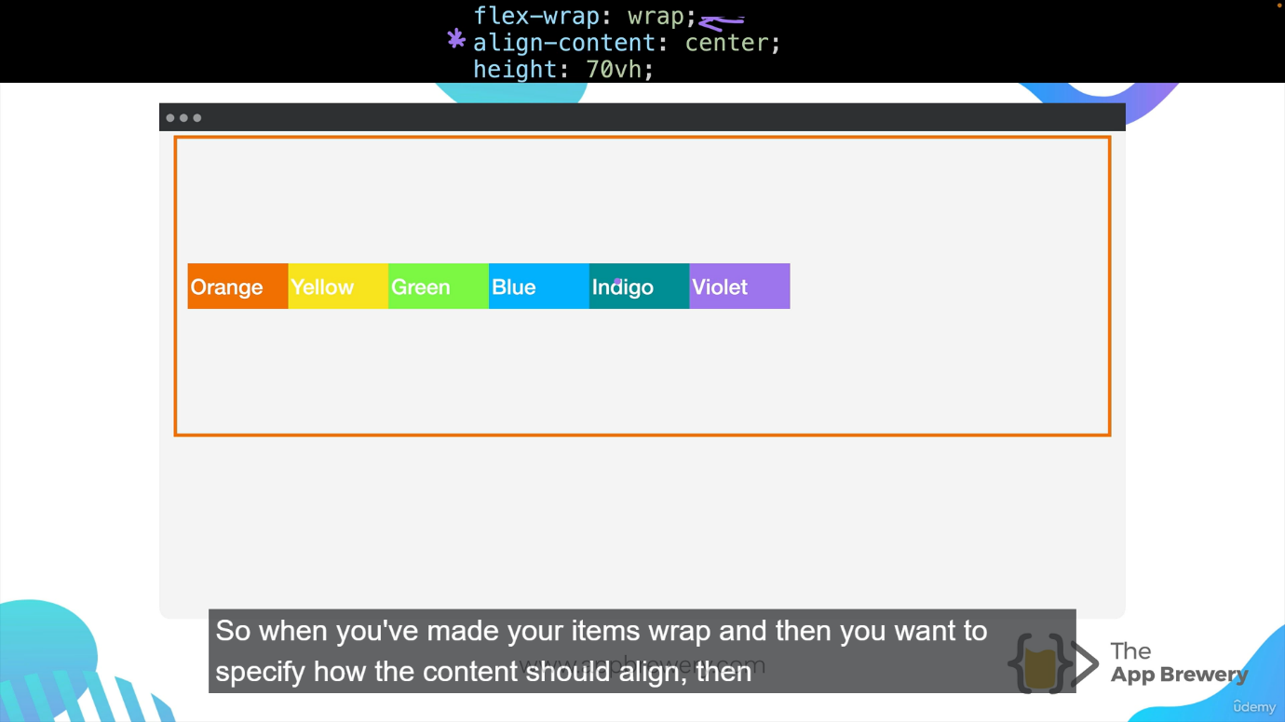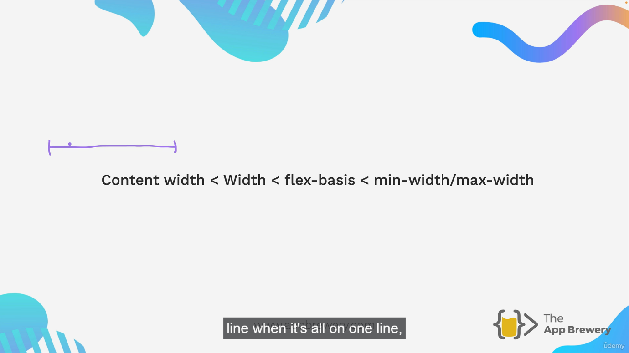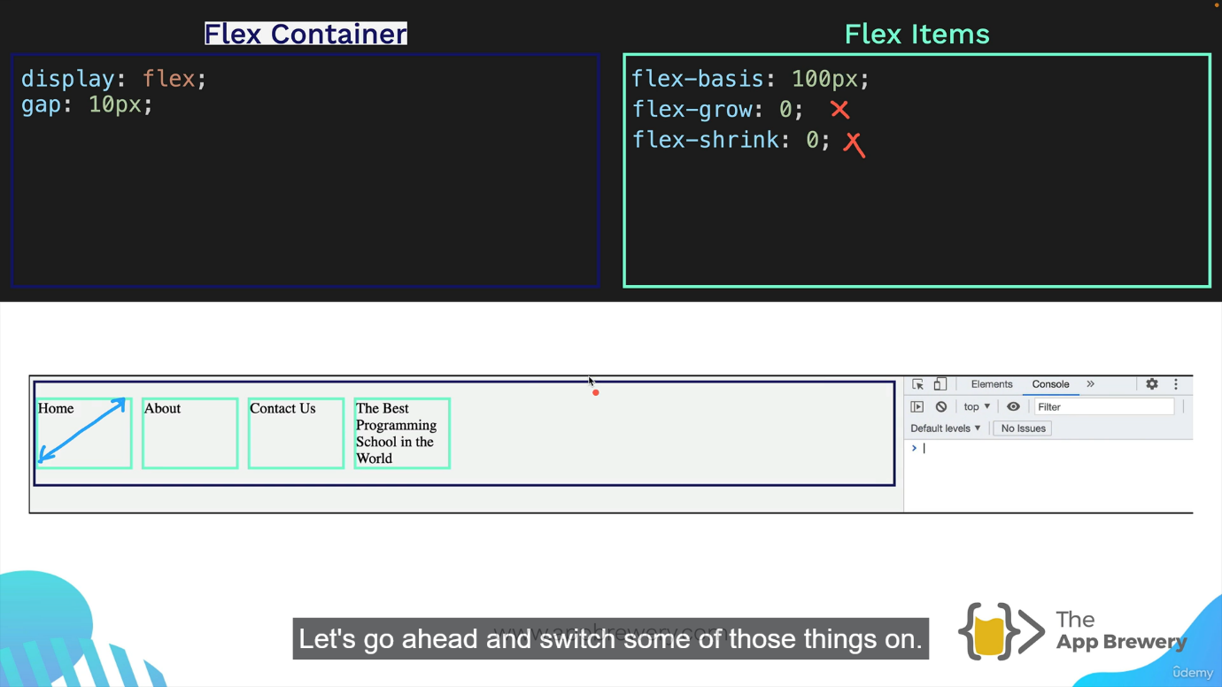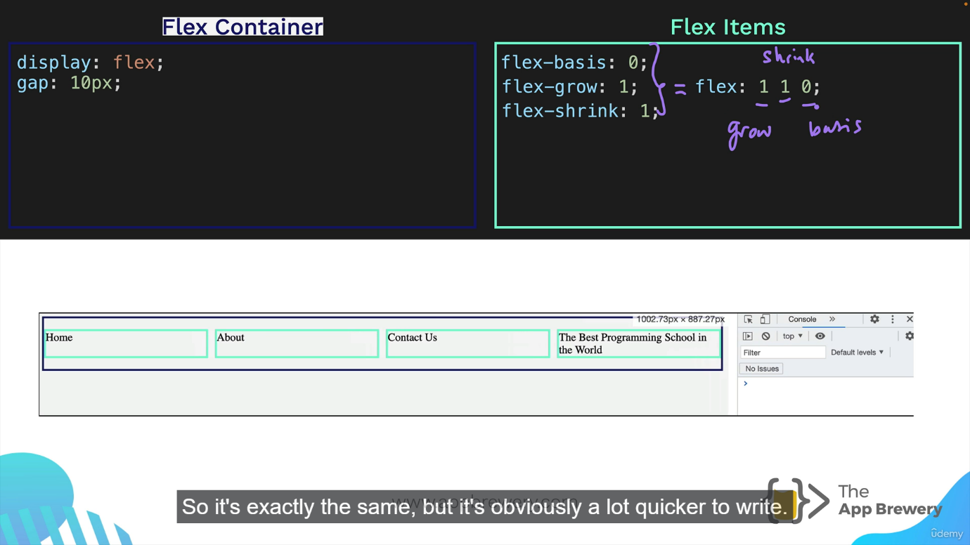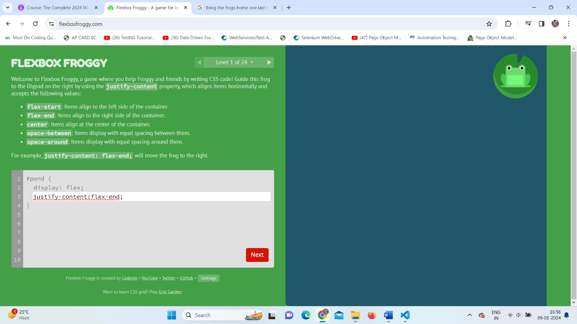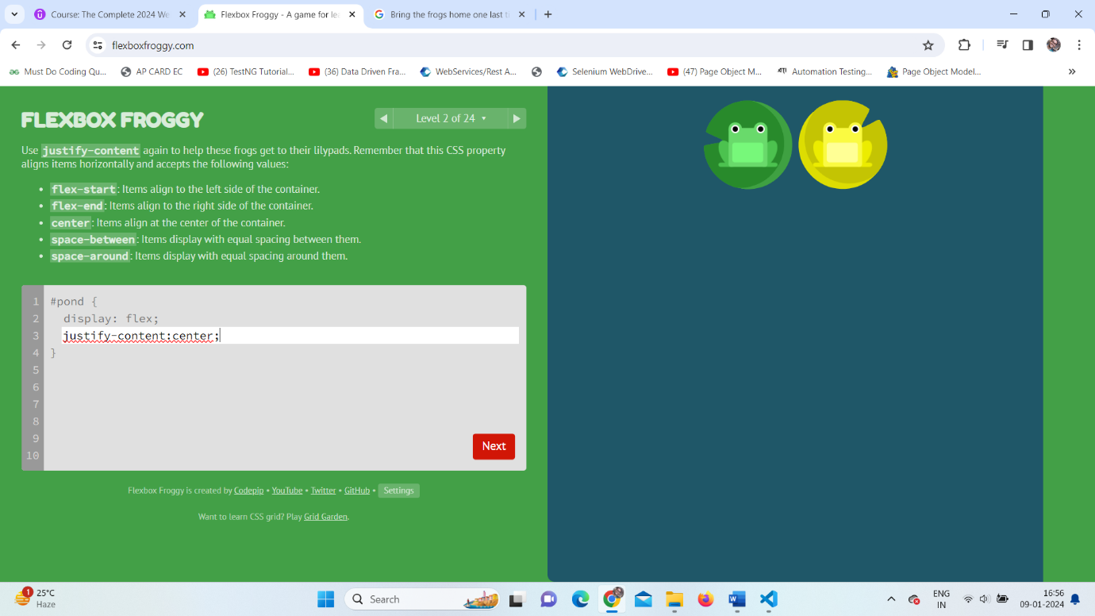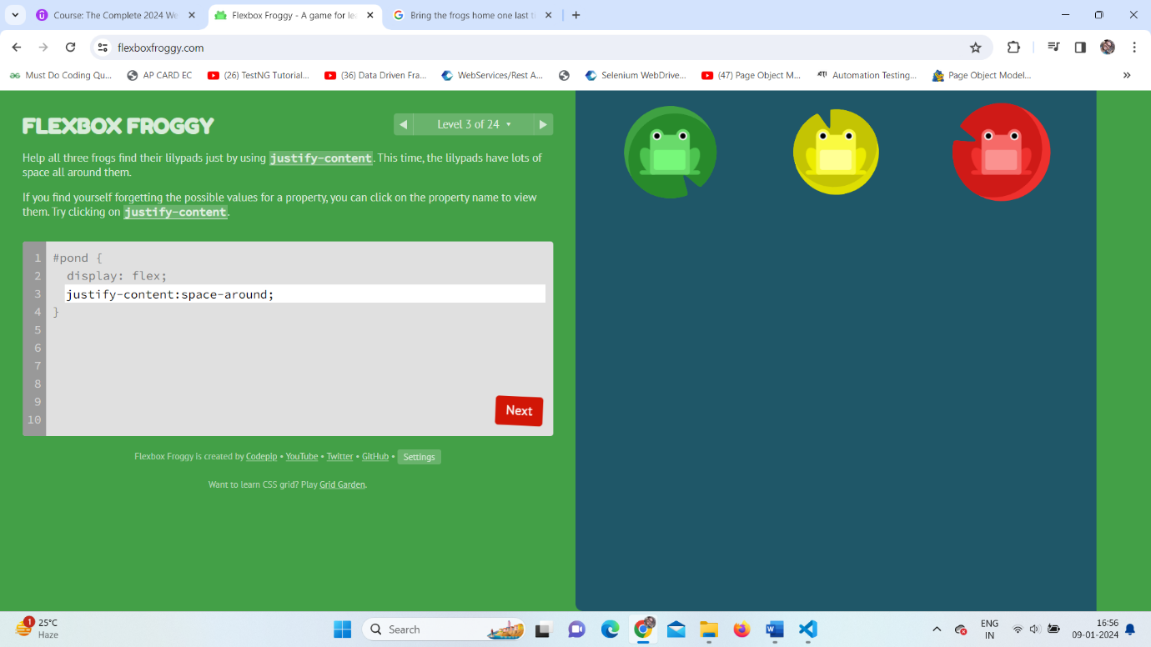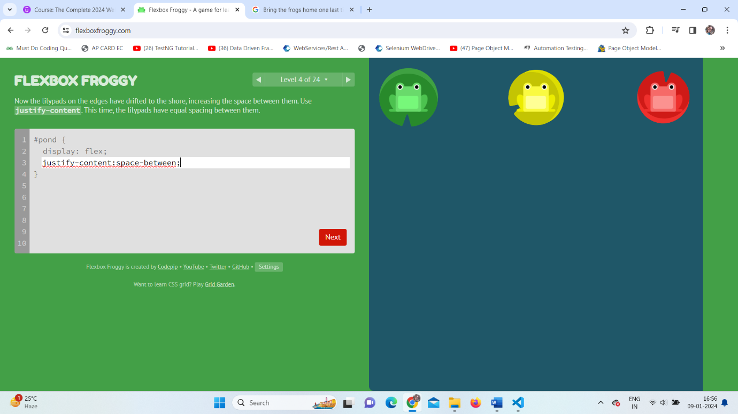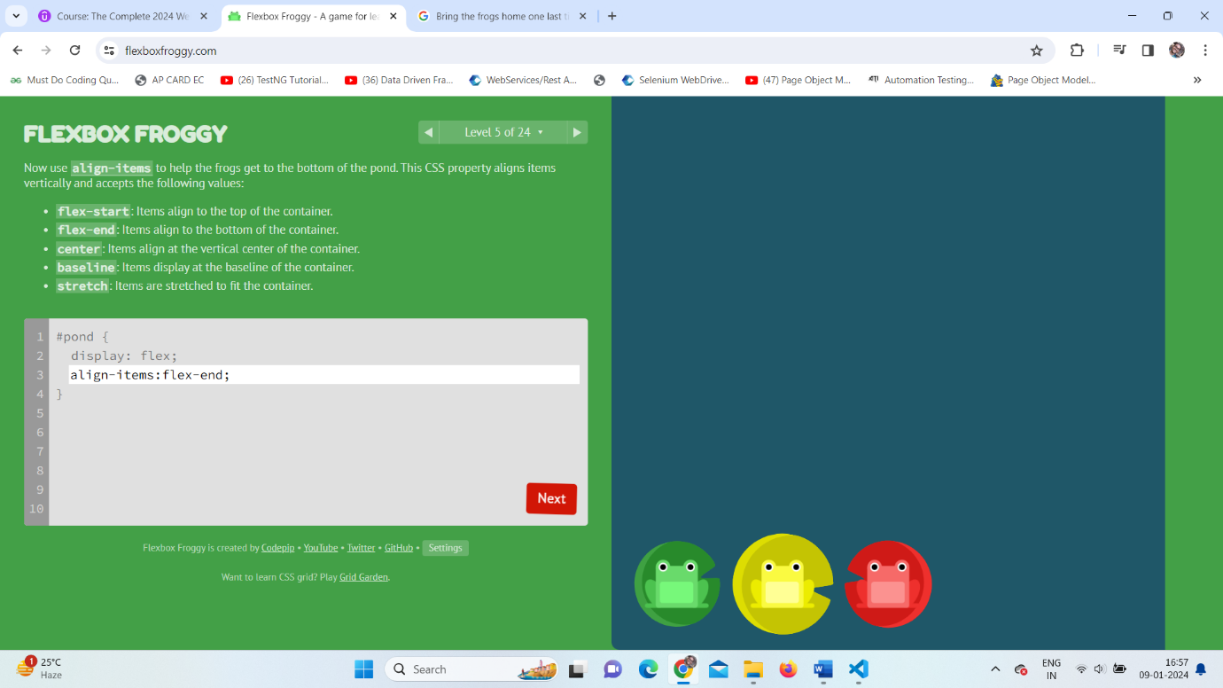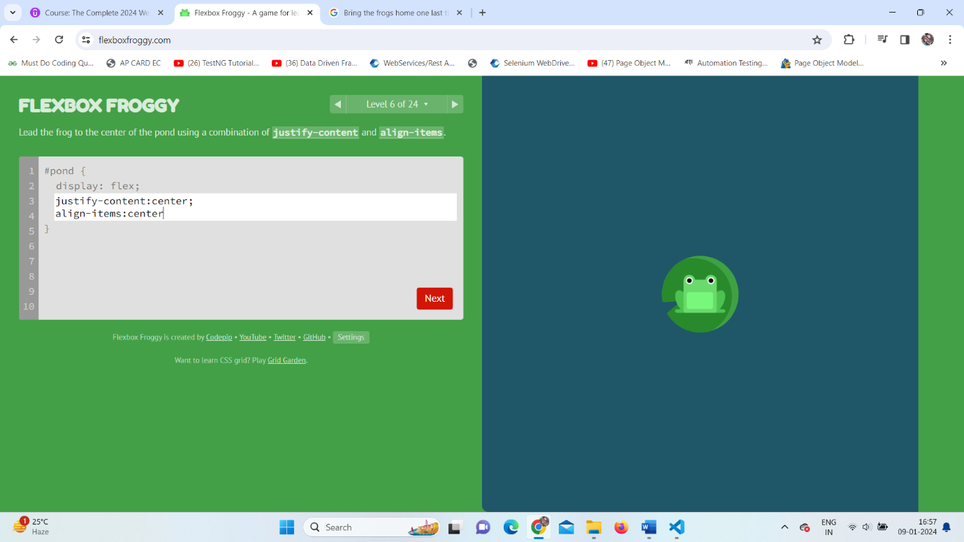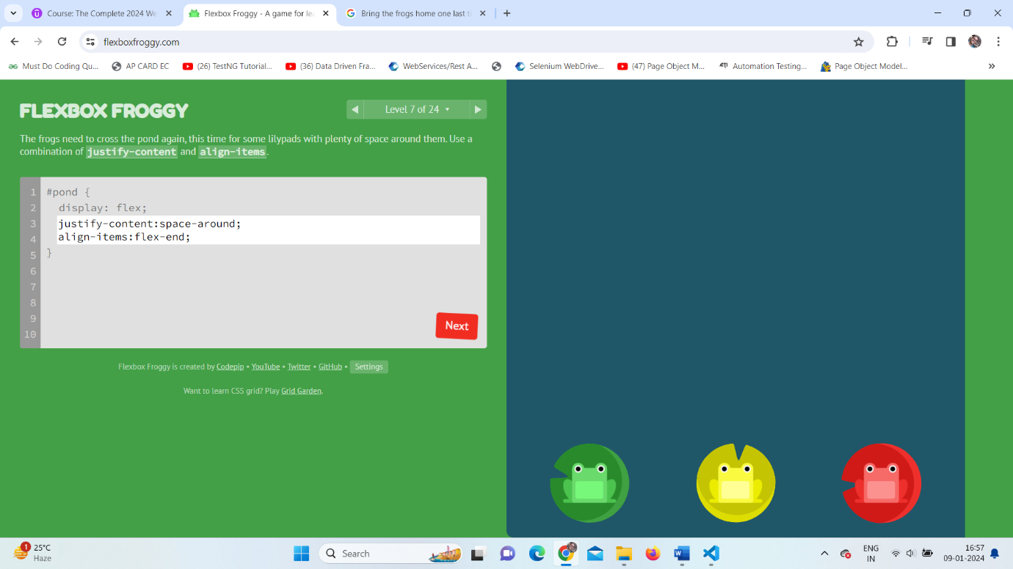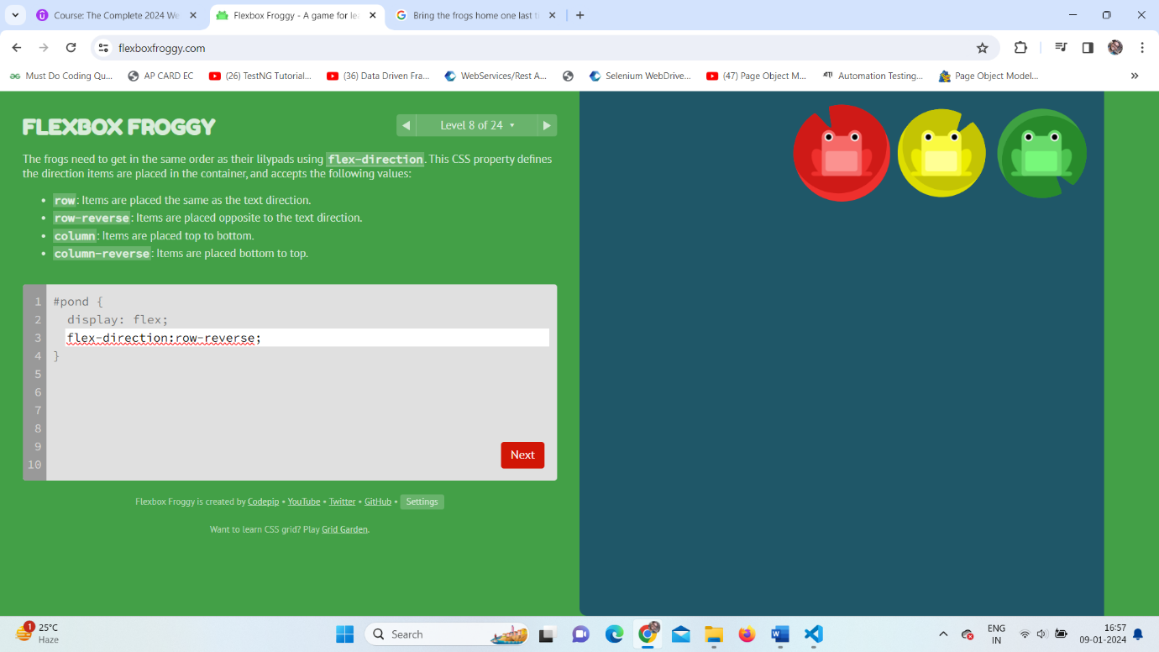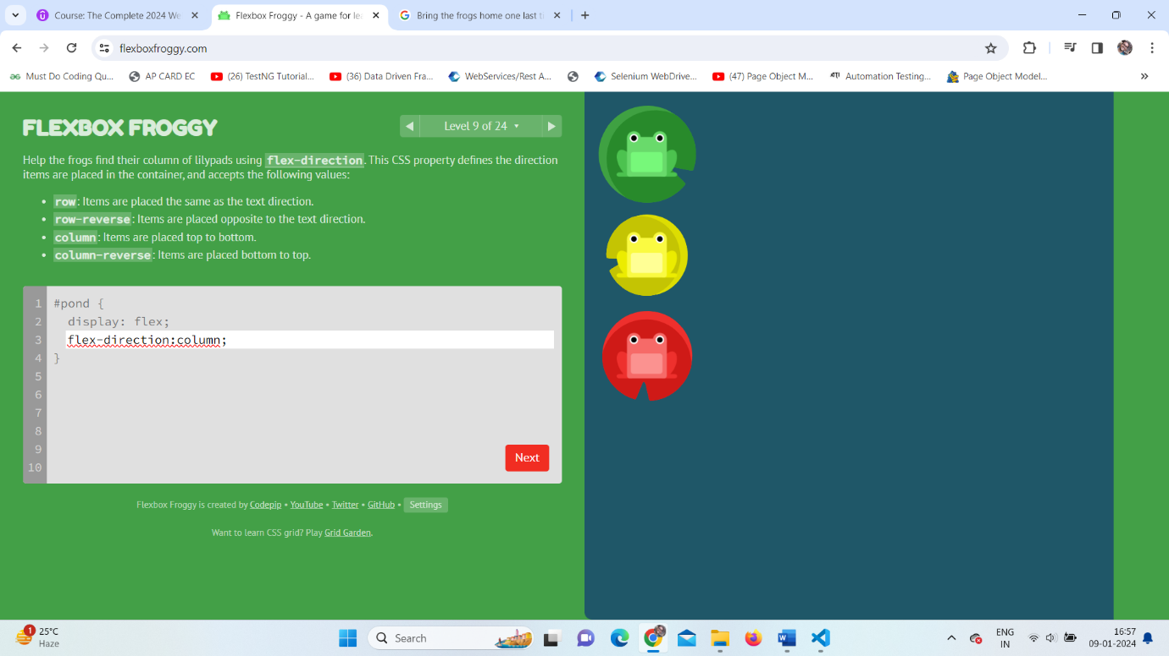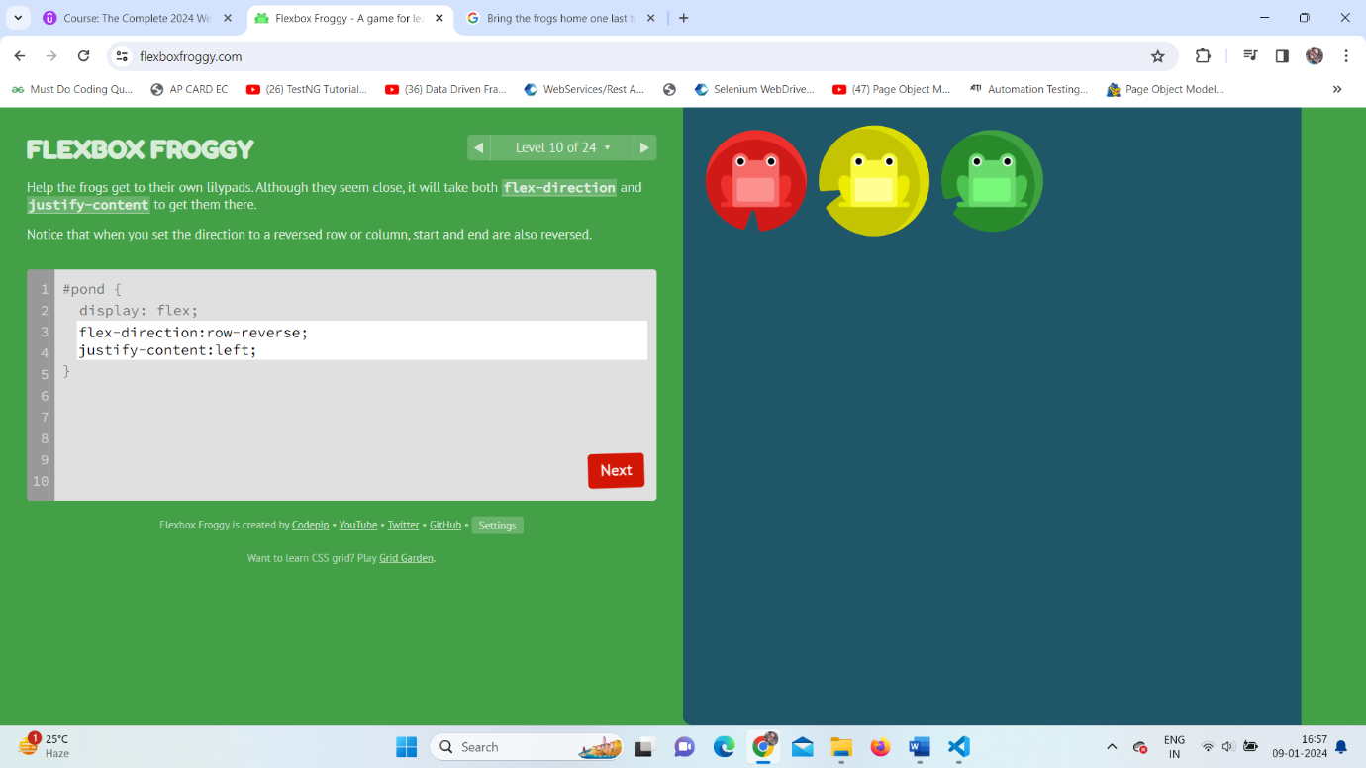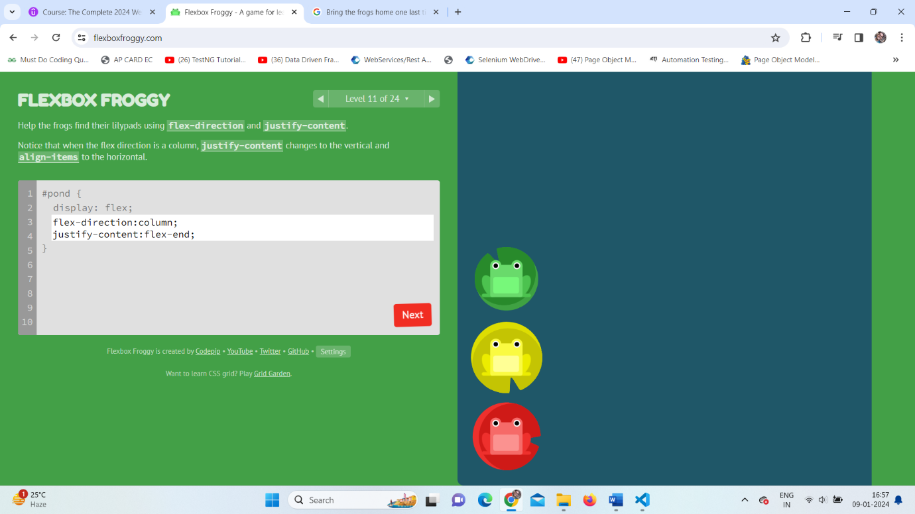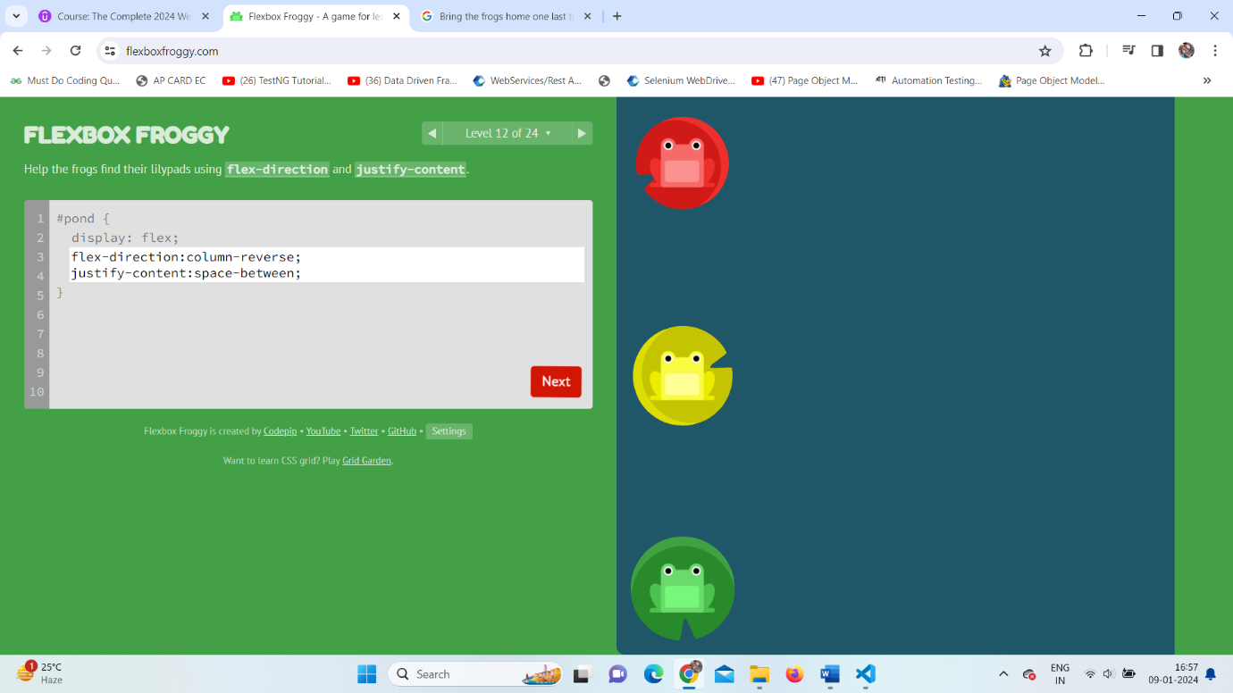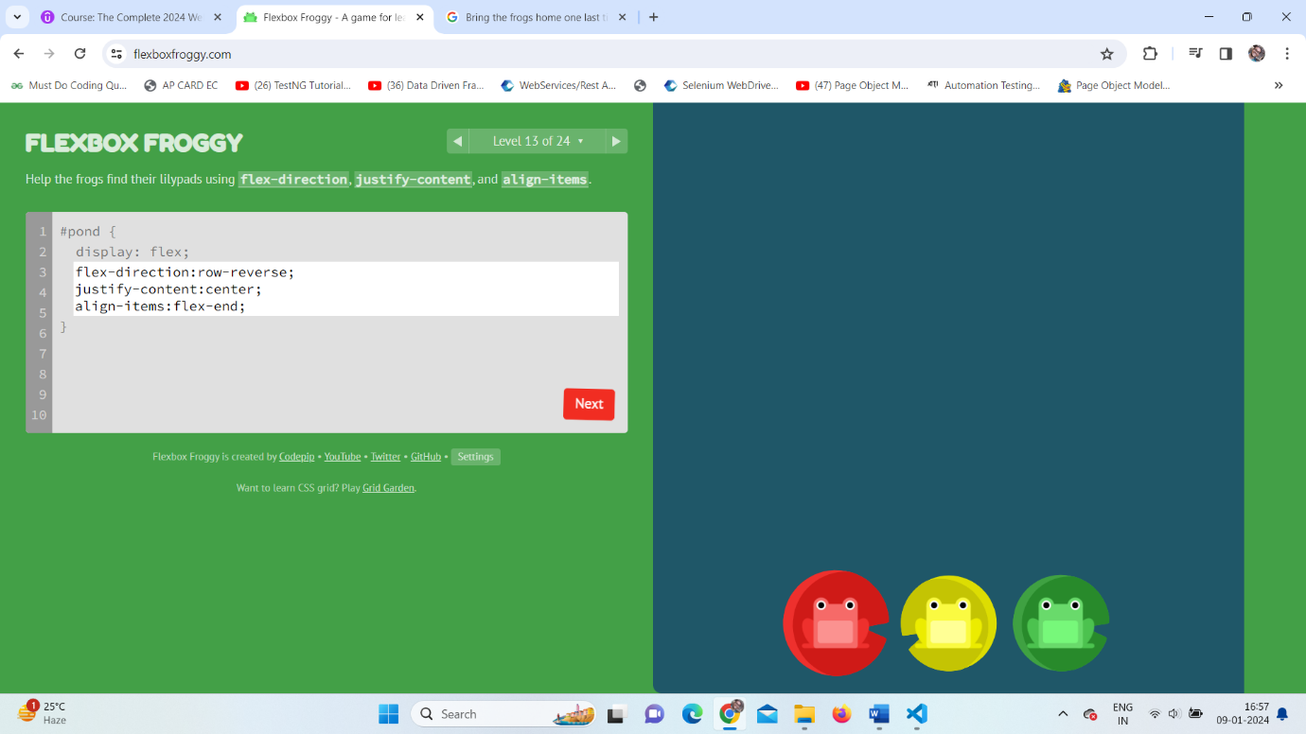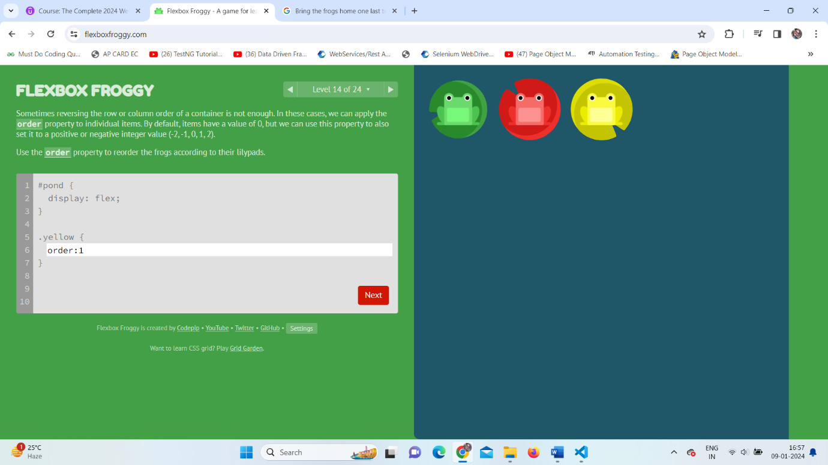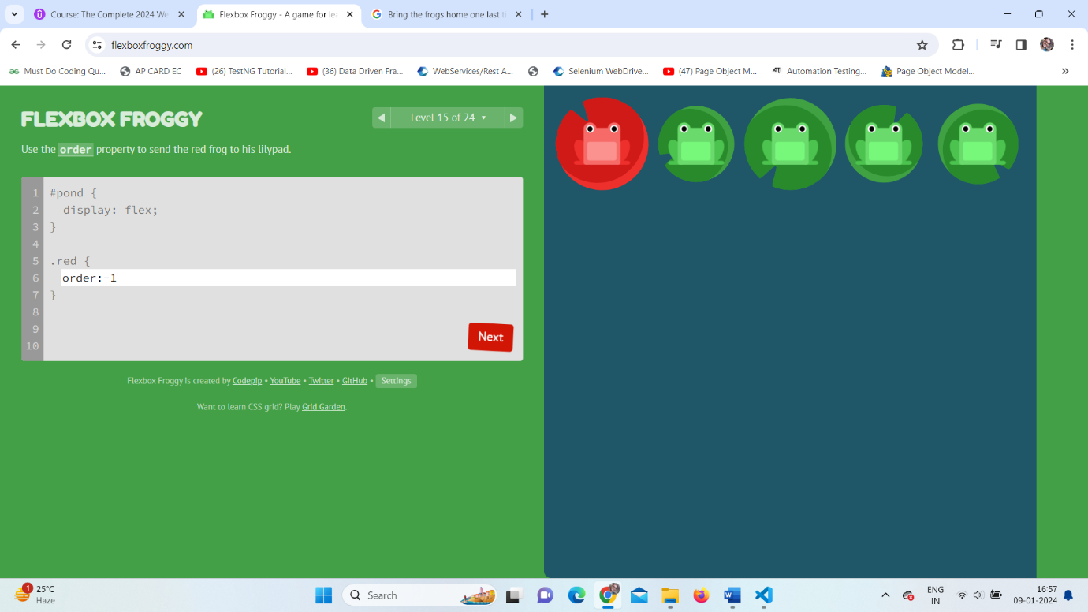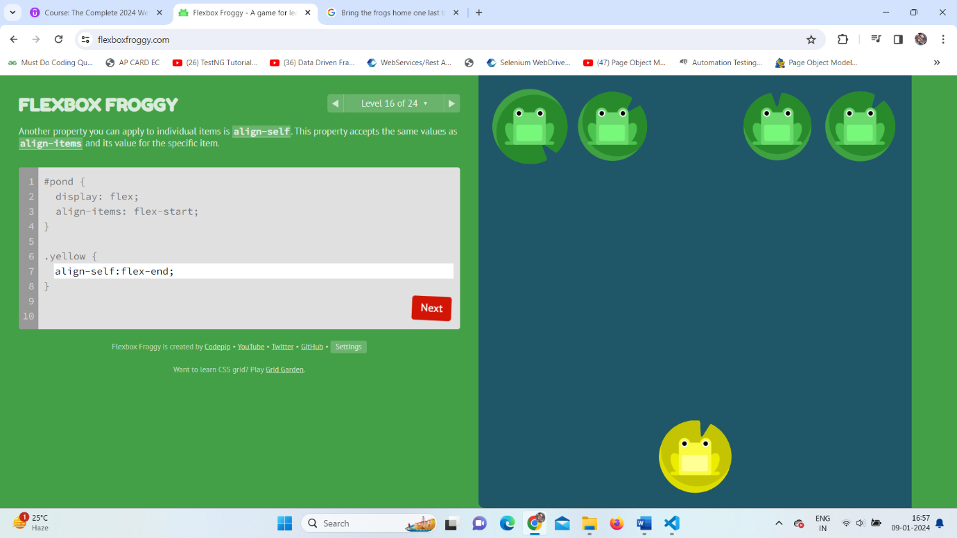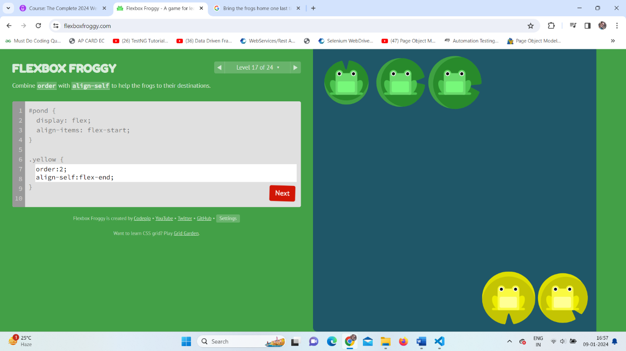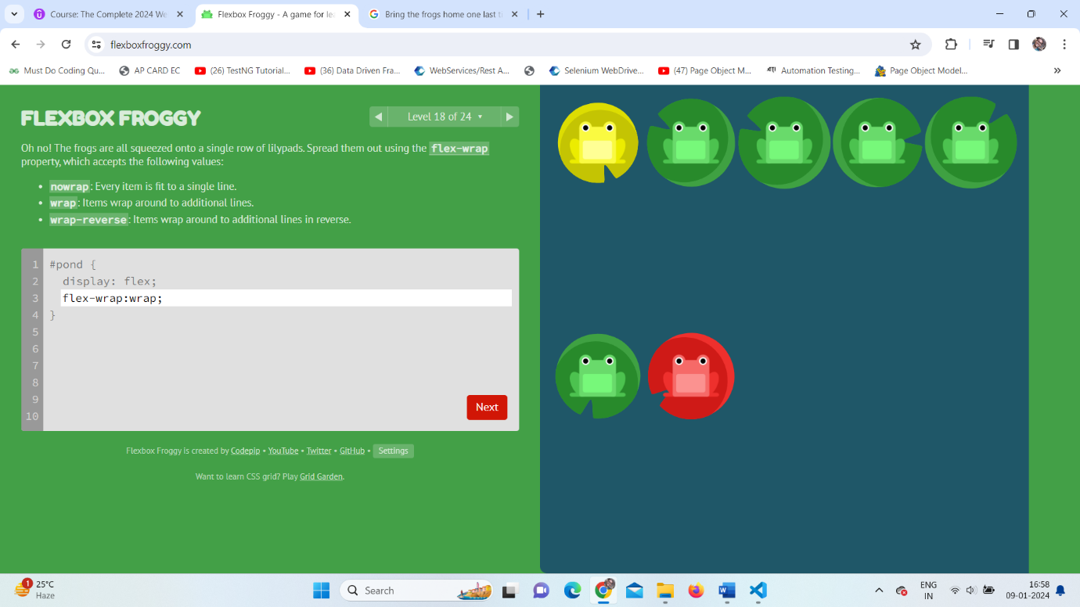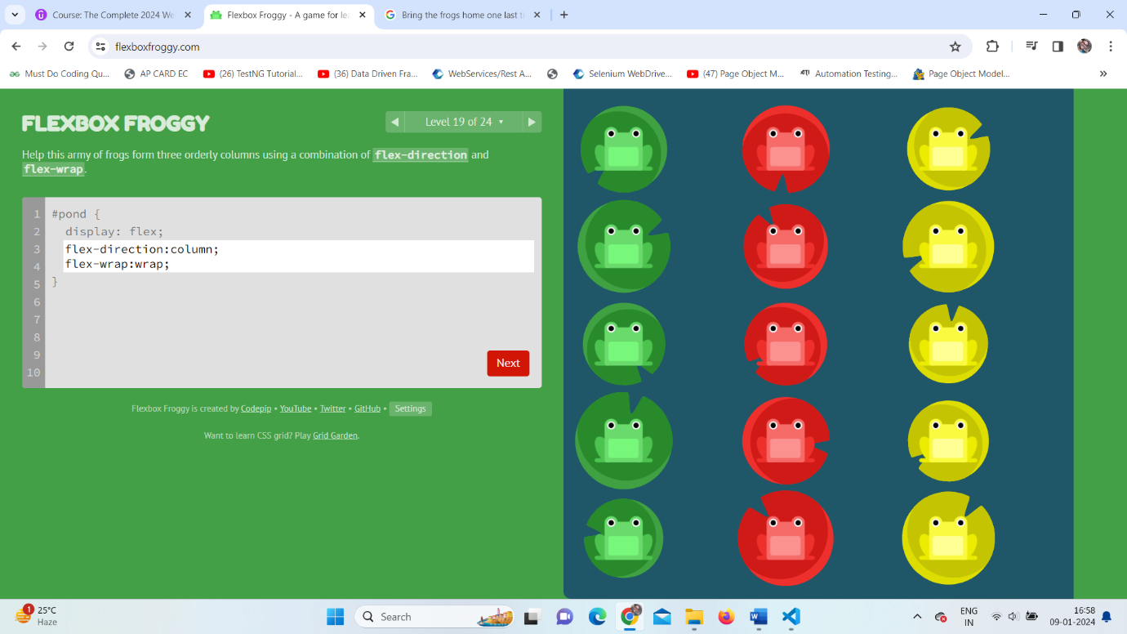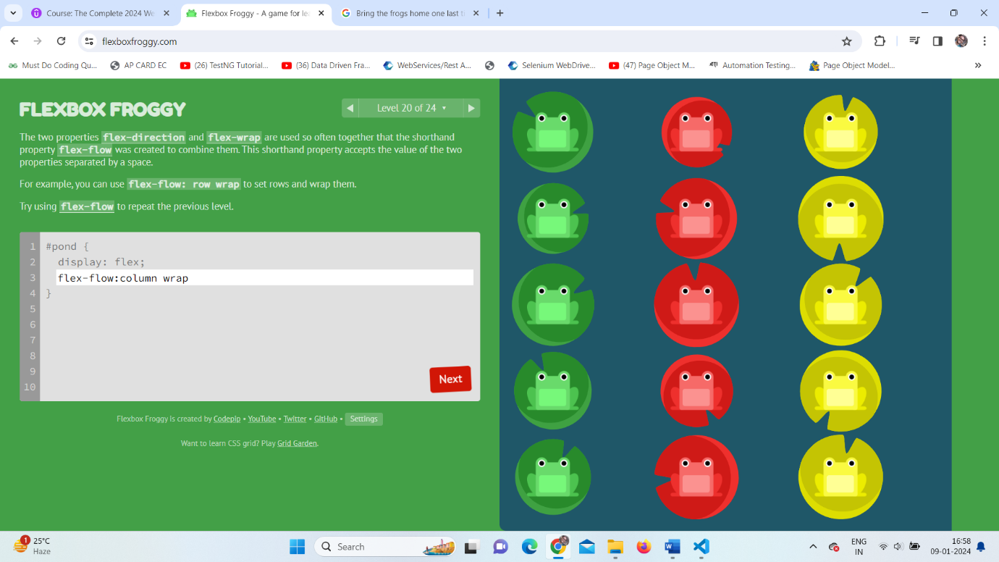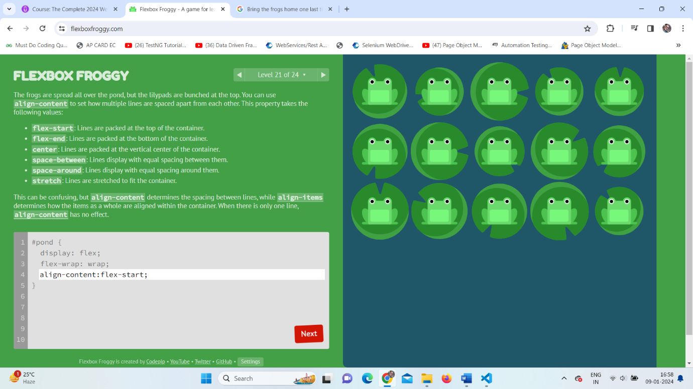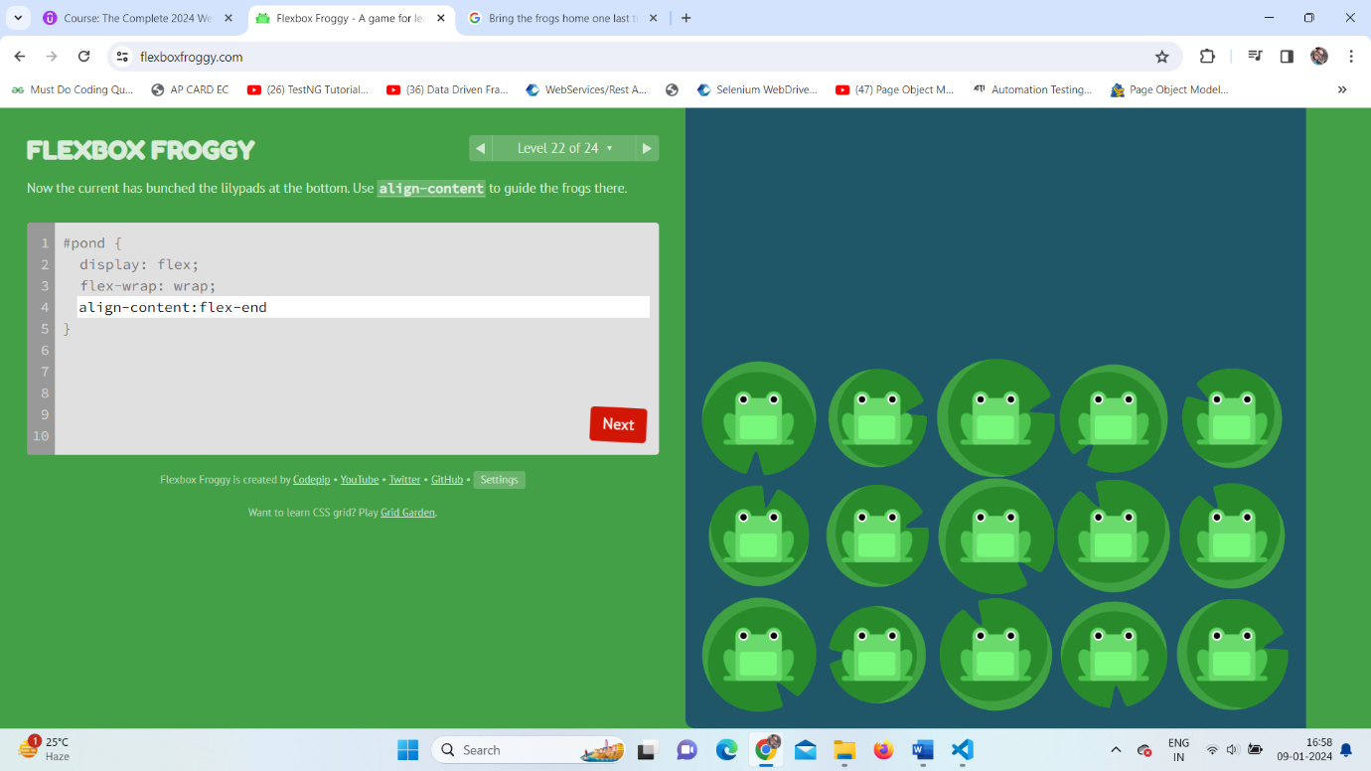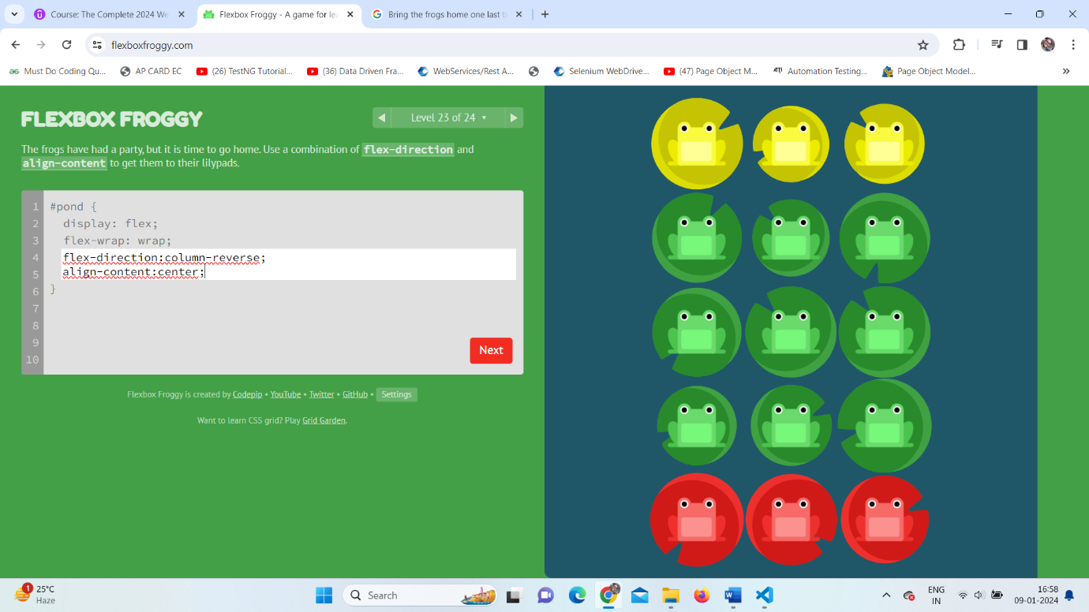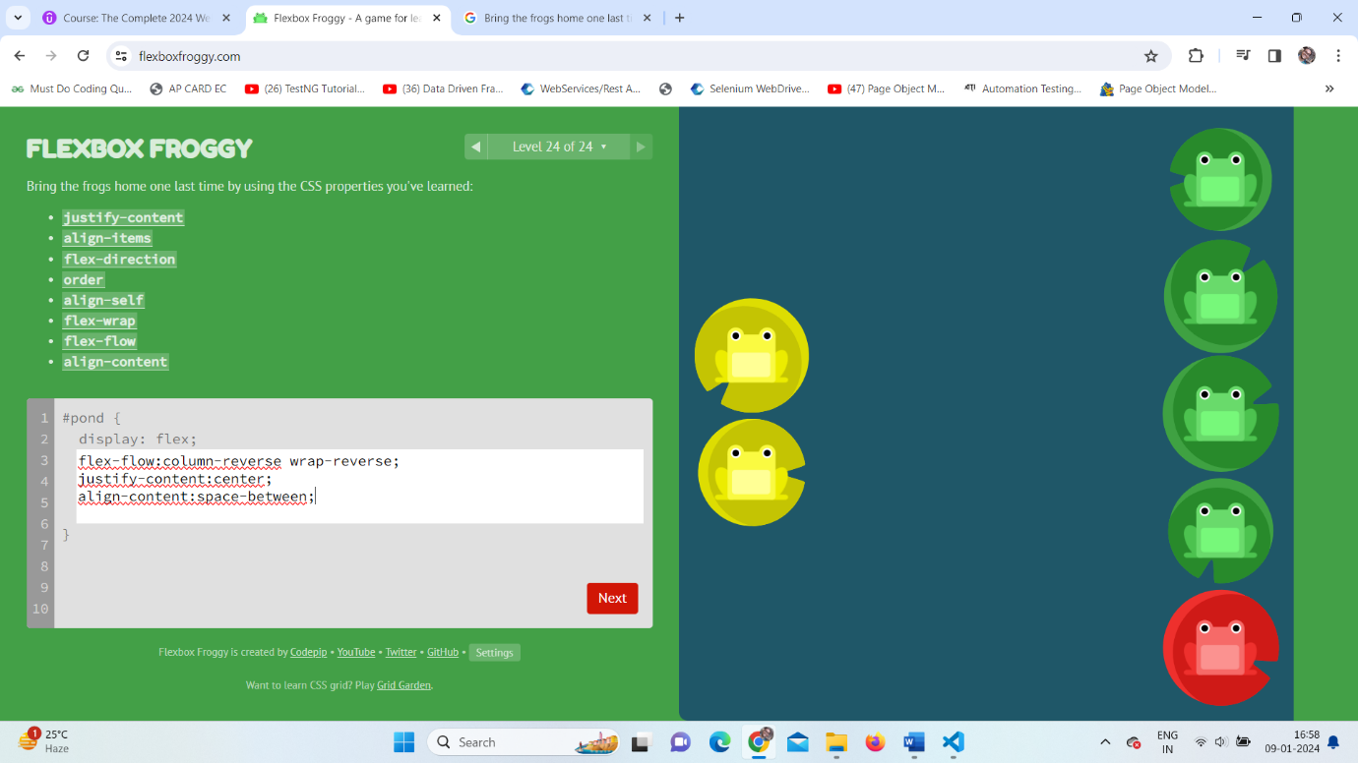

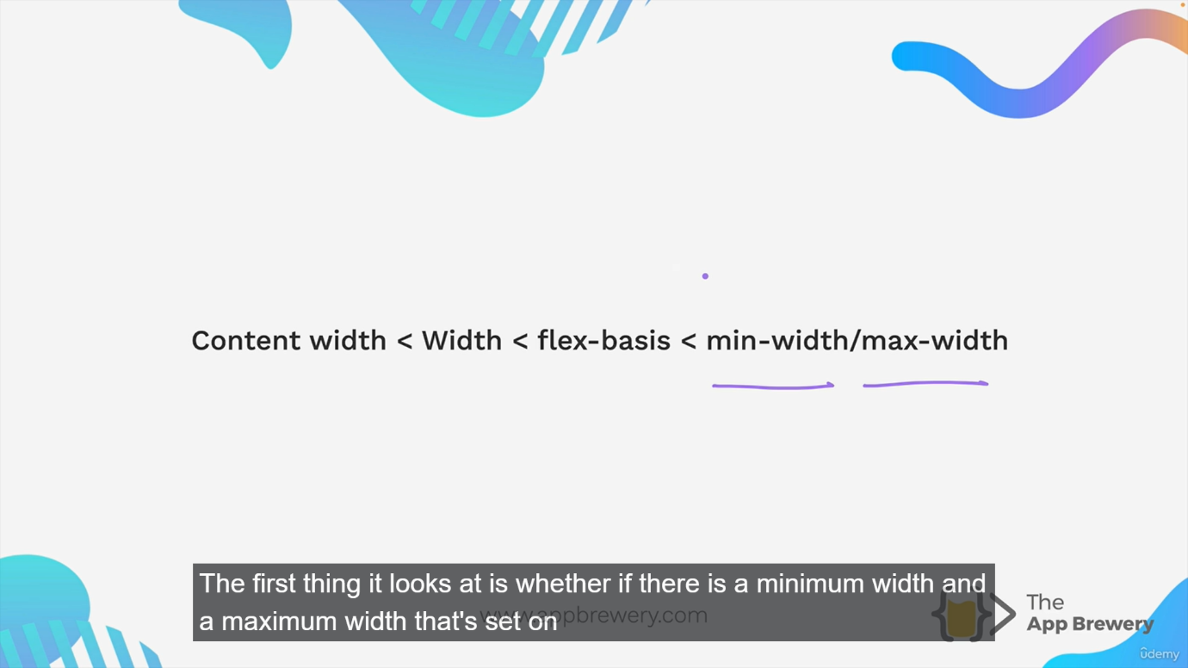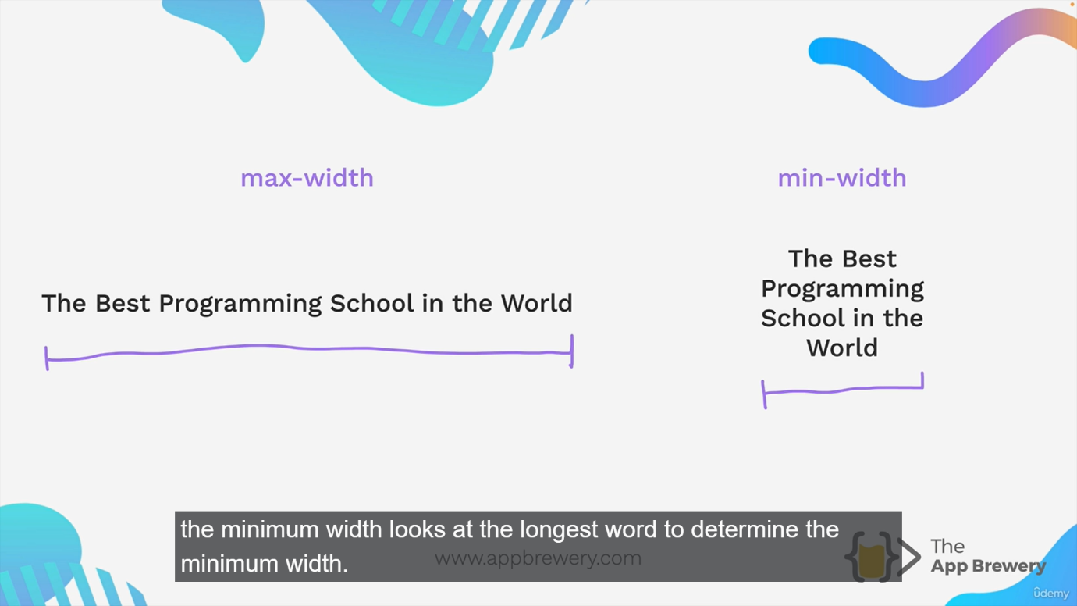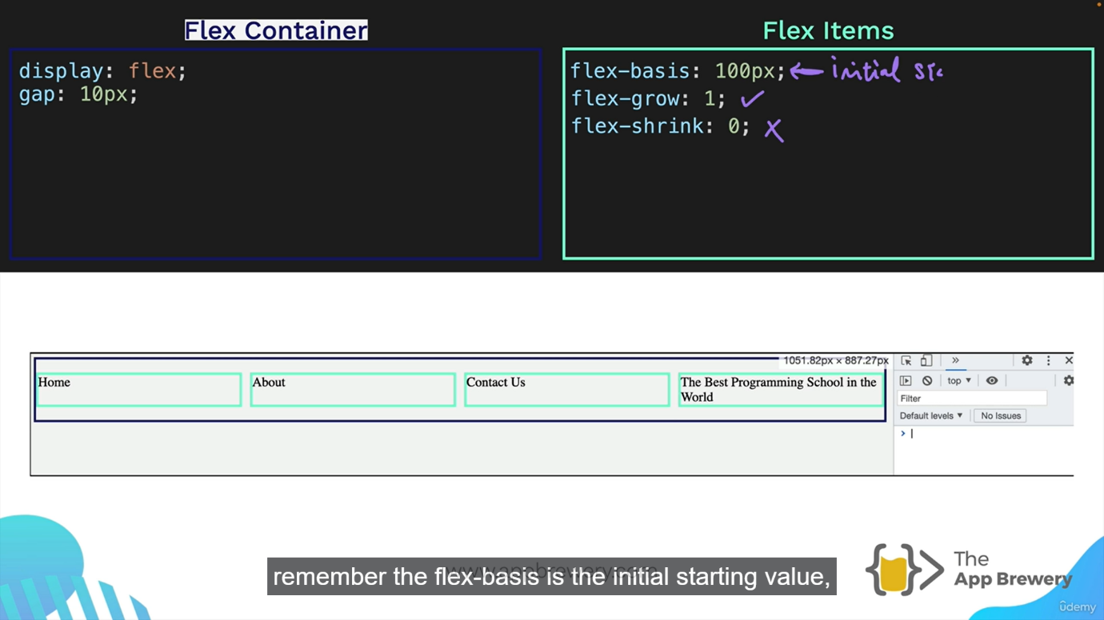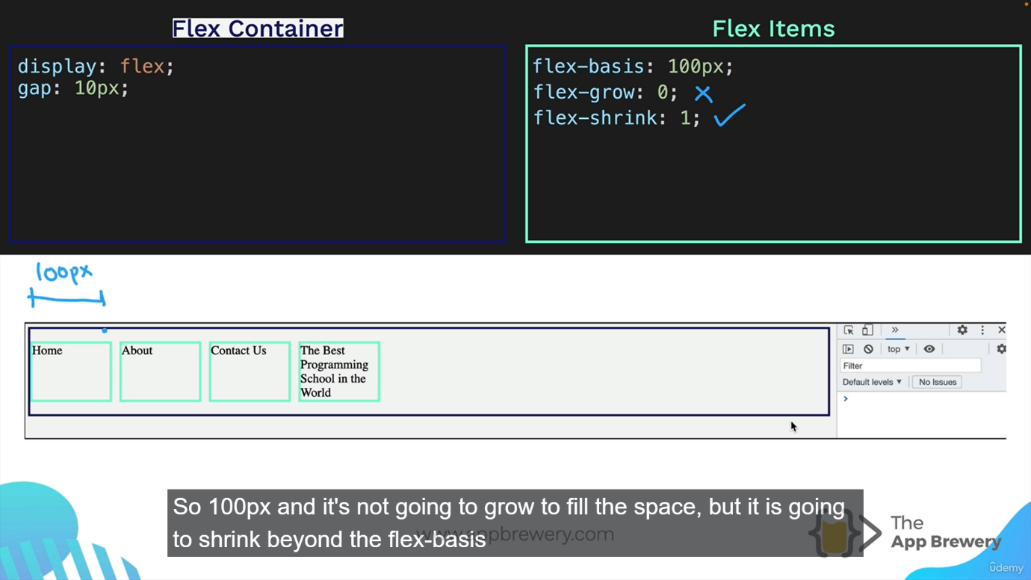

**Grid:**

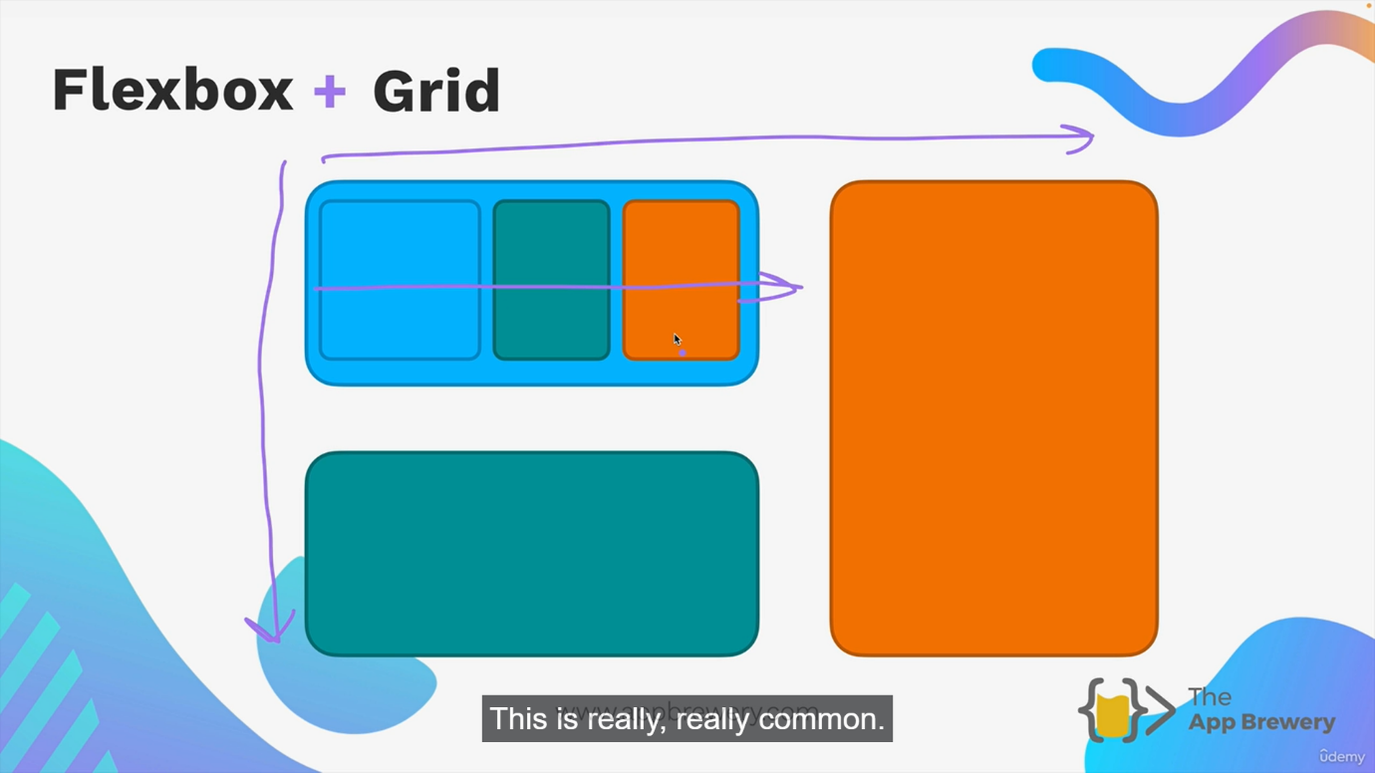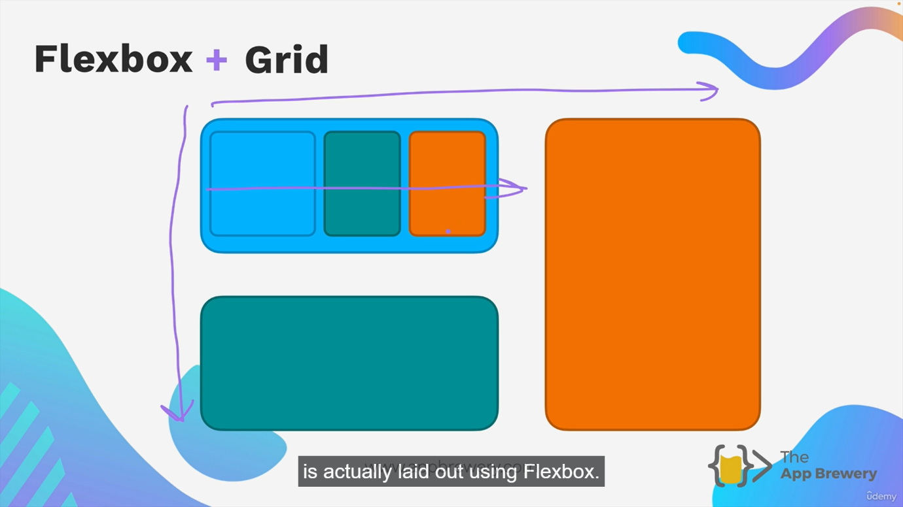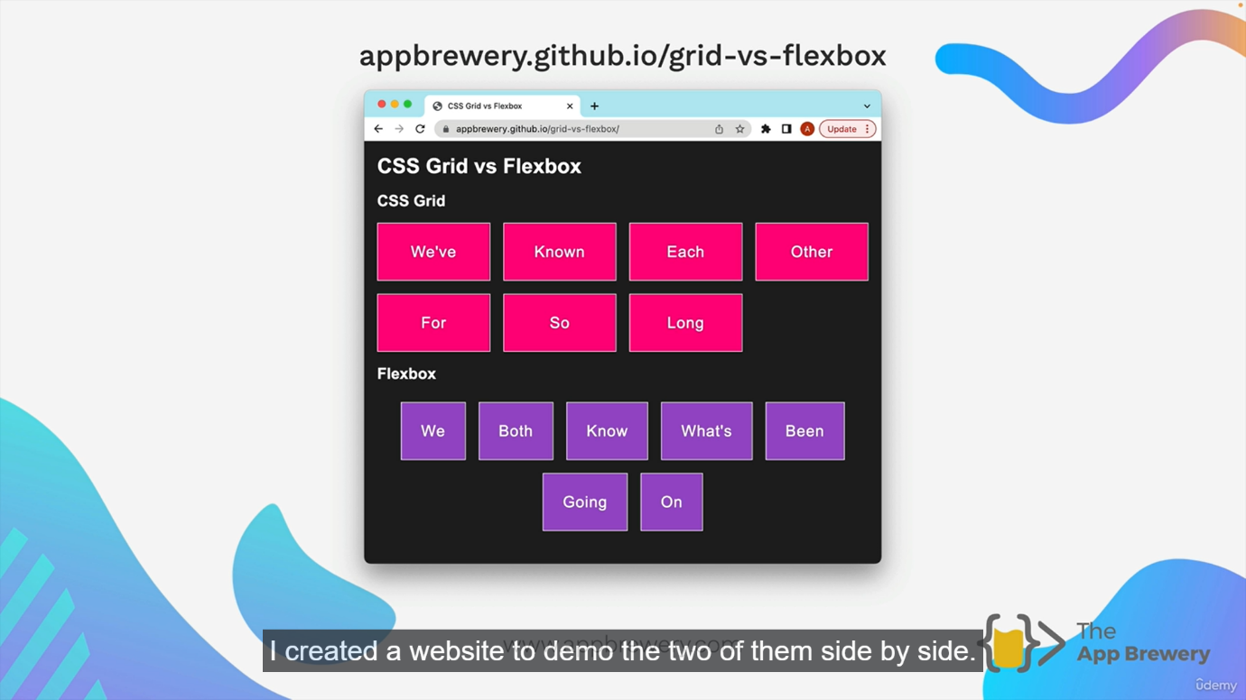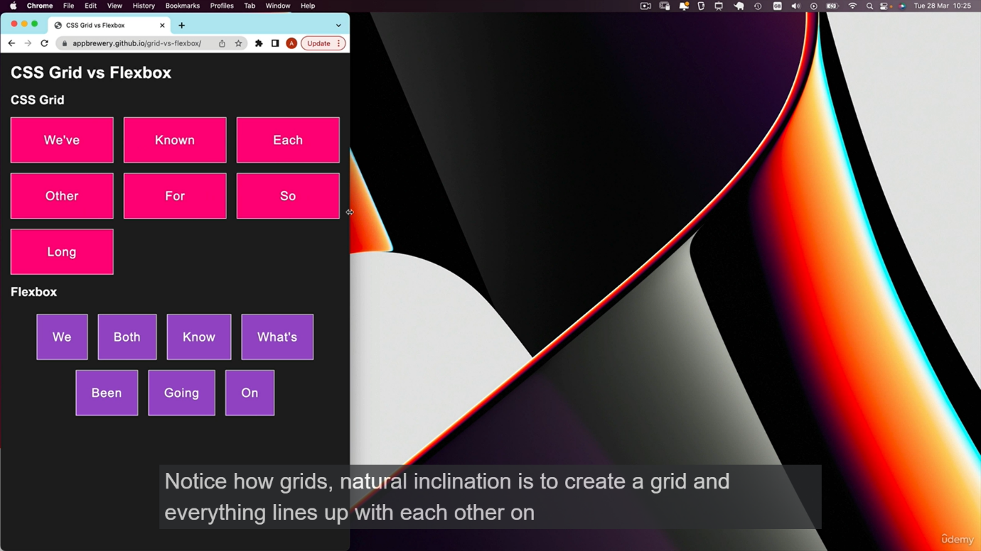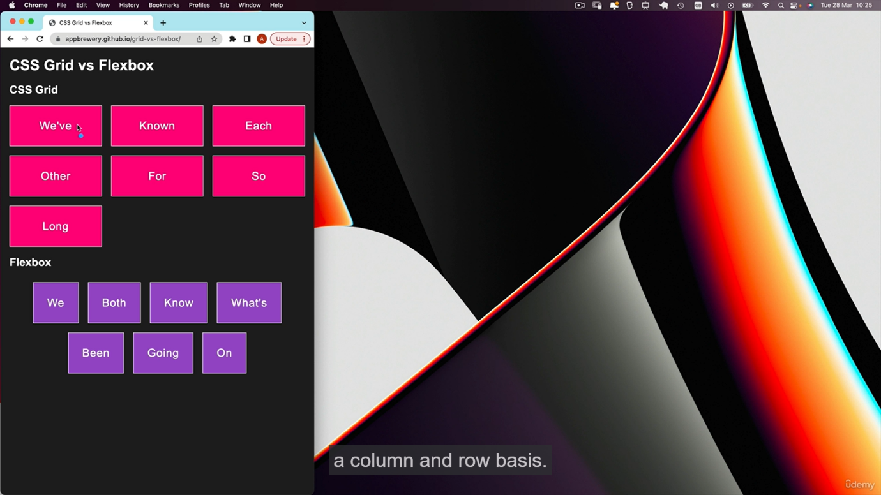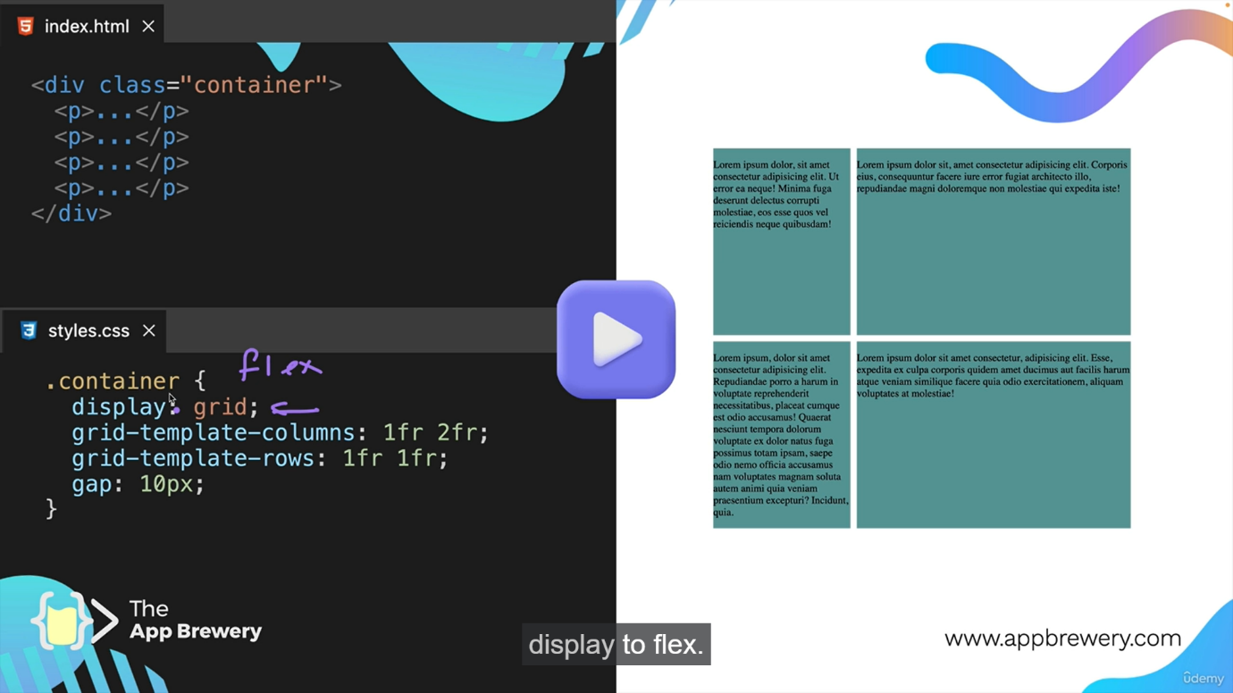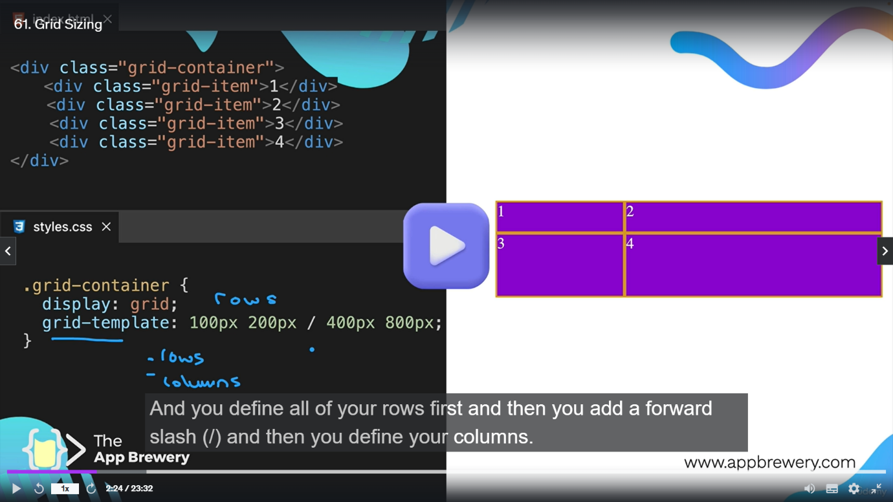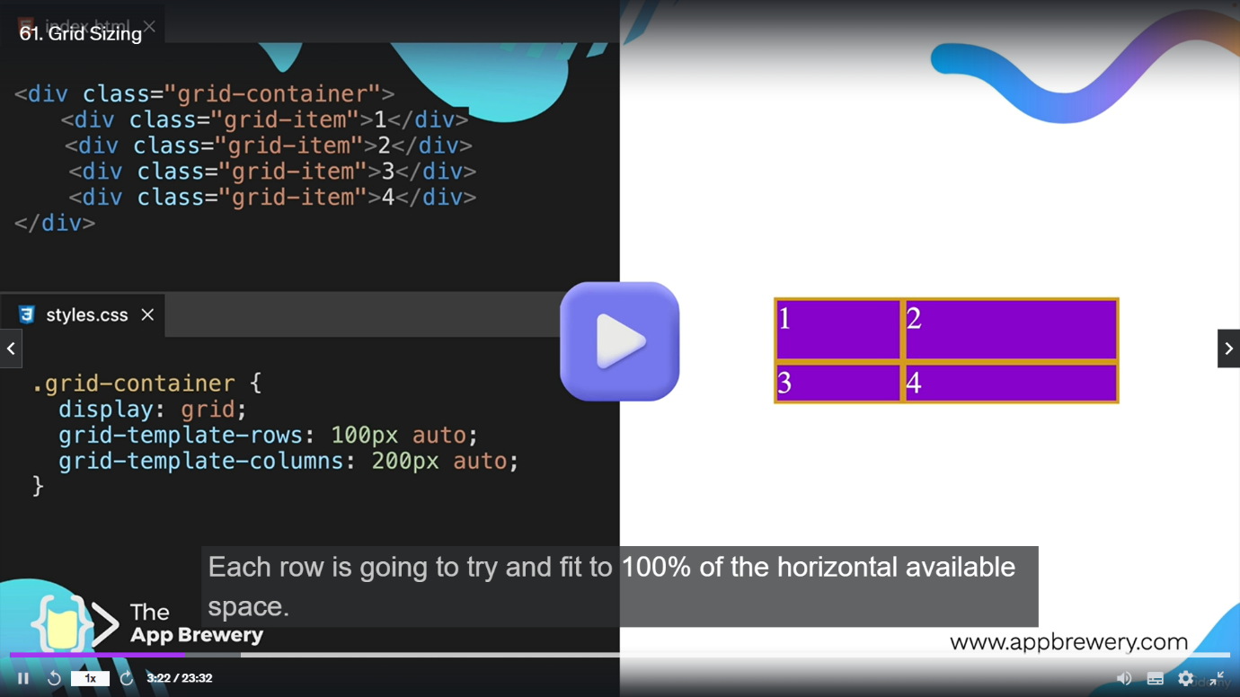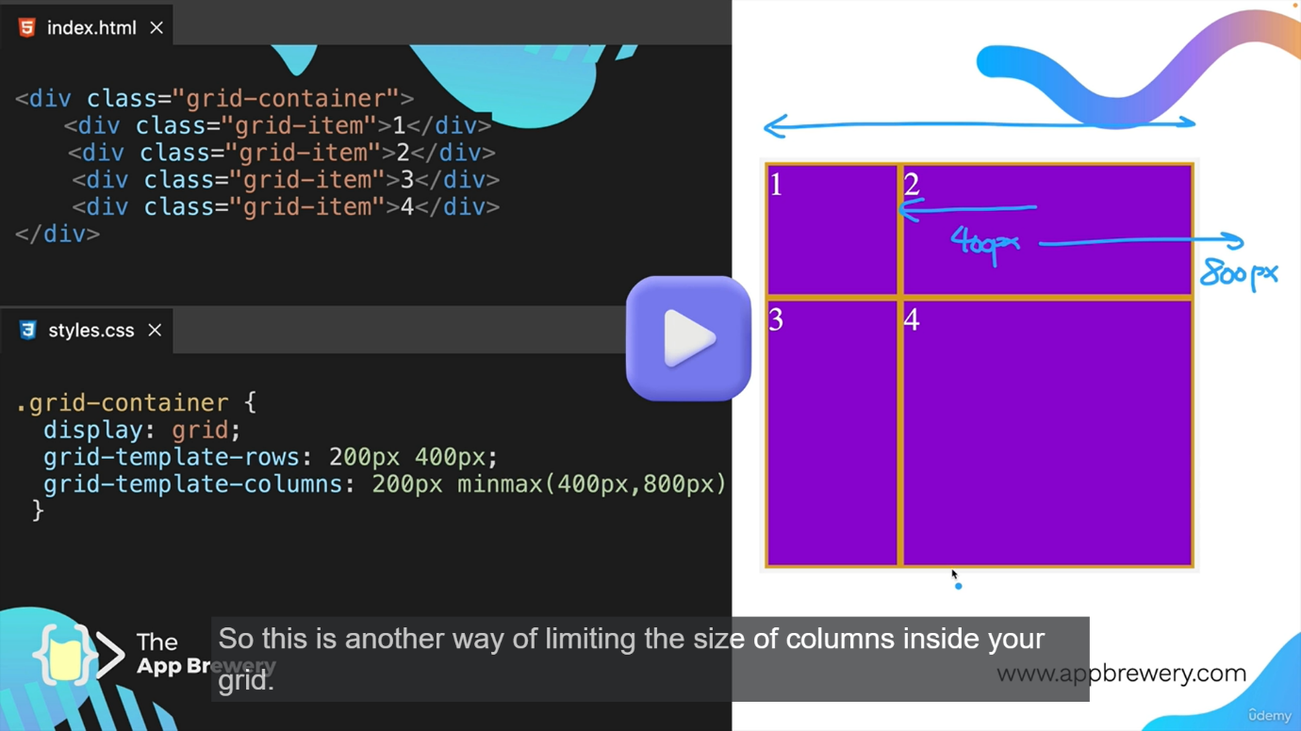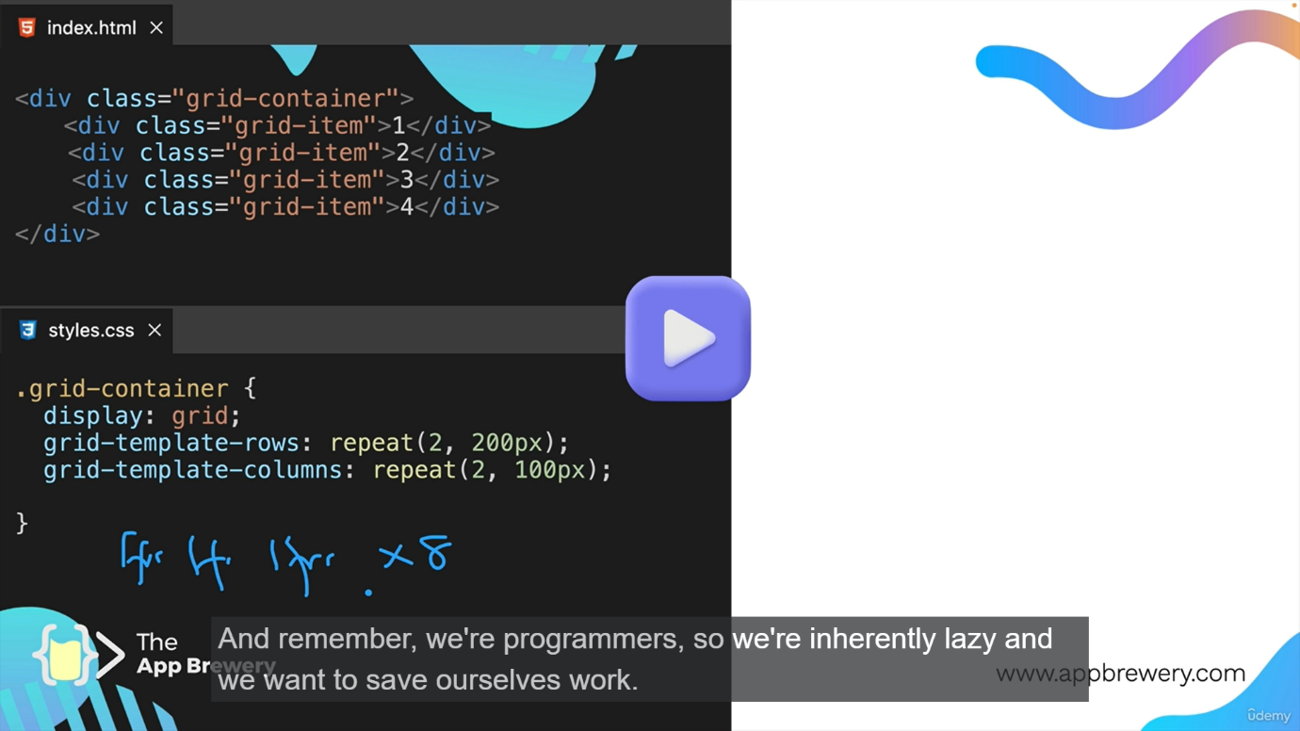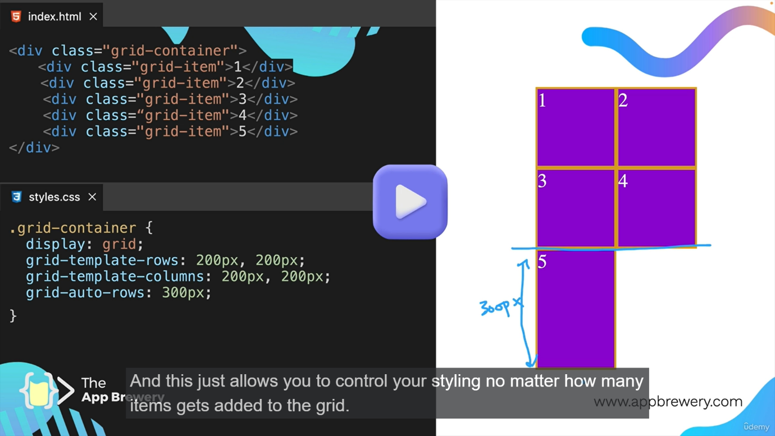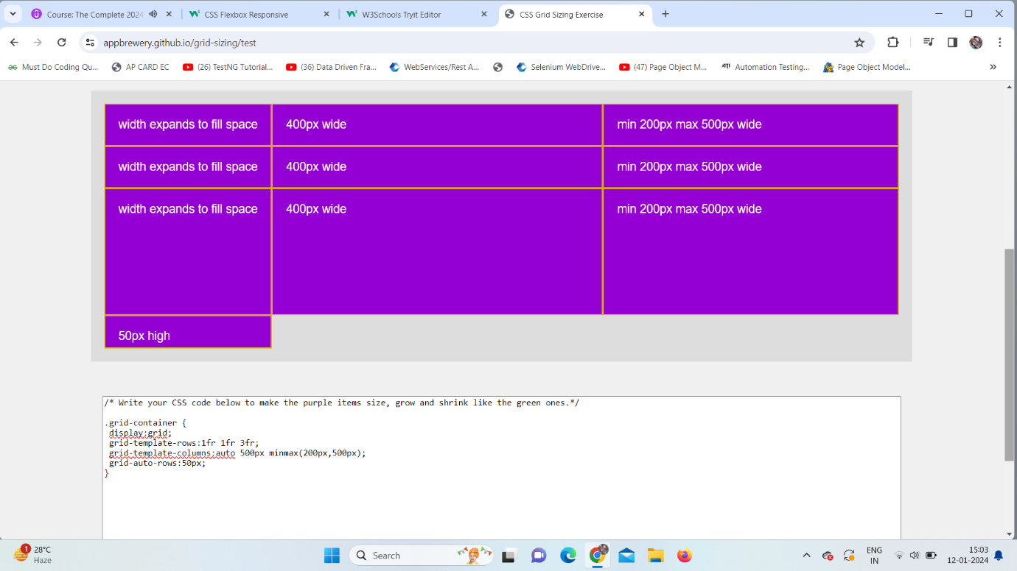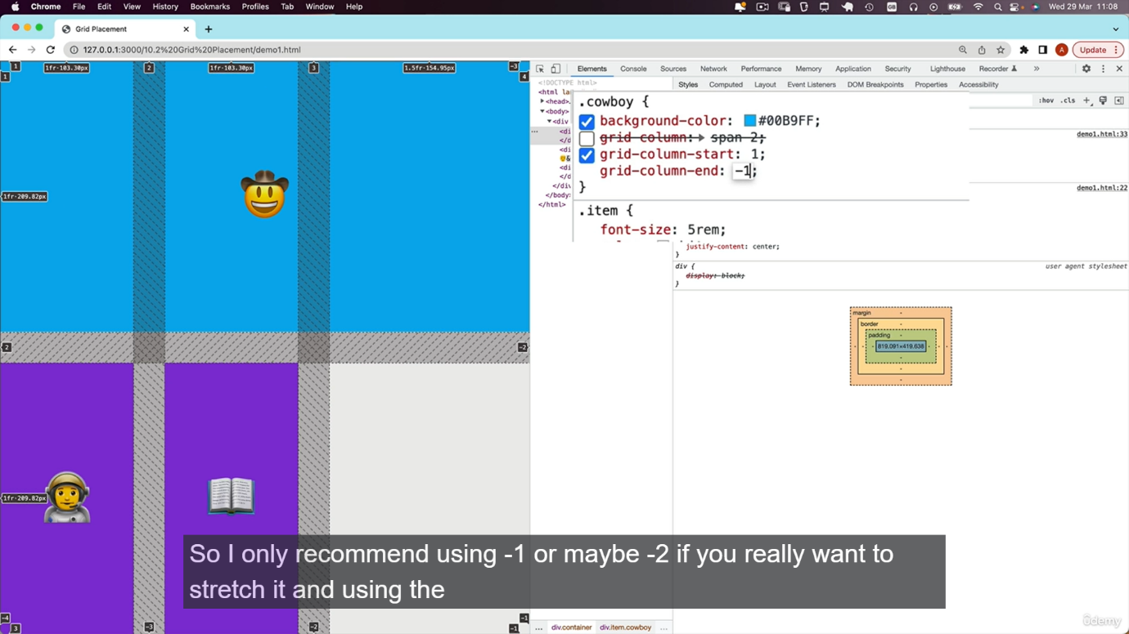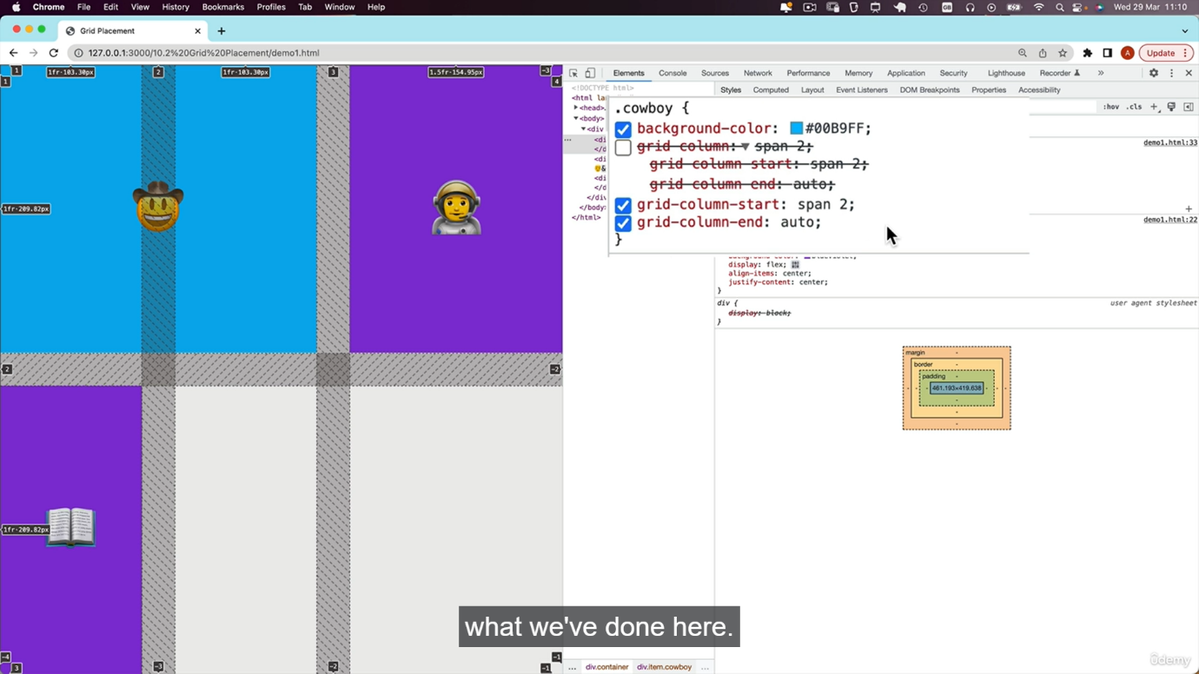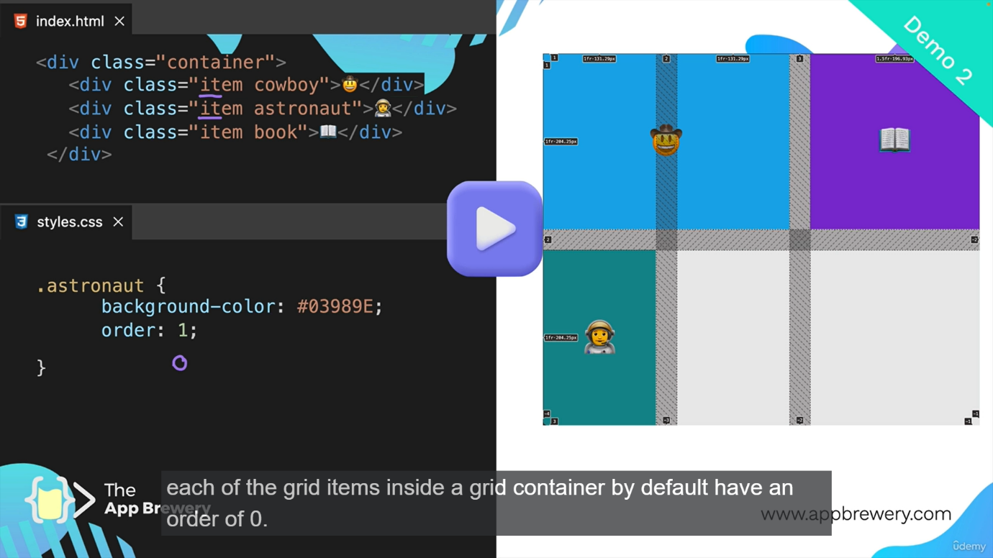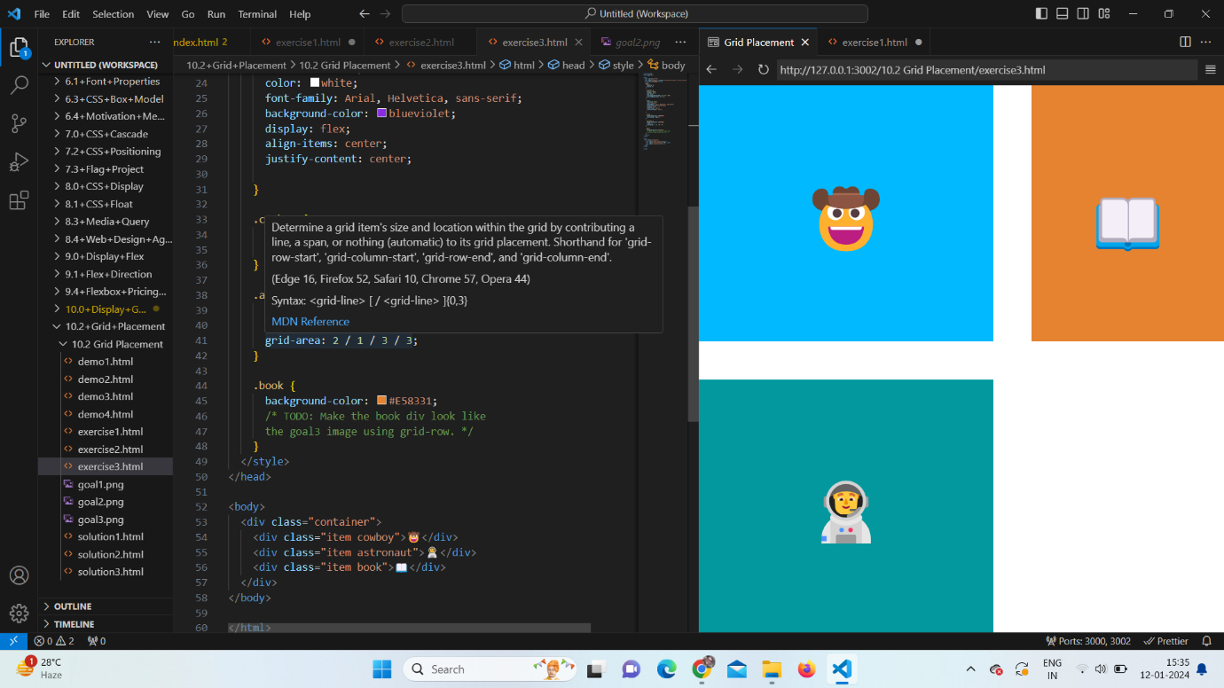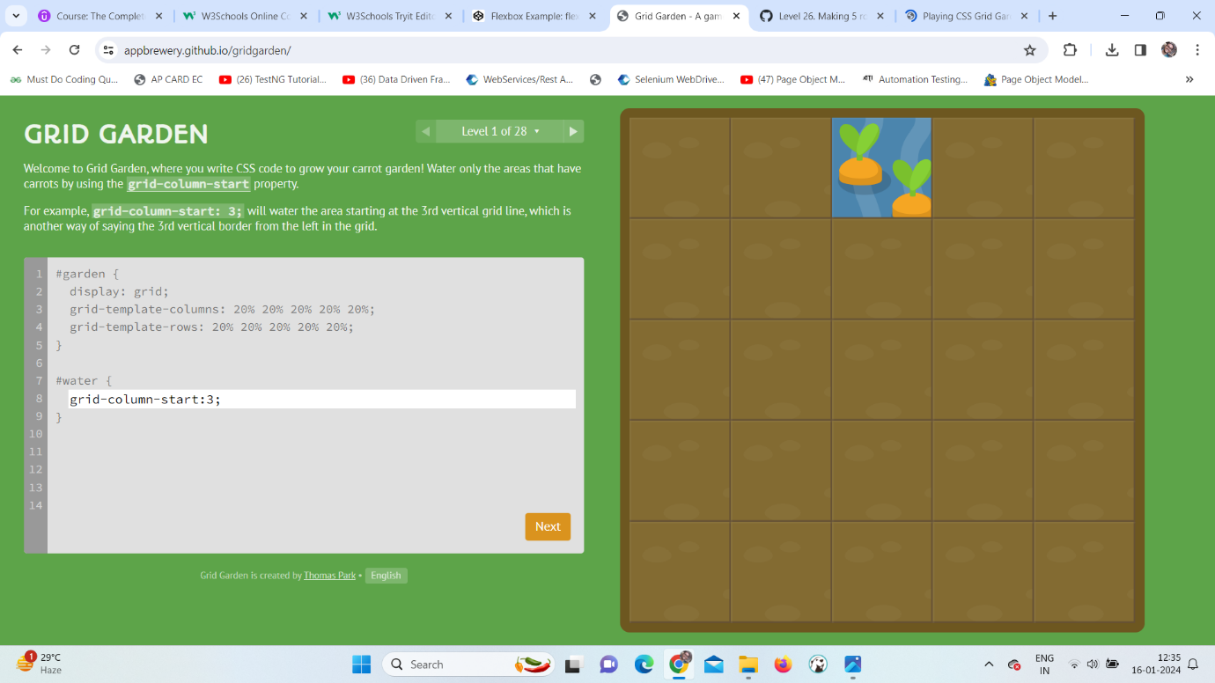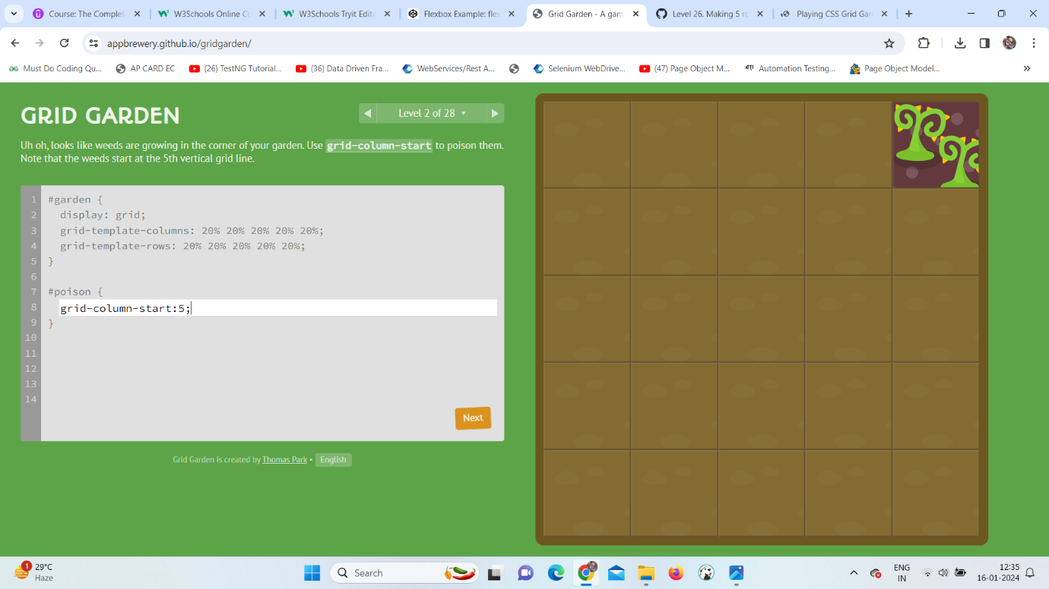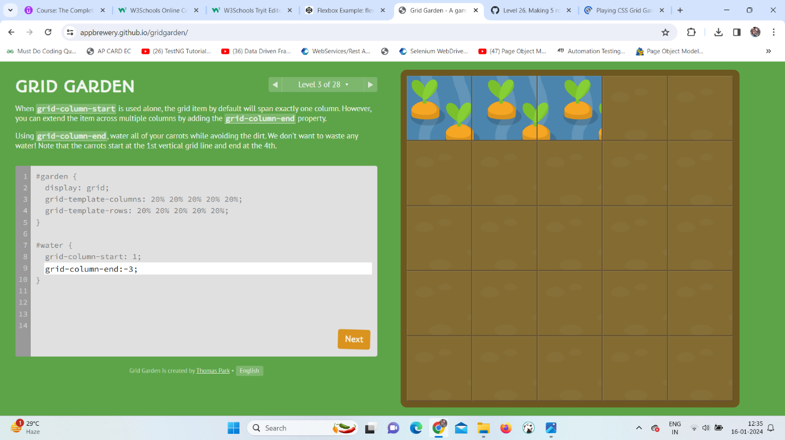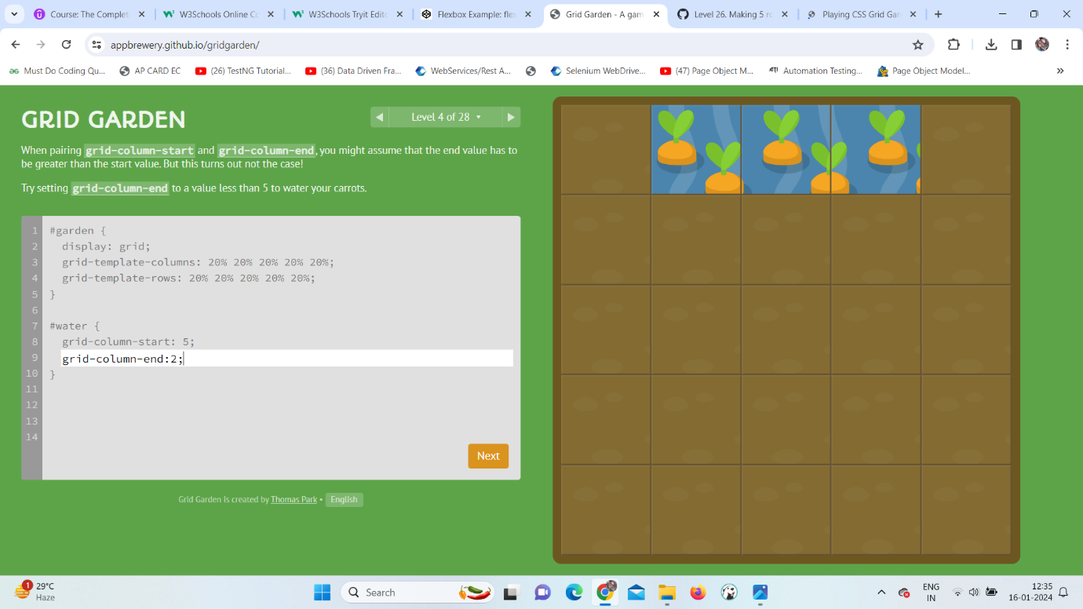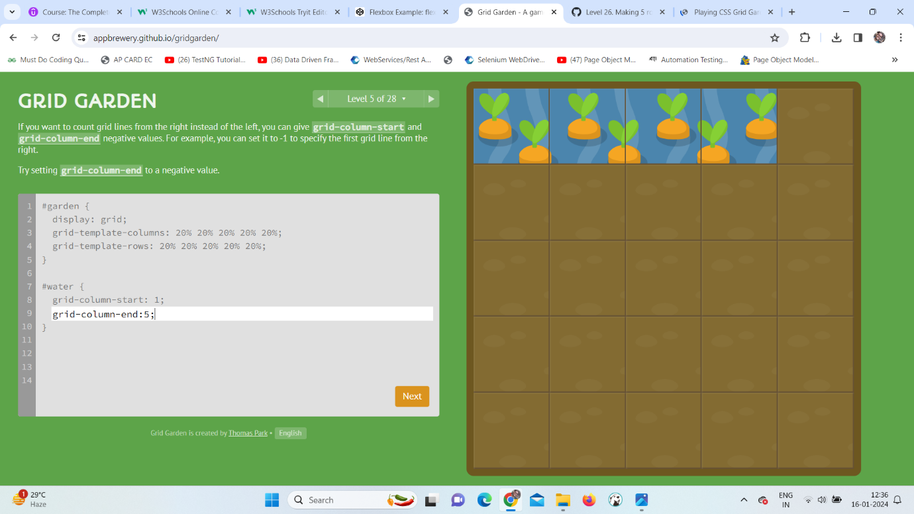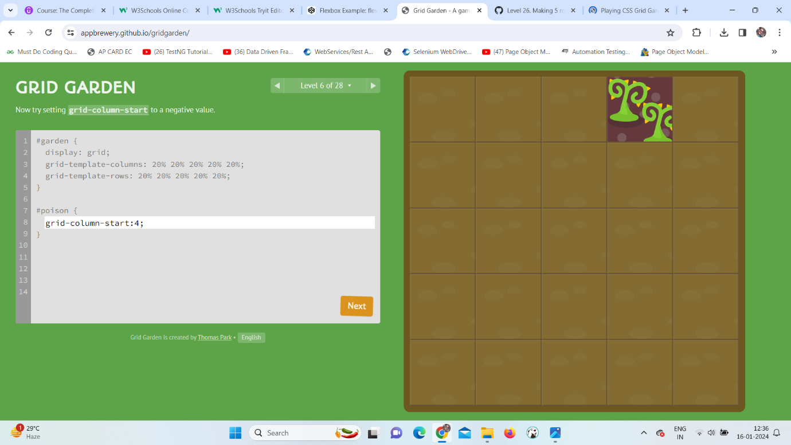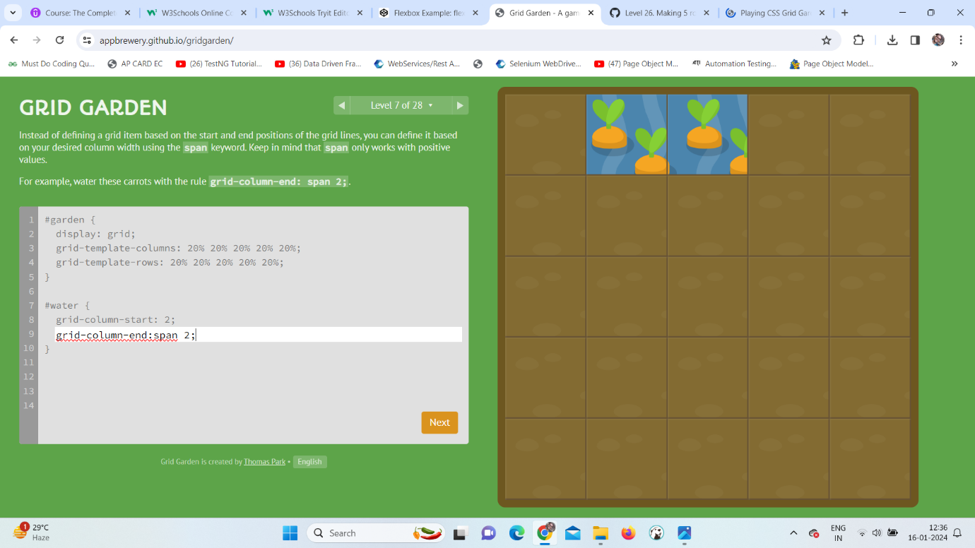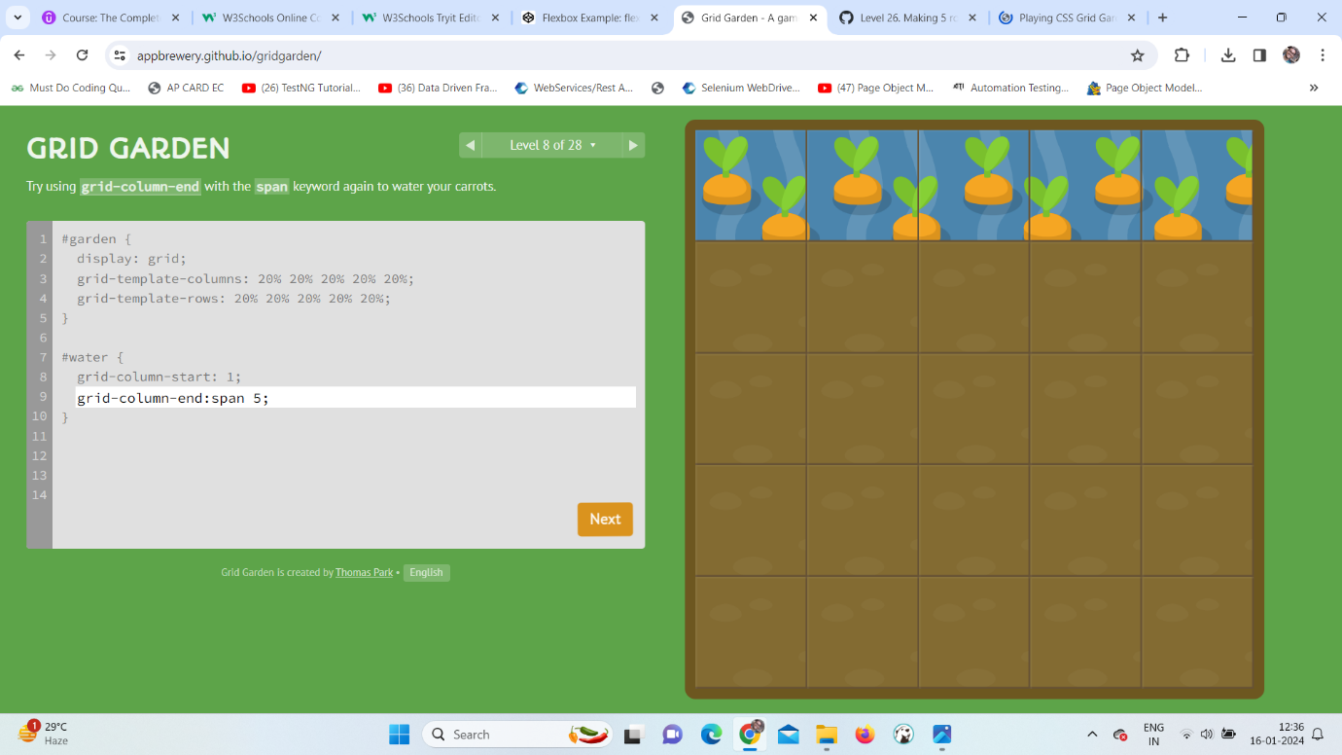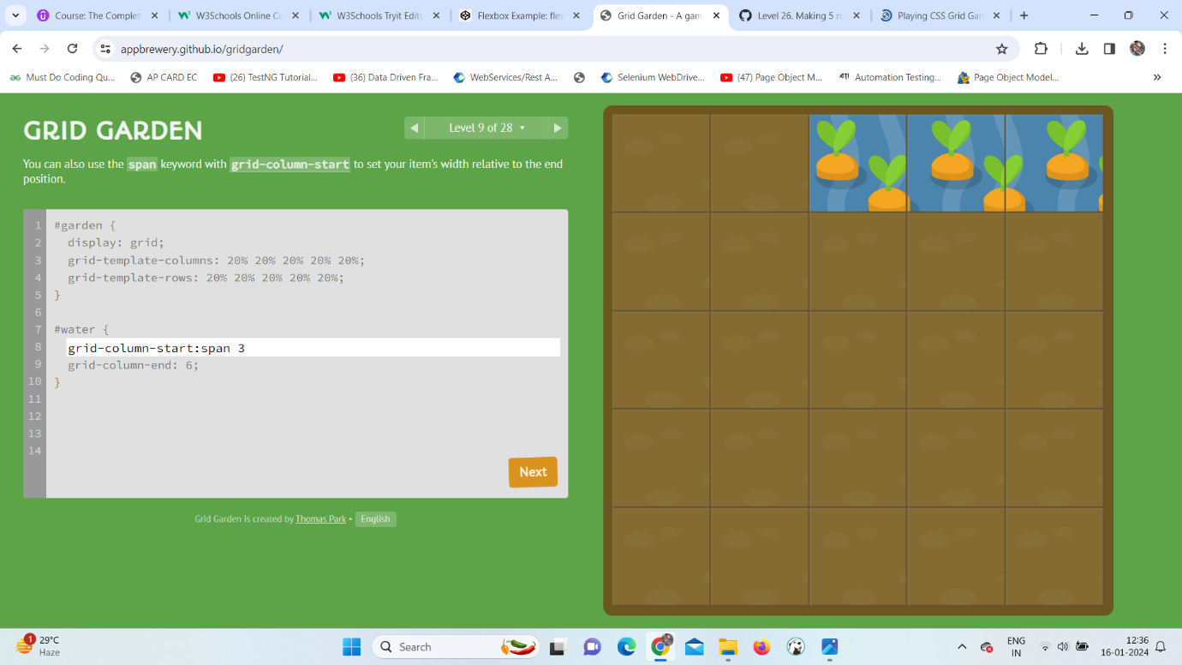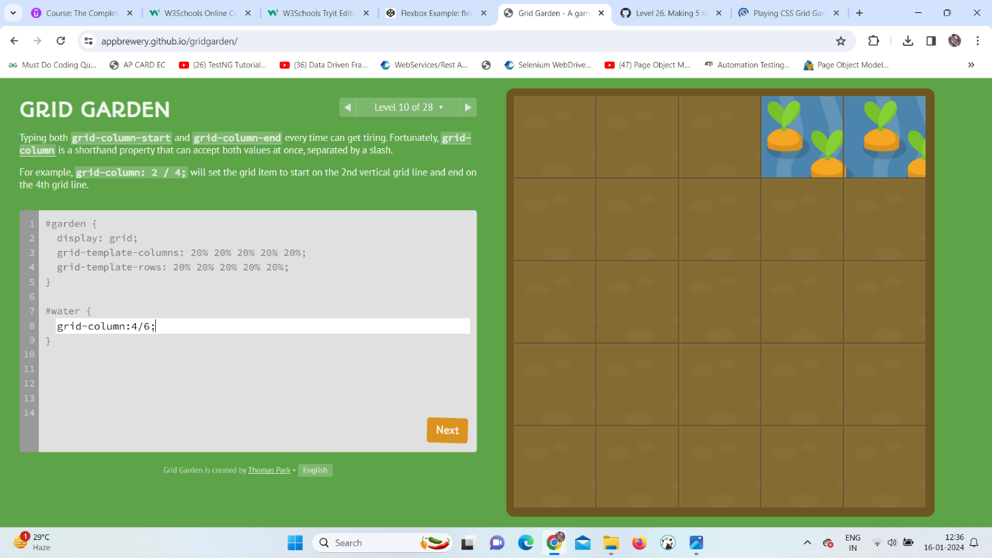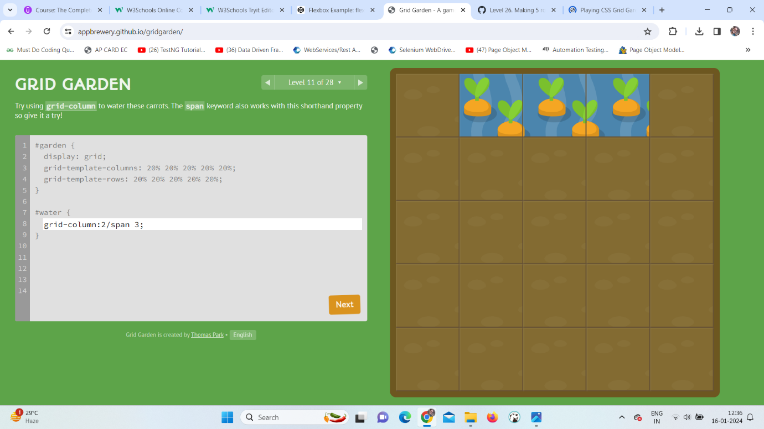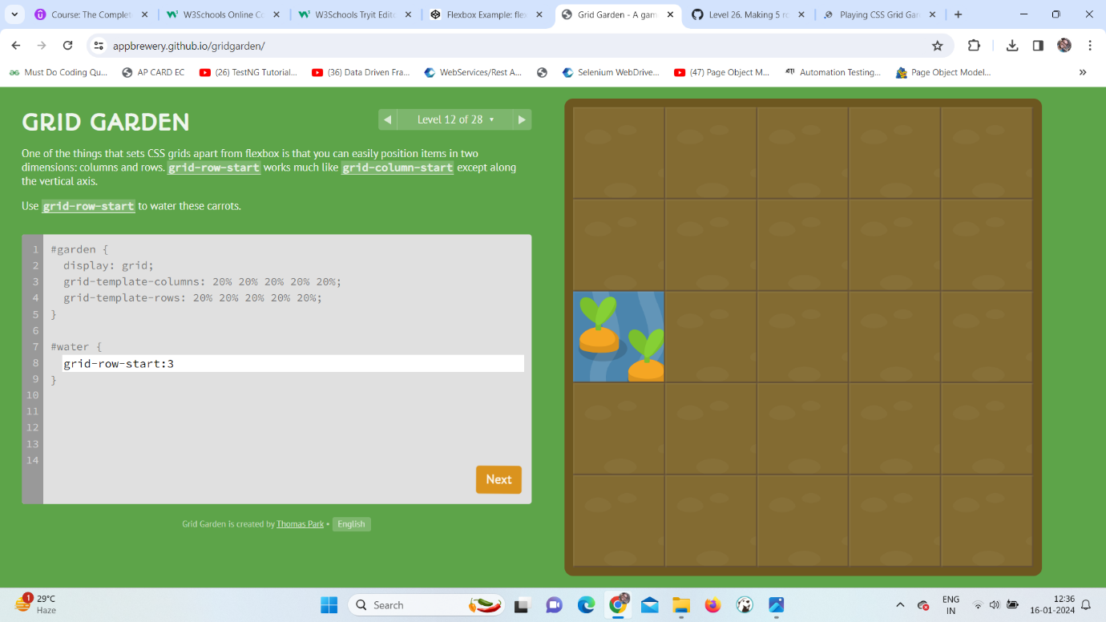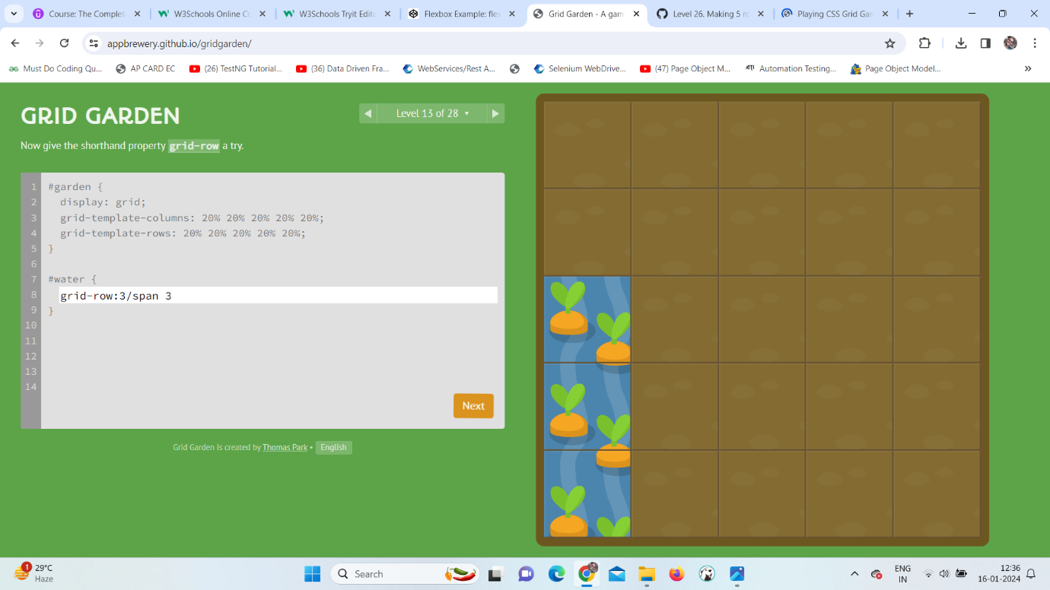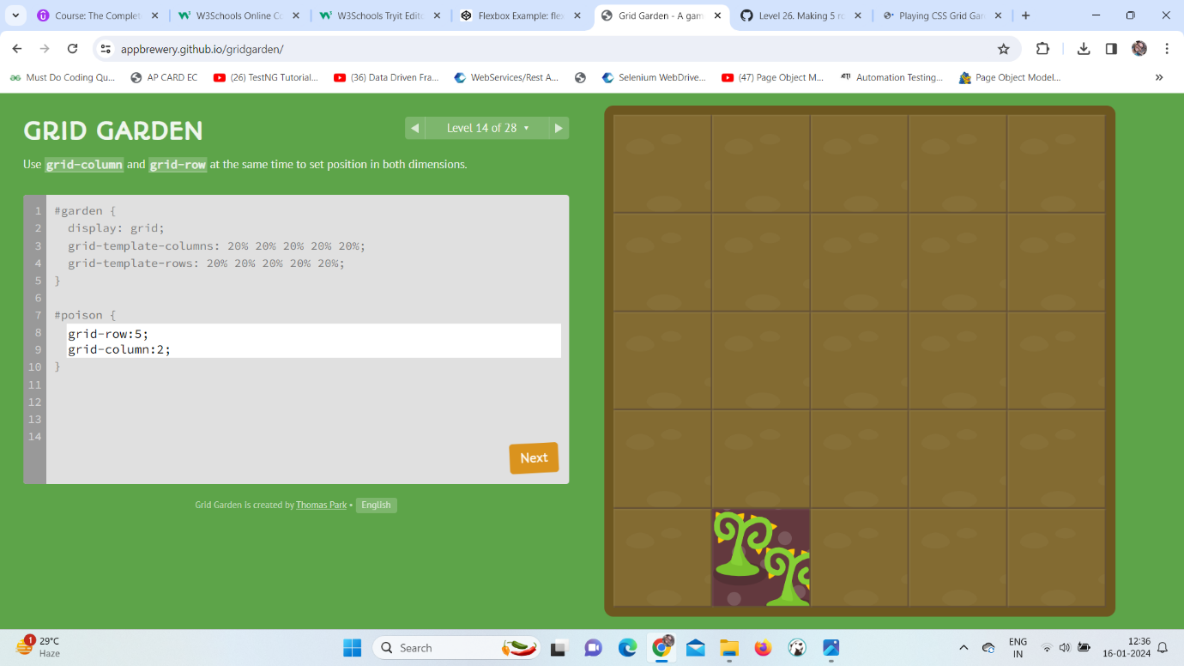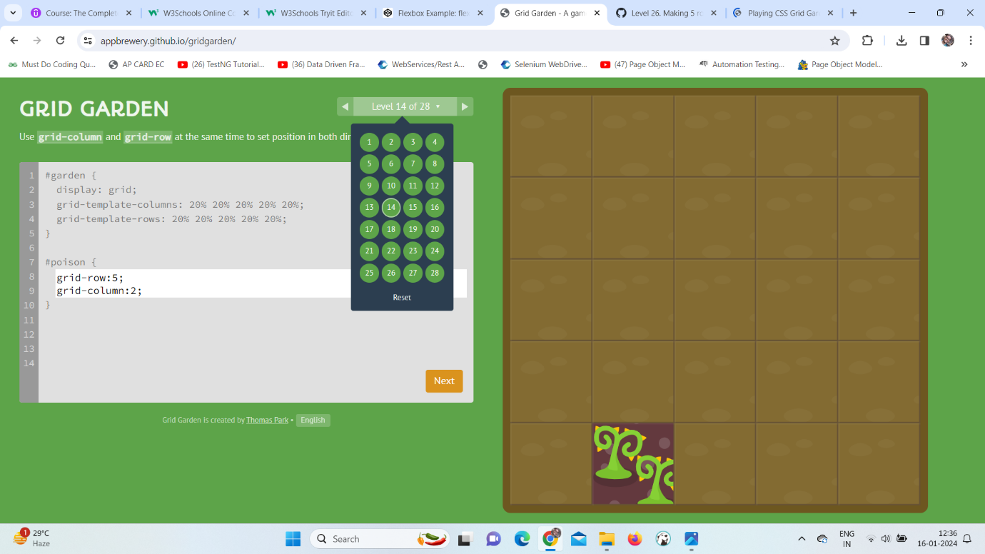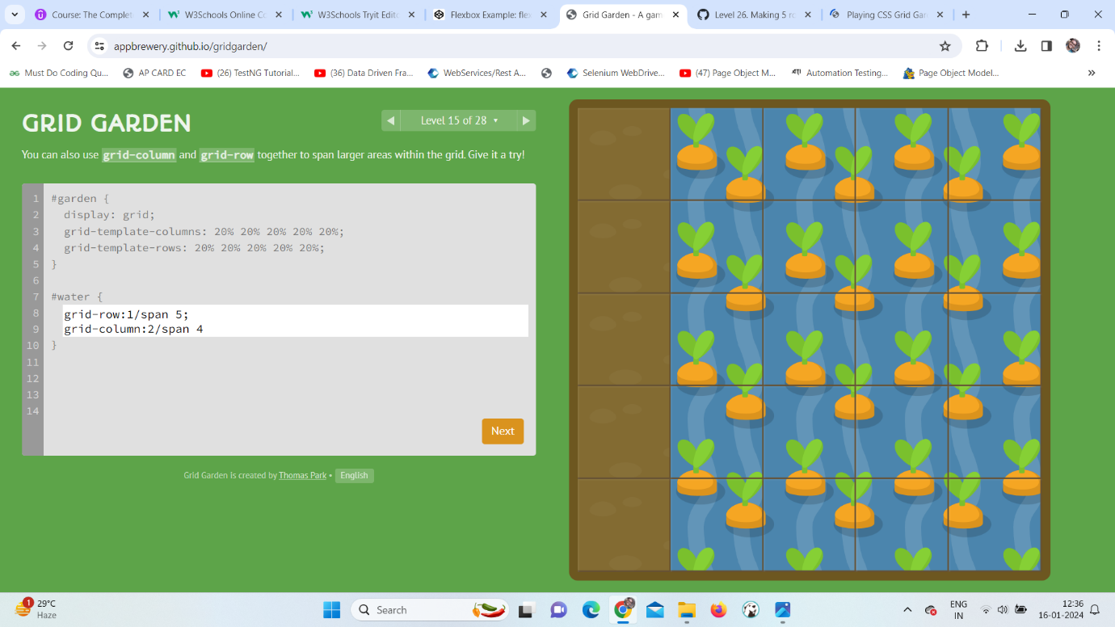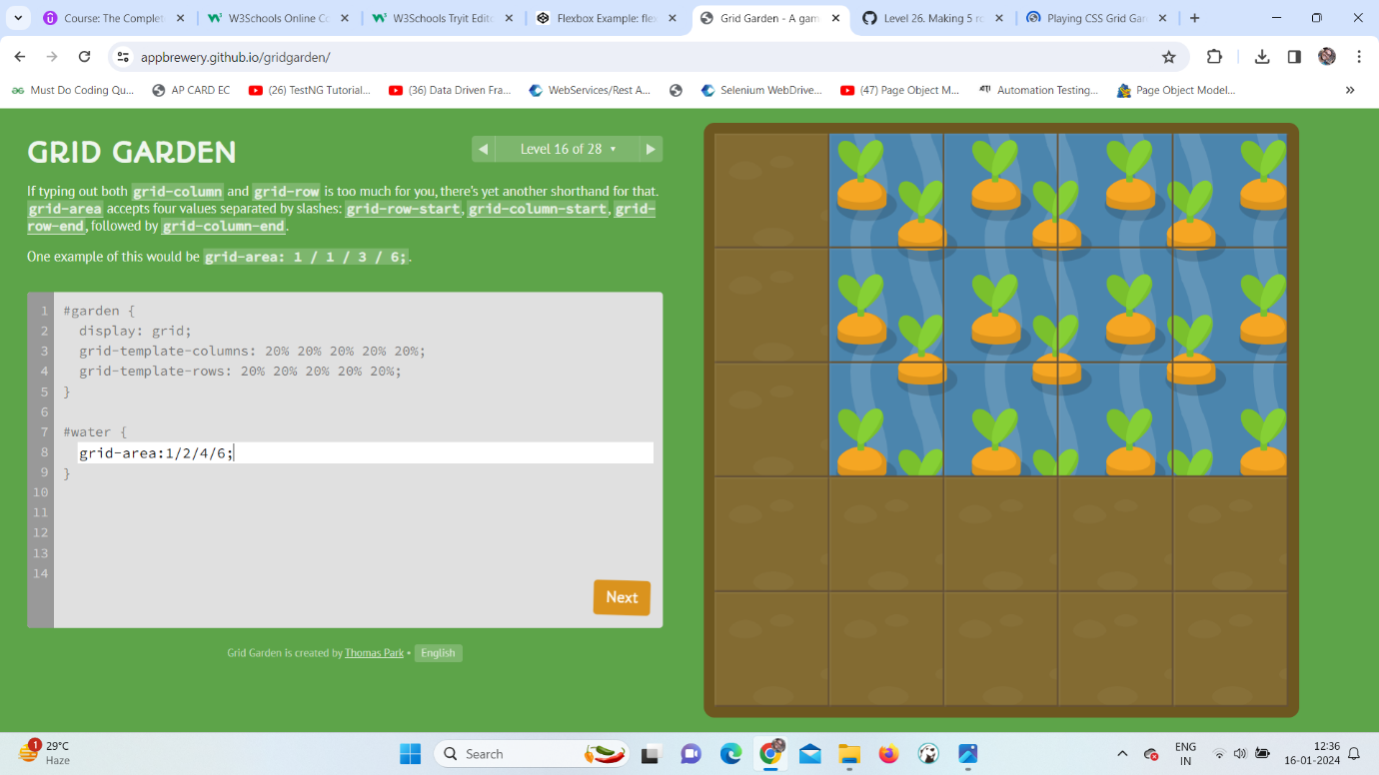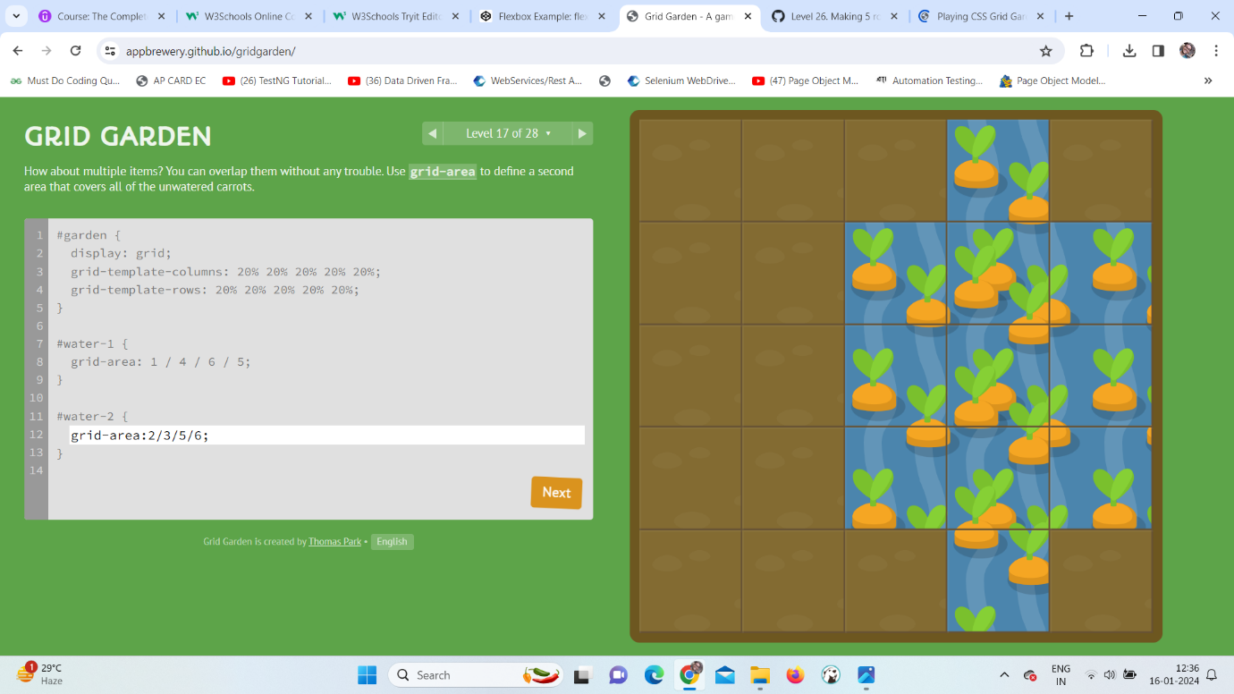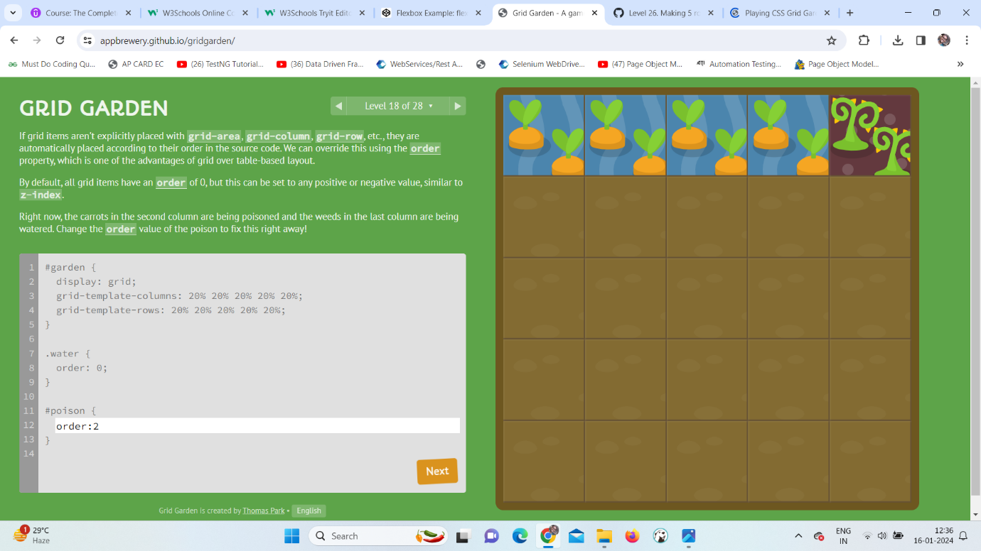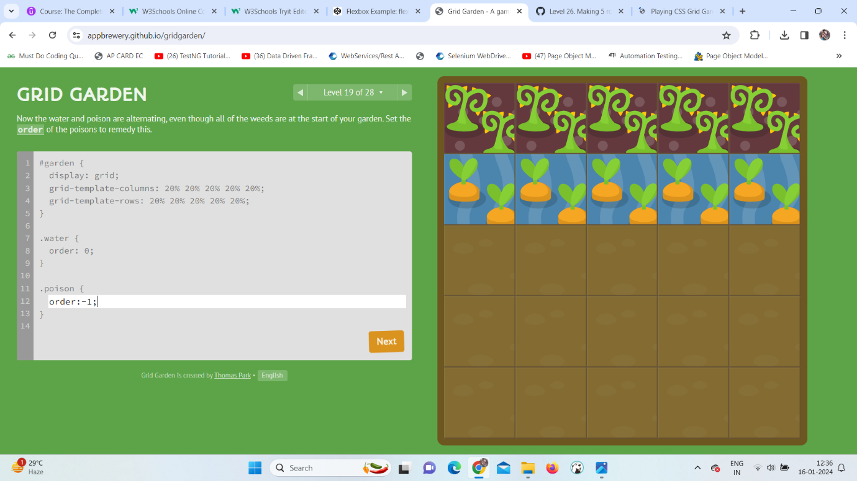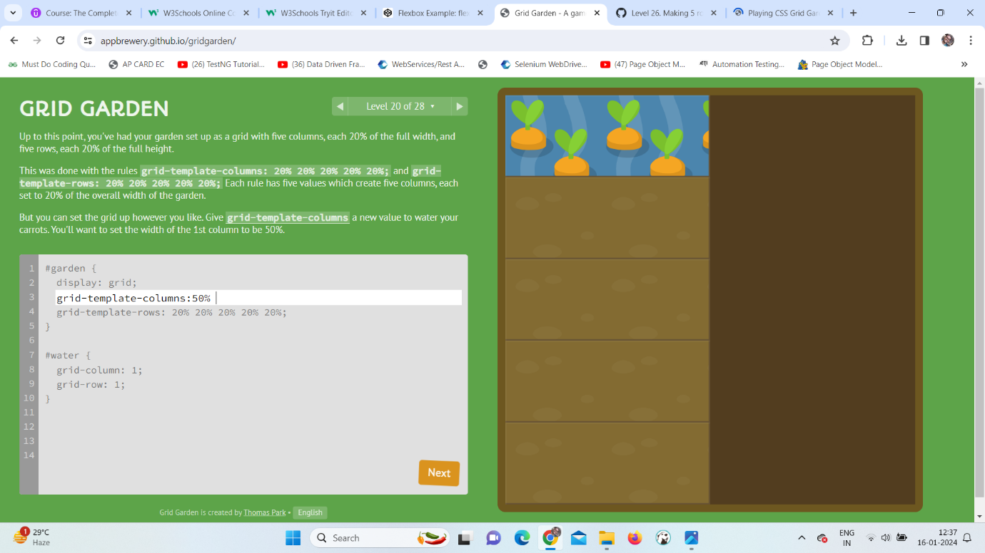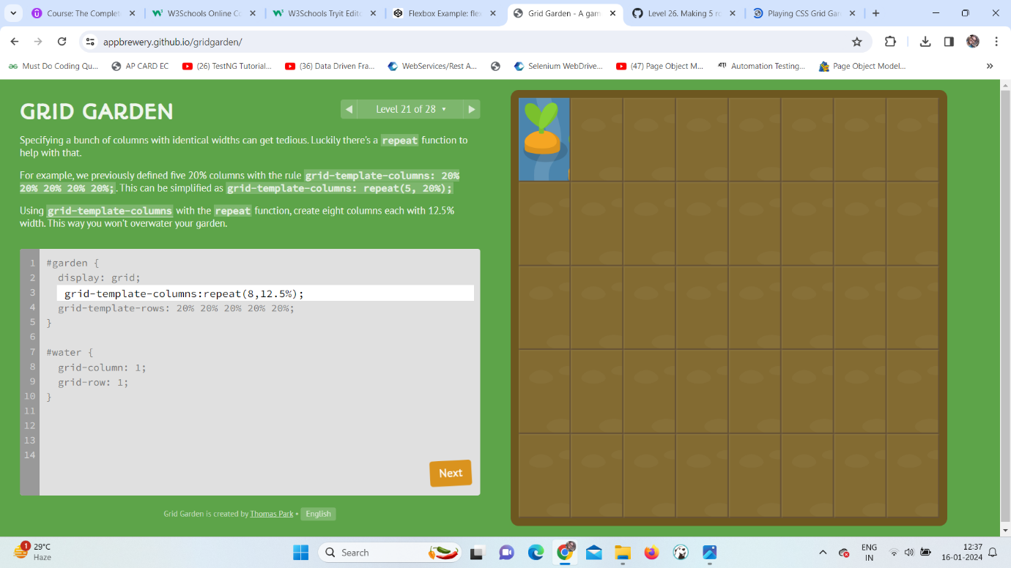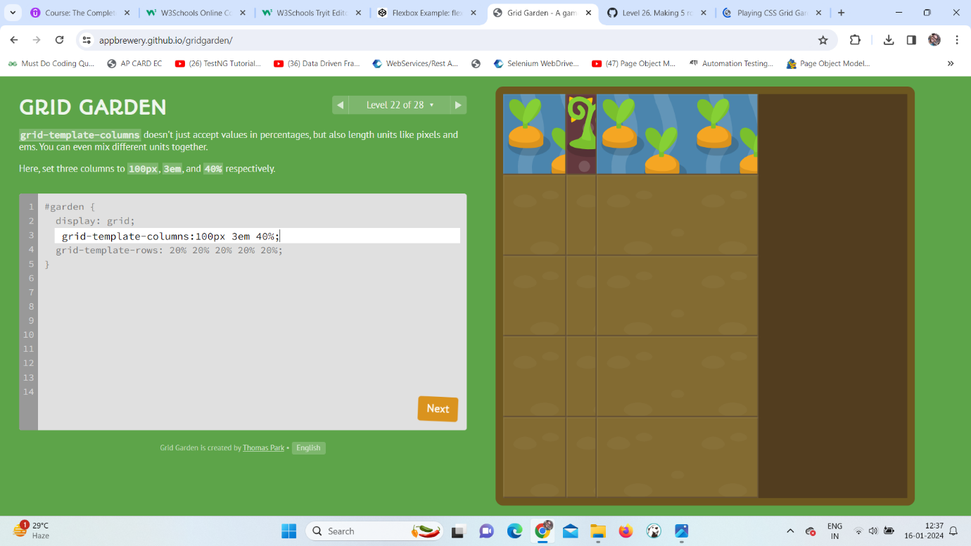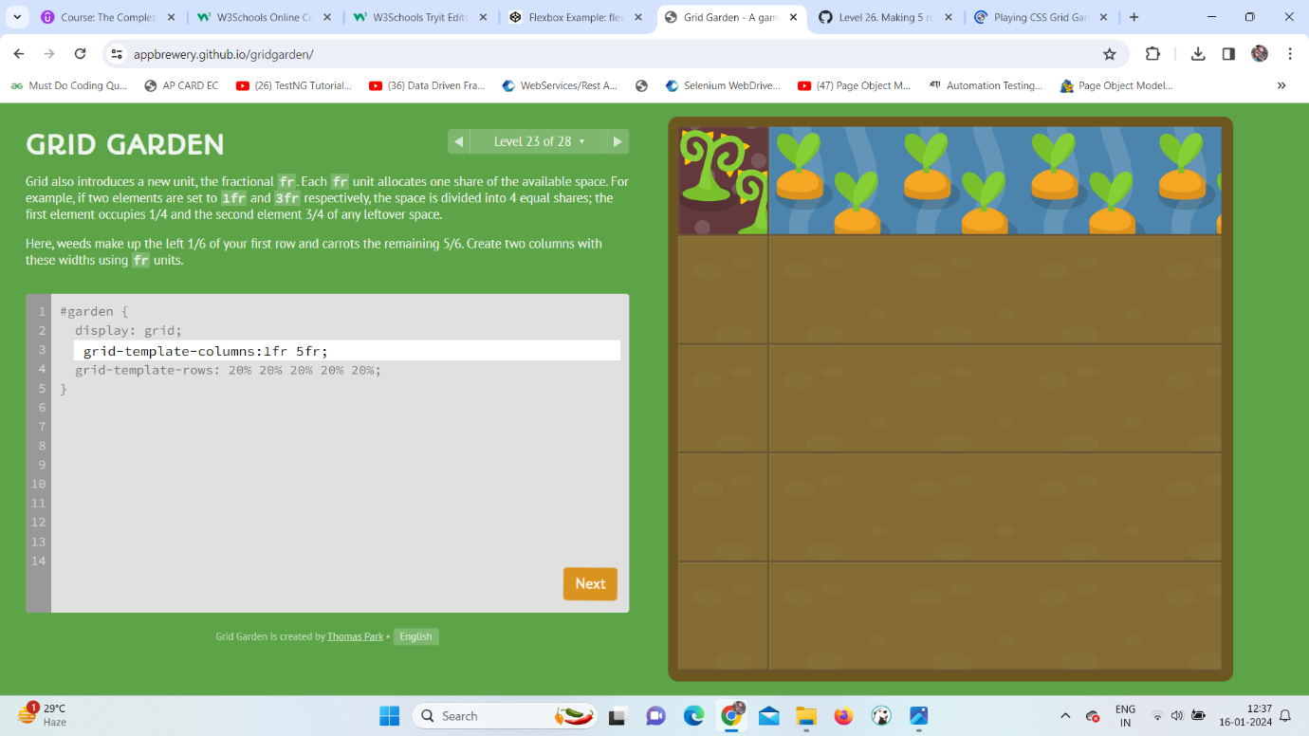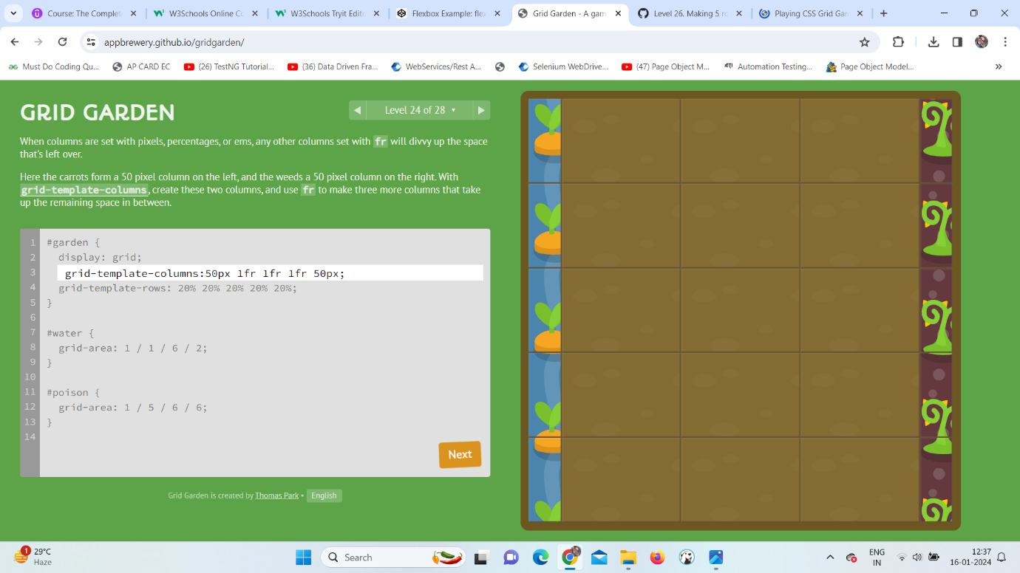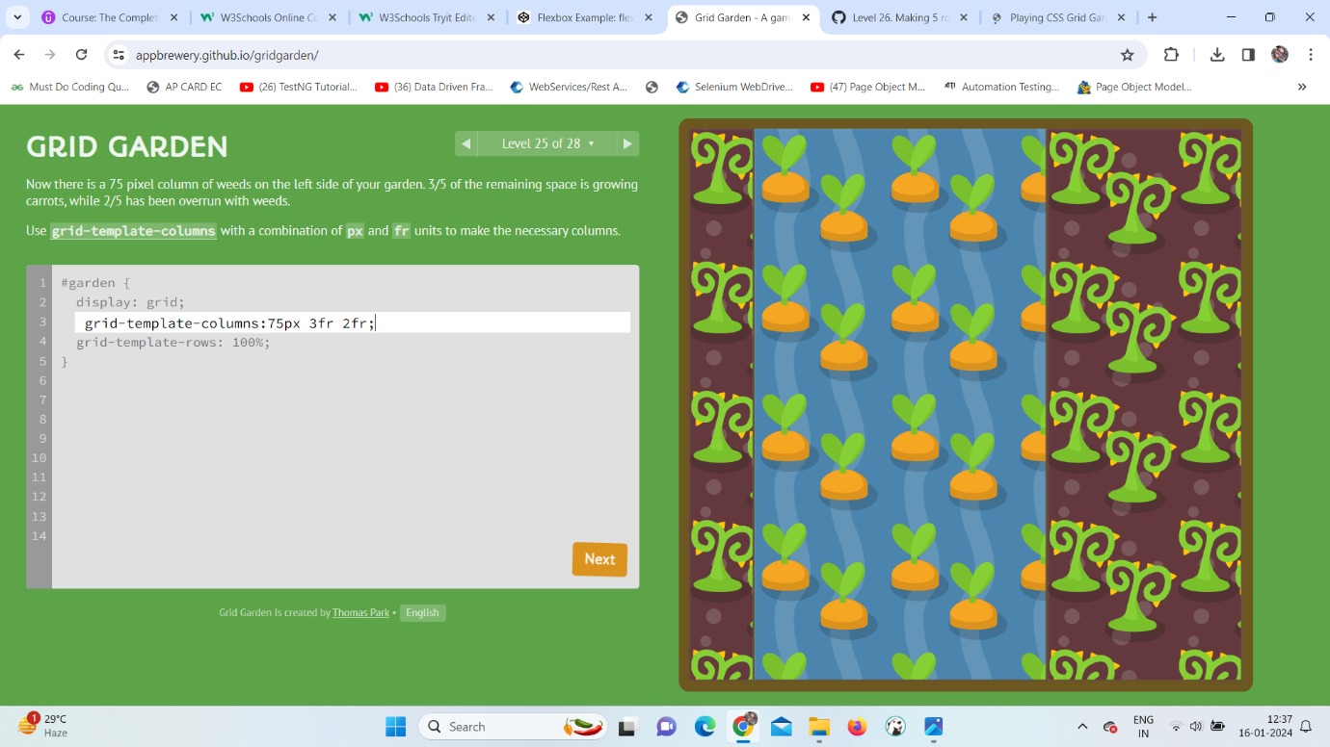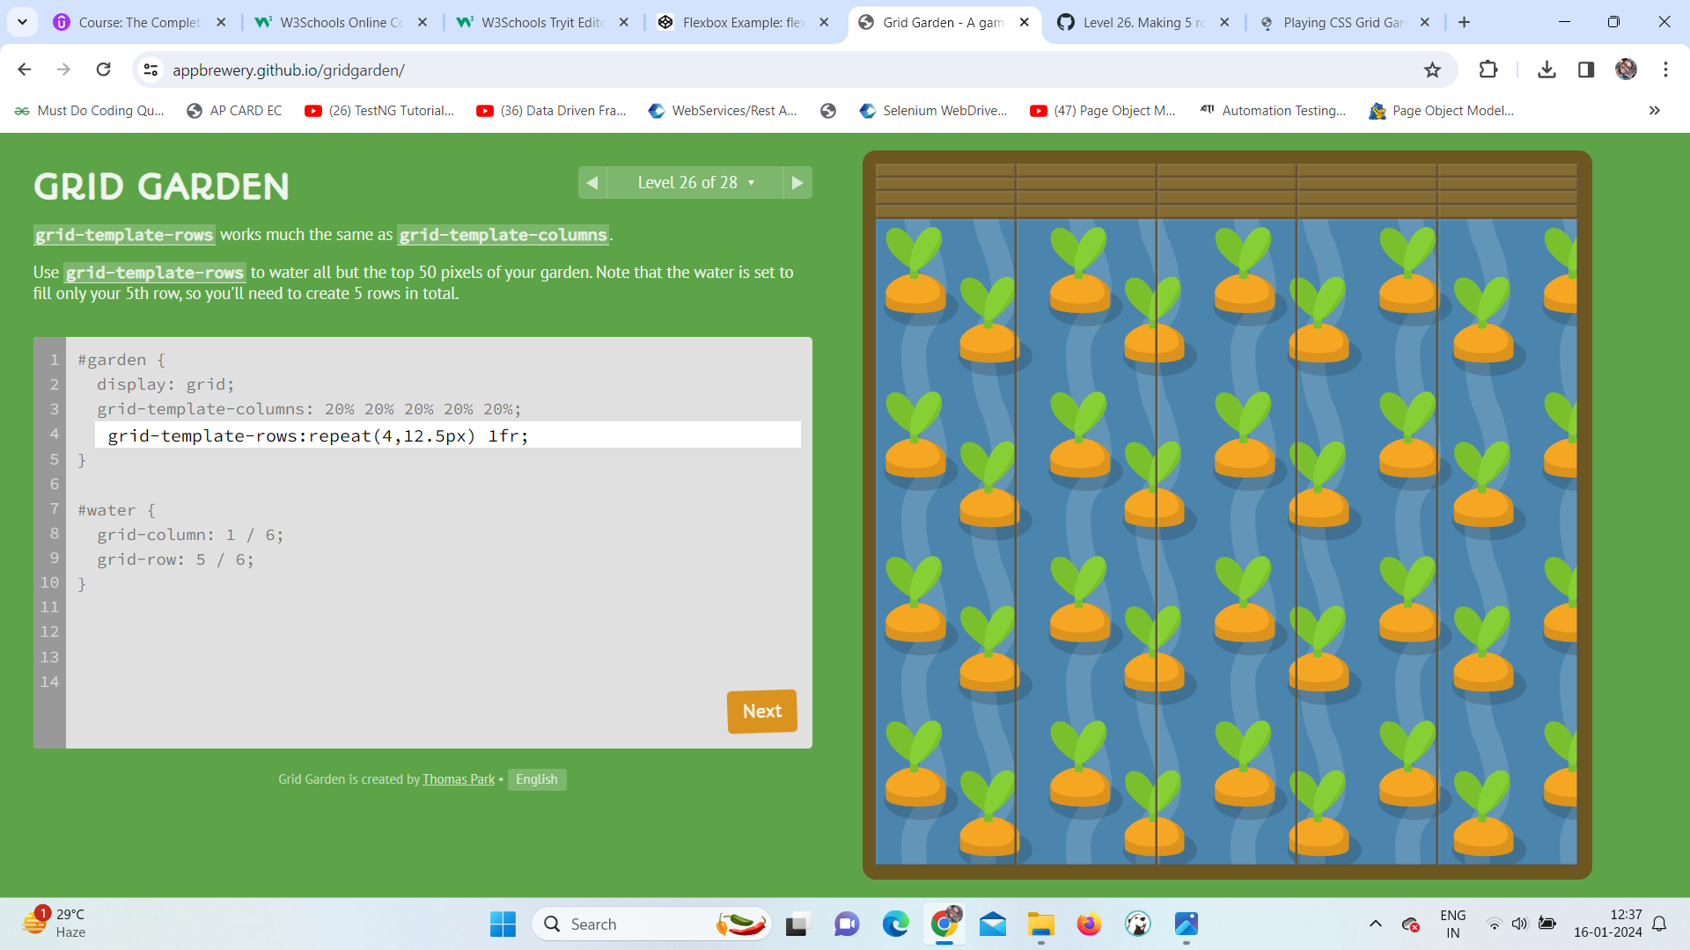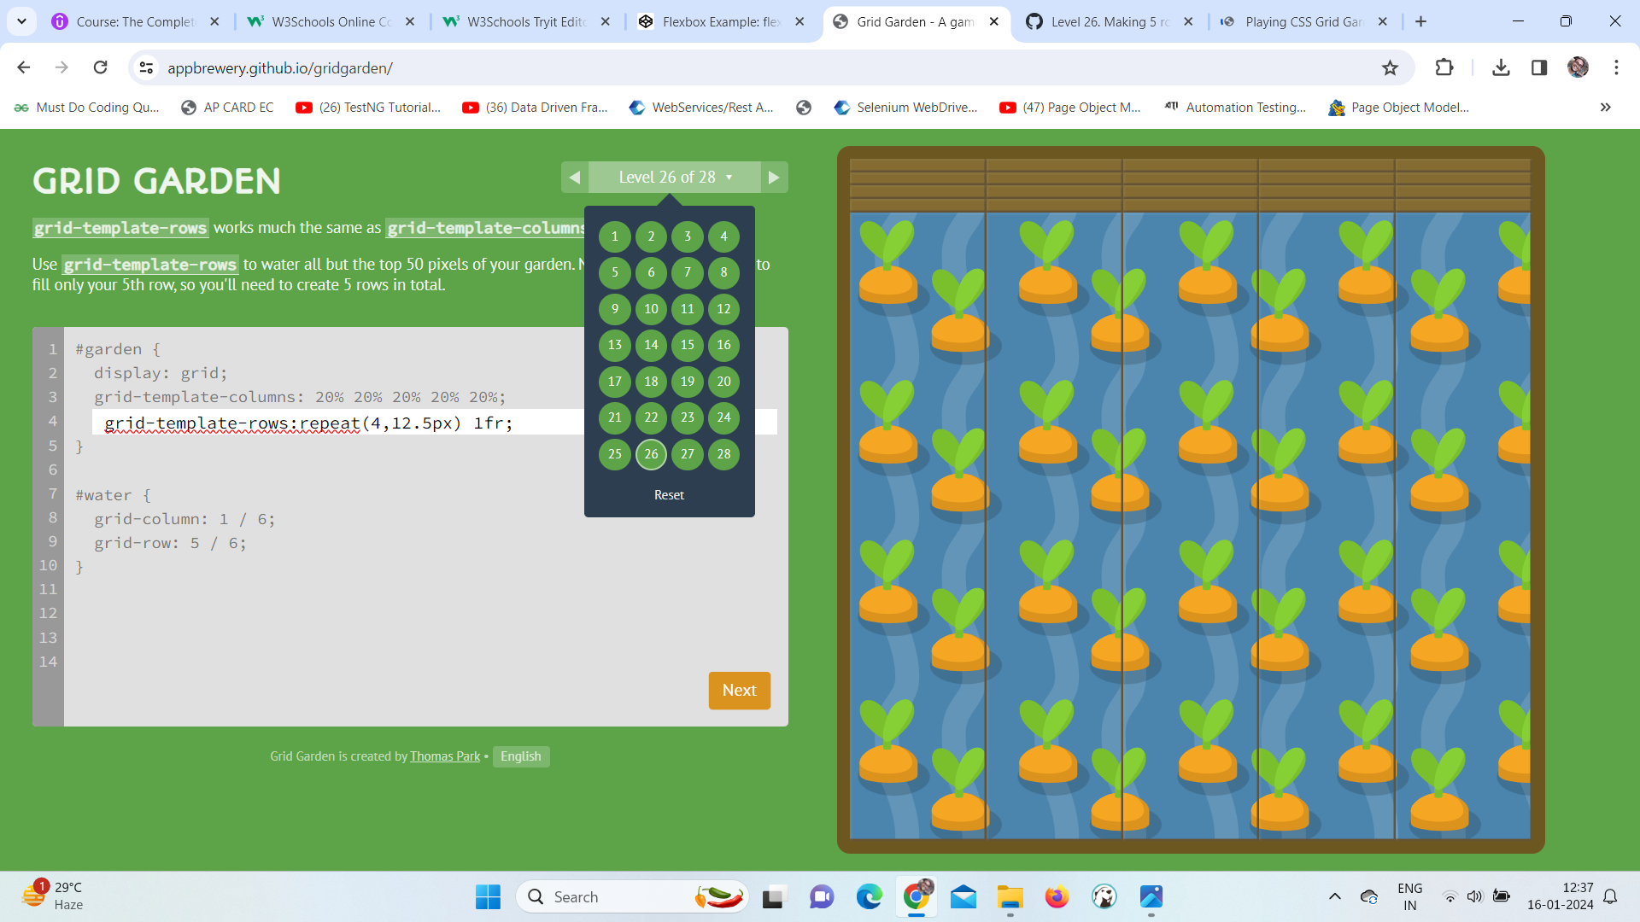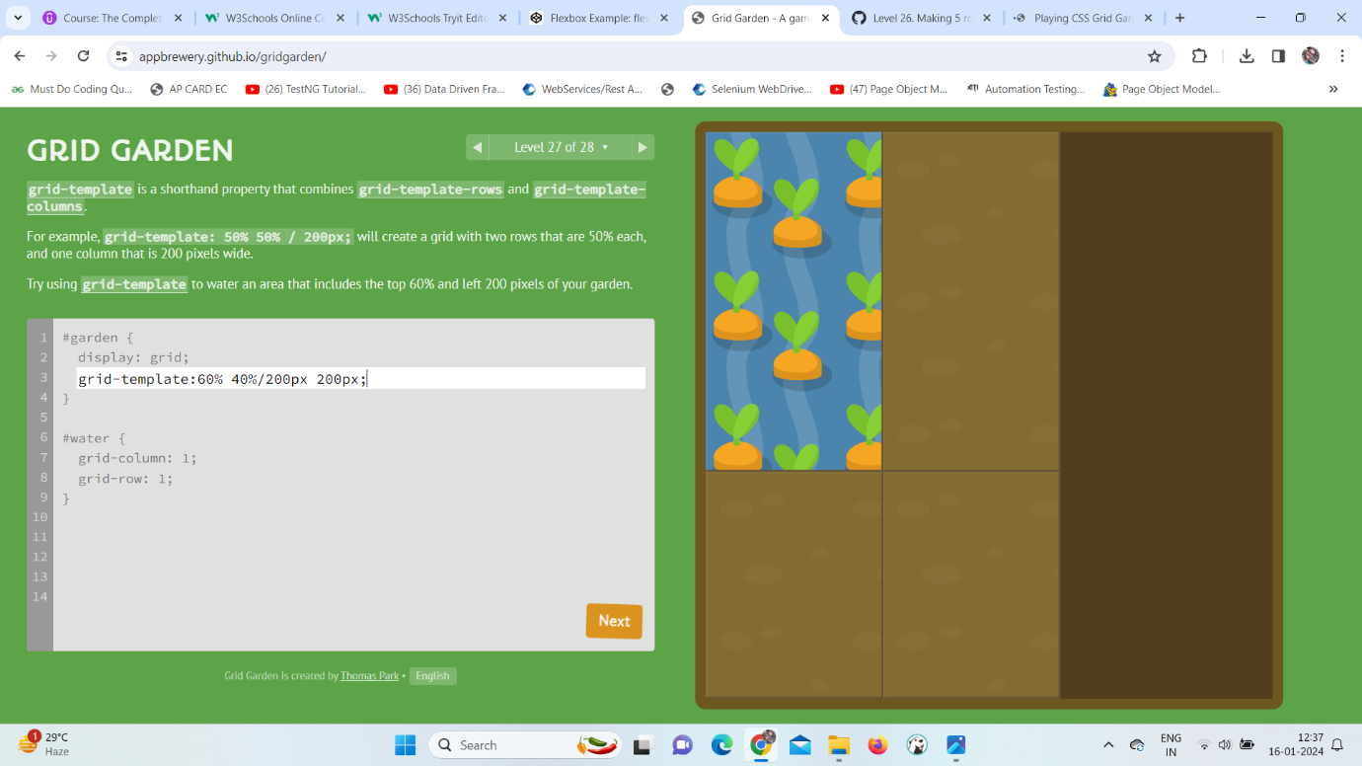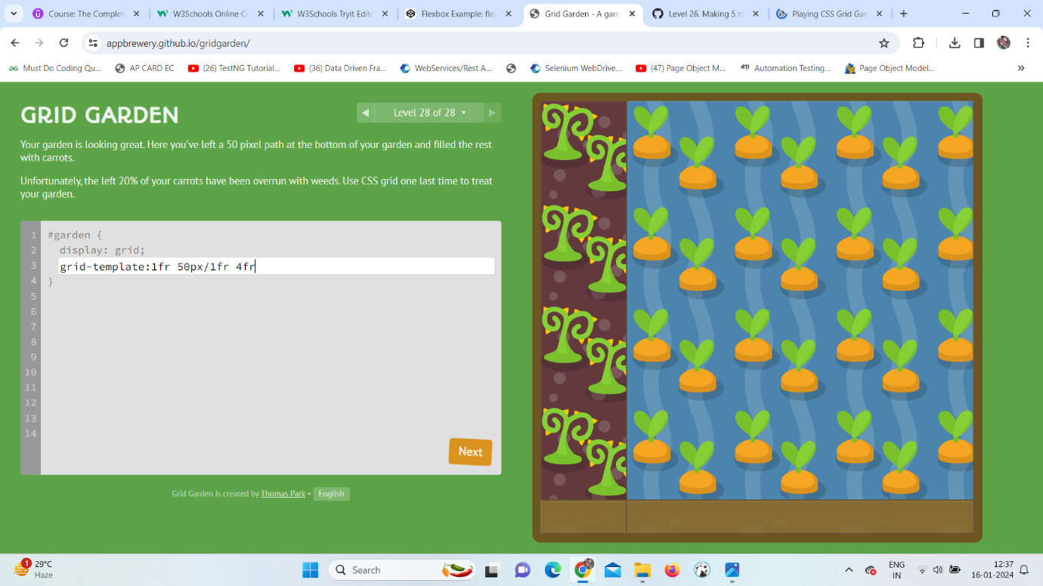

**Boostrap:**

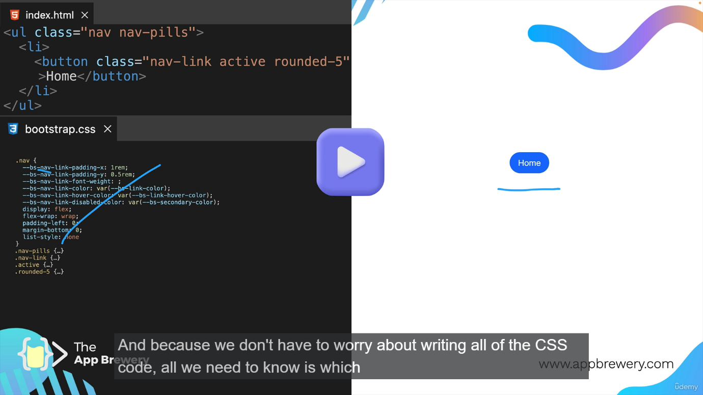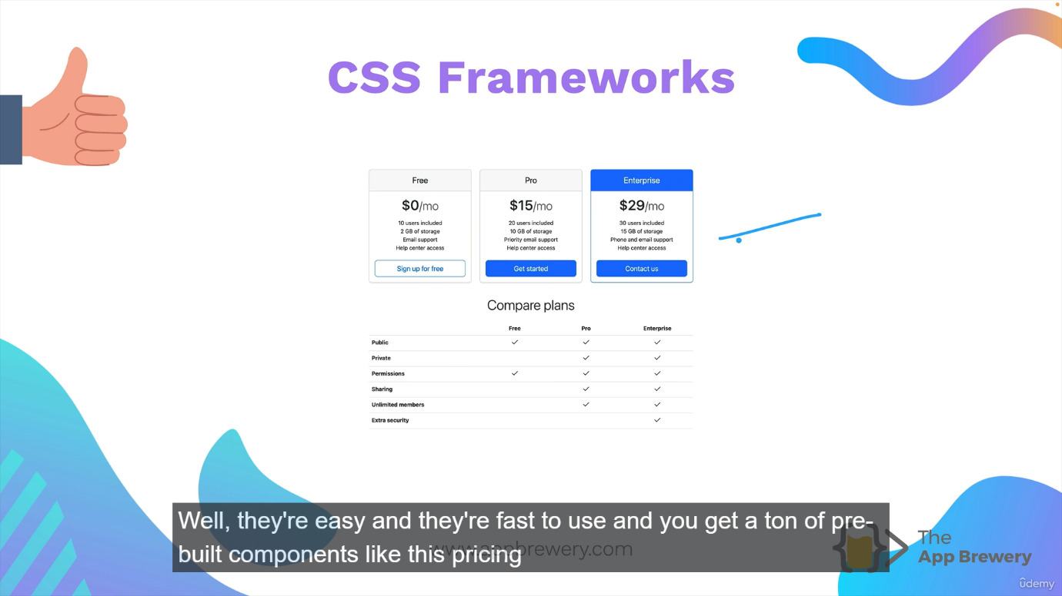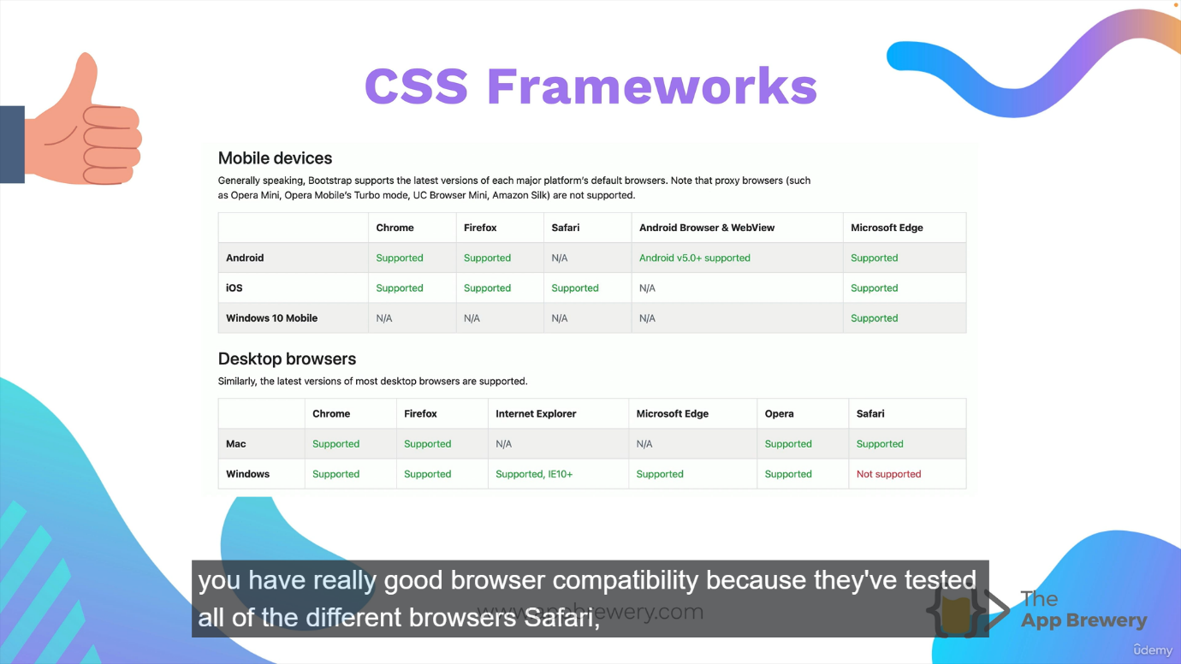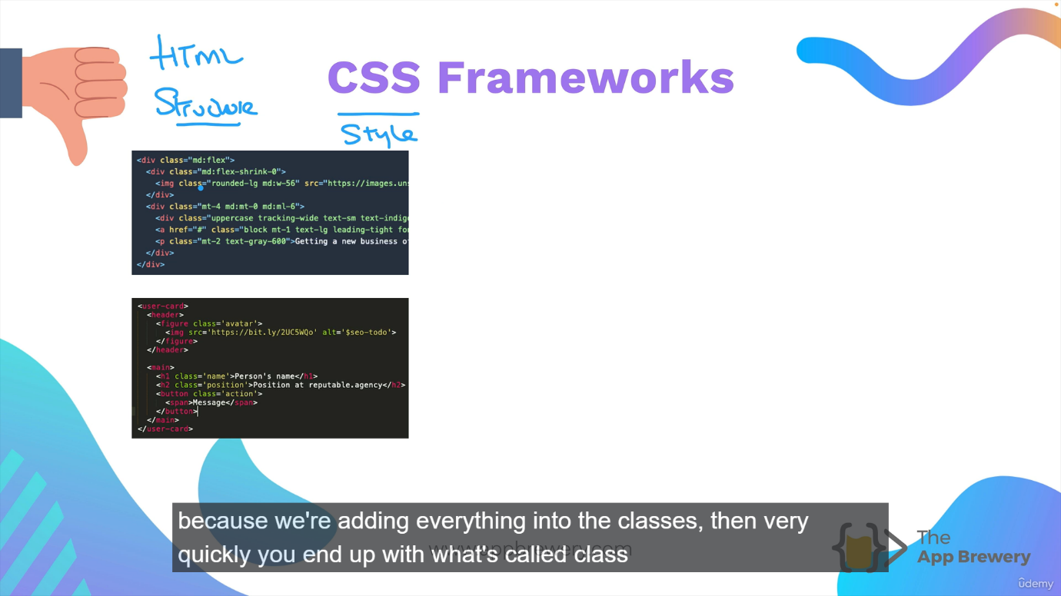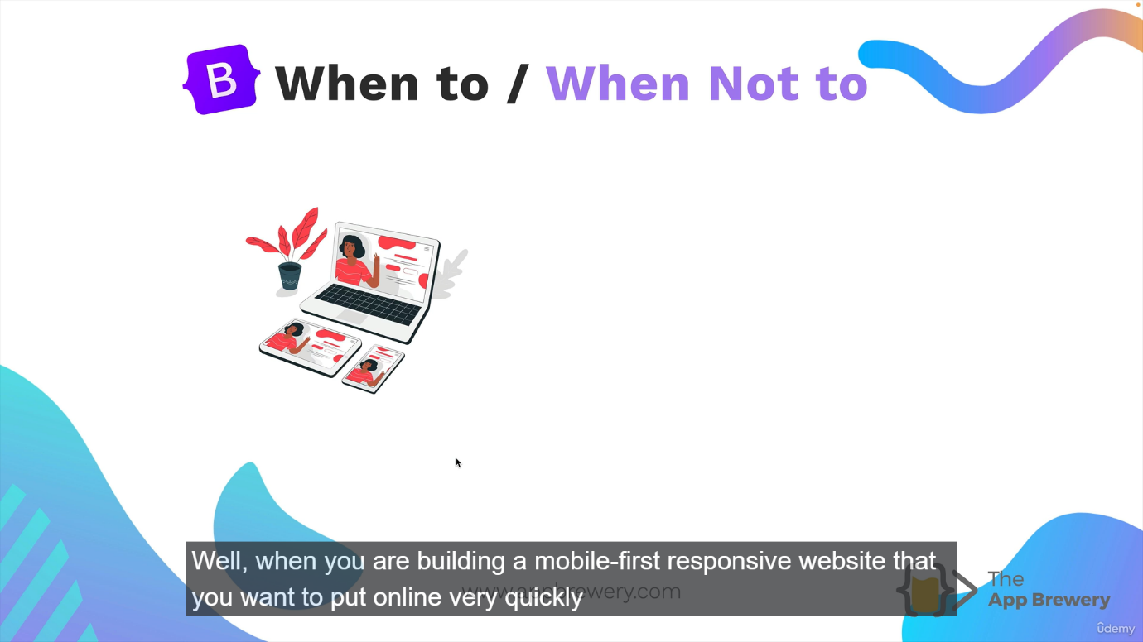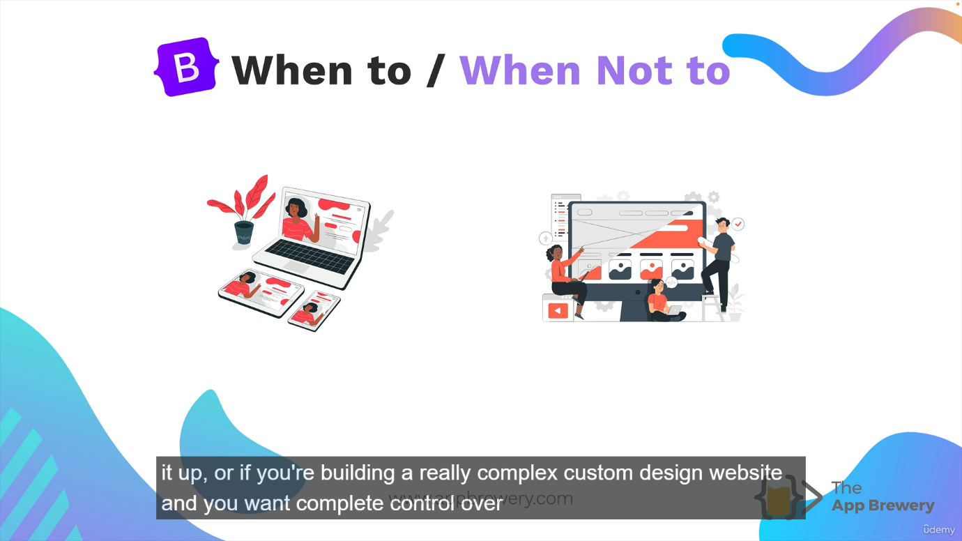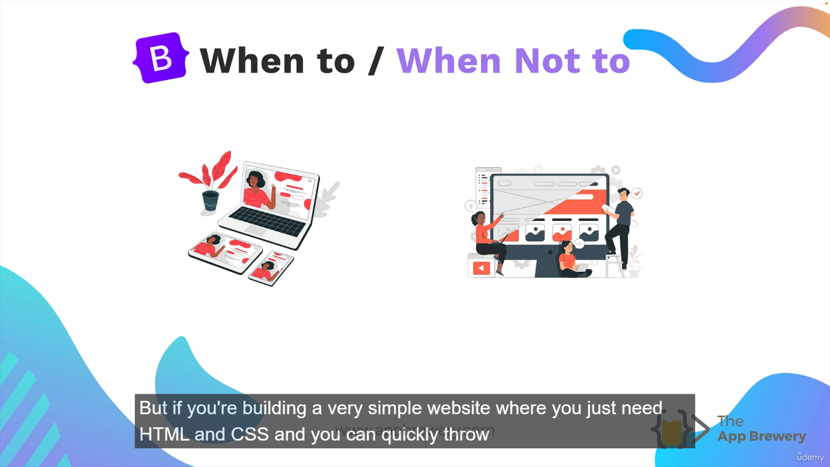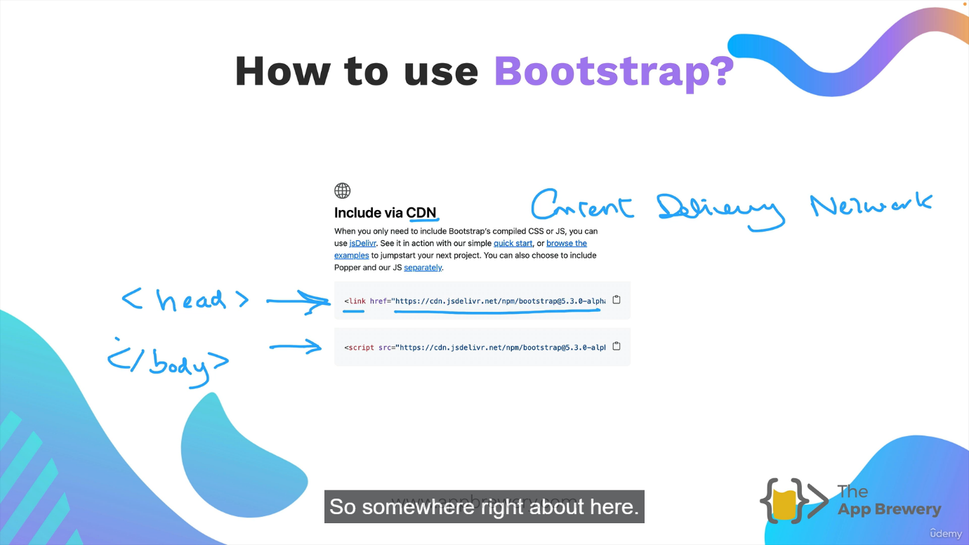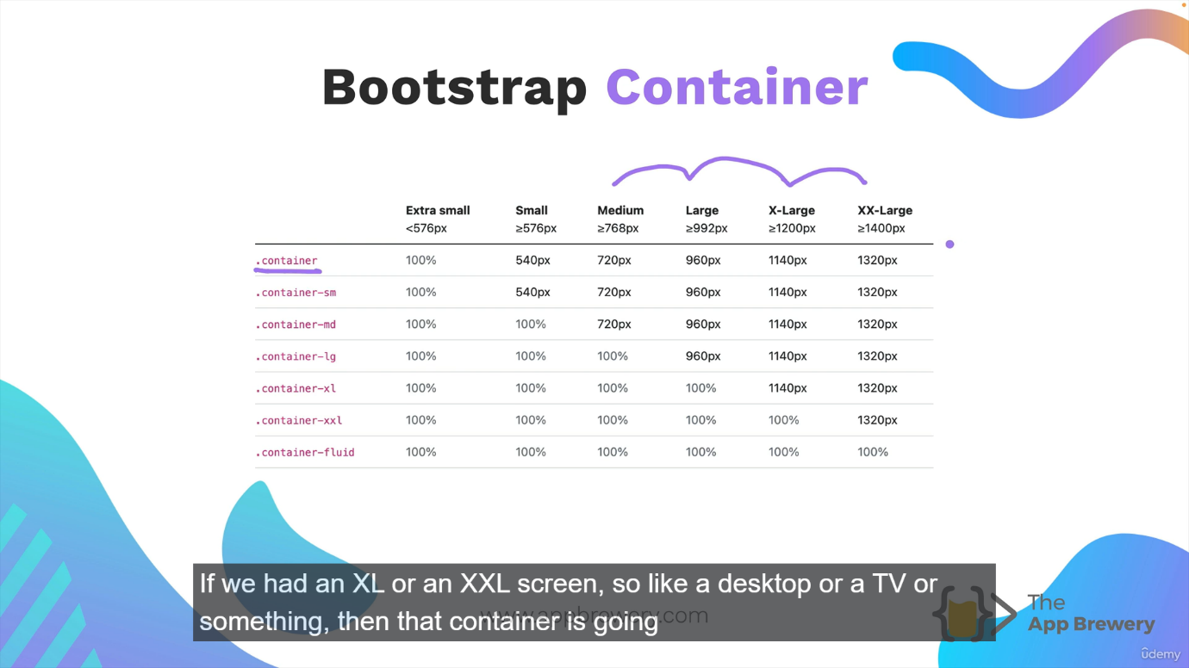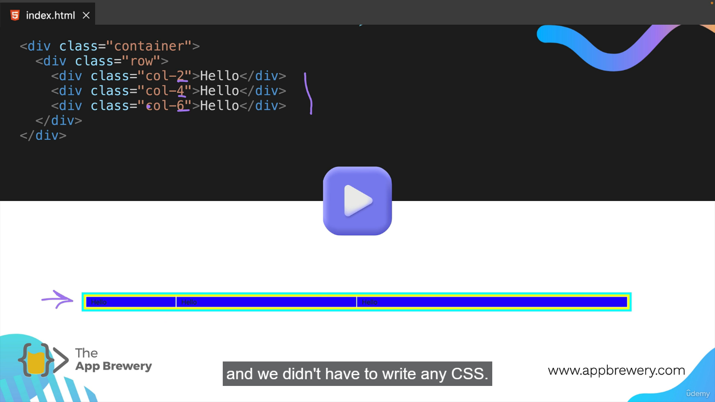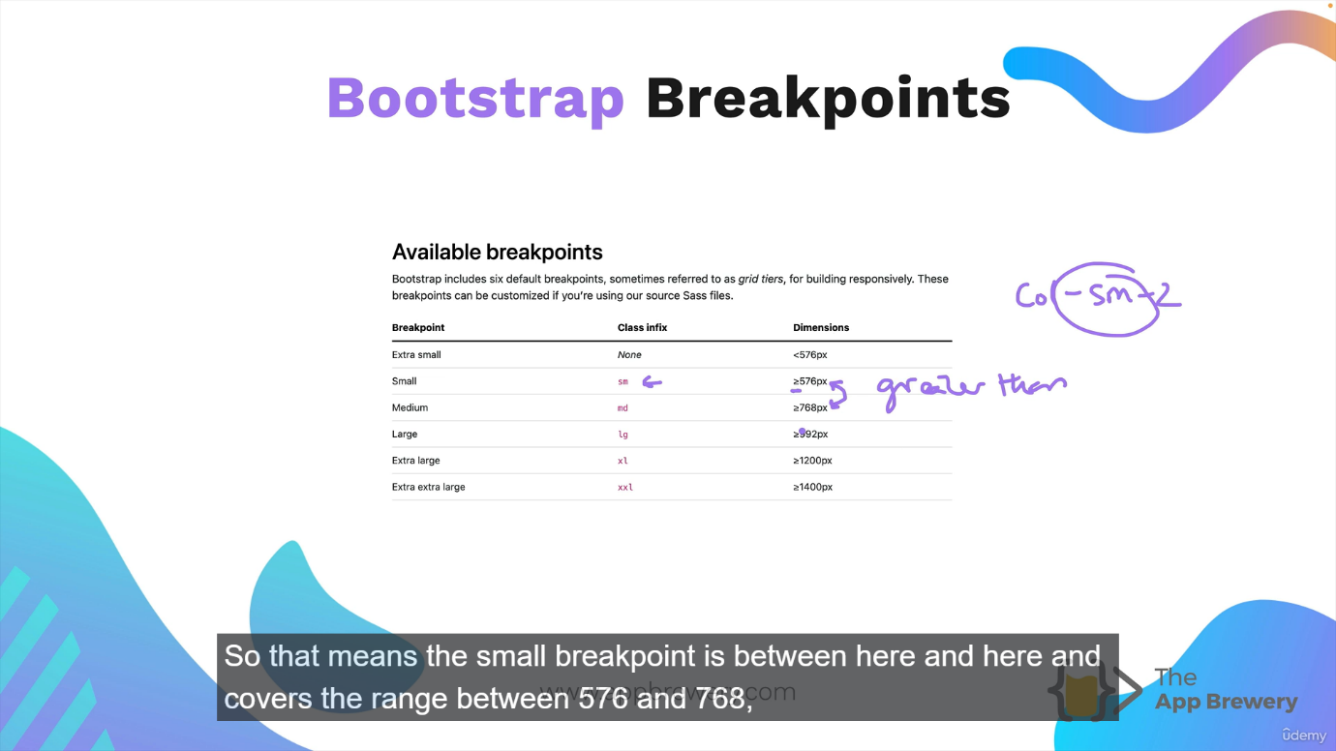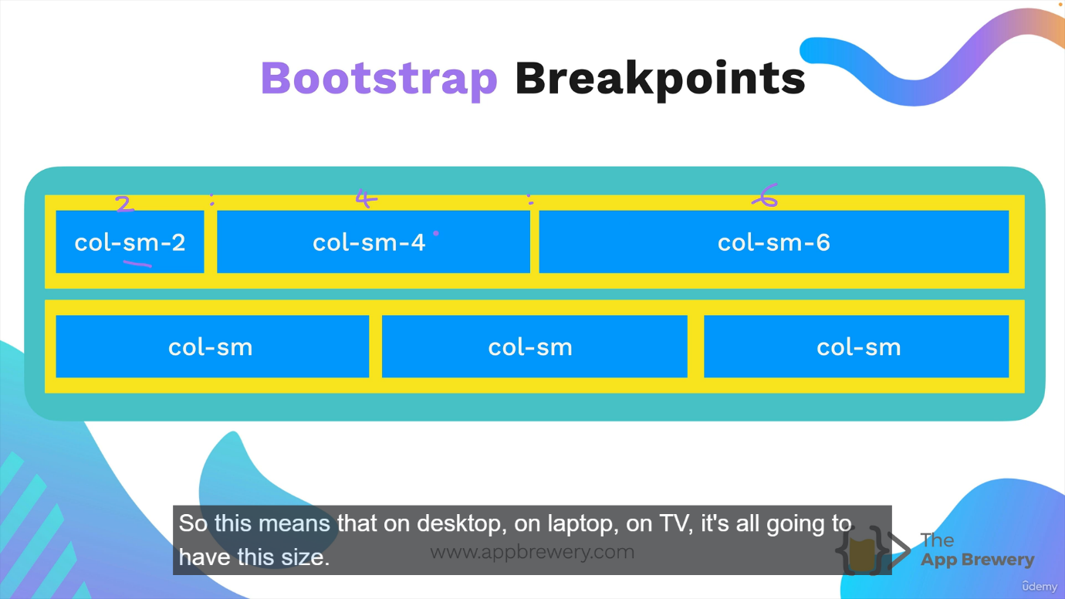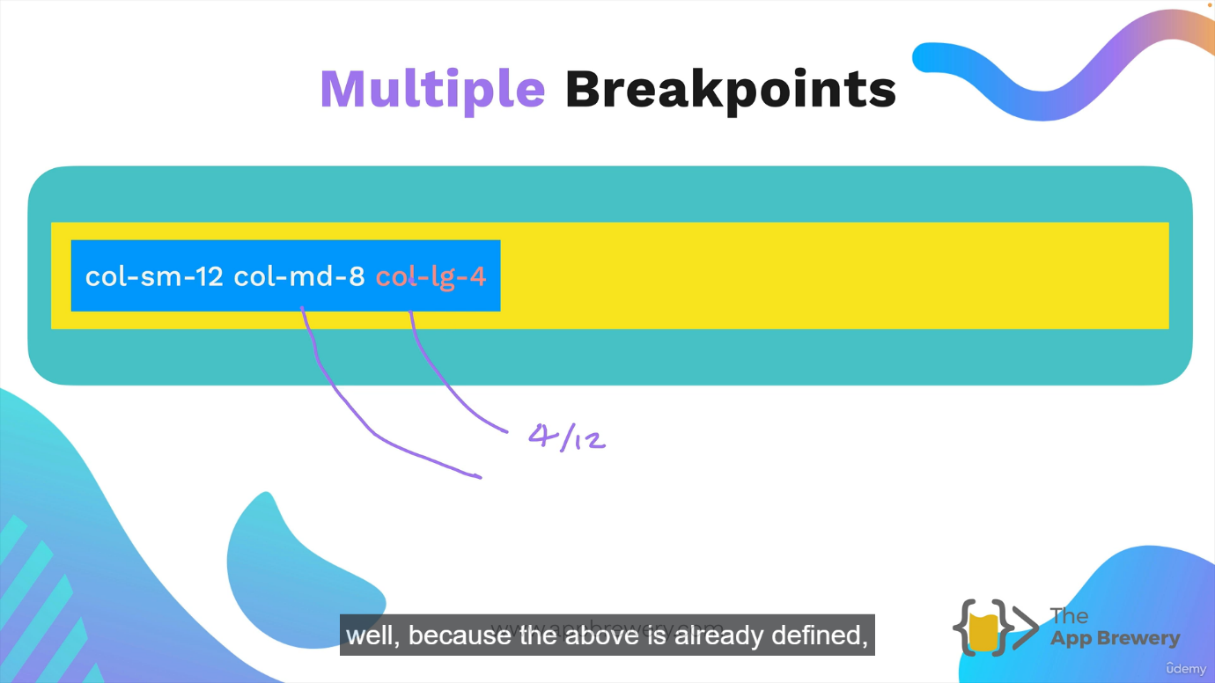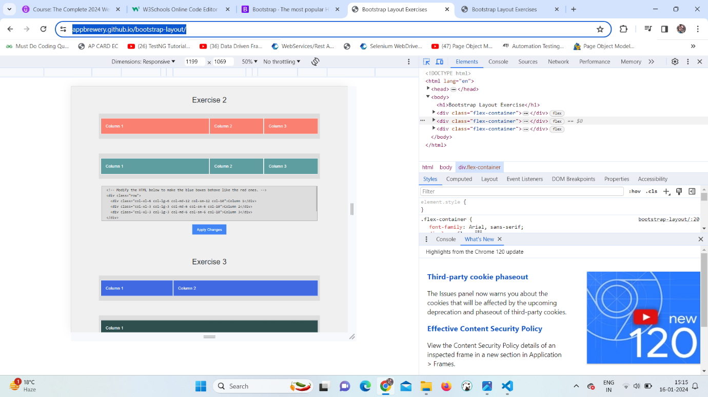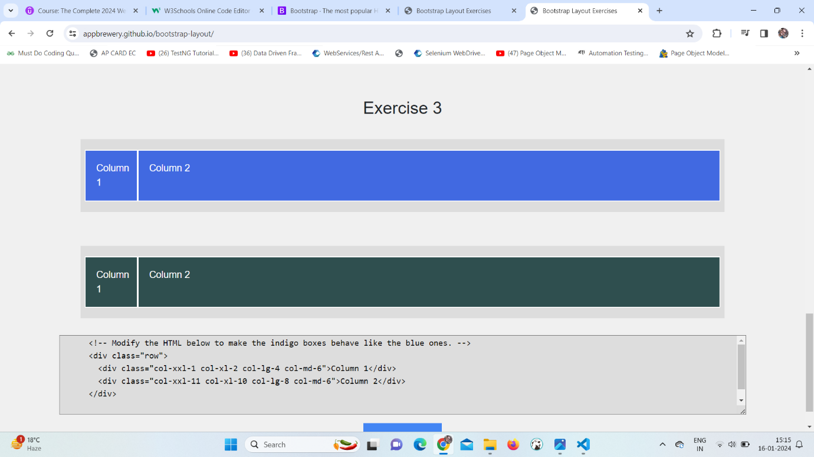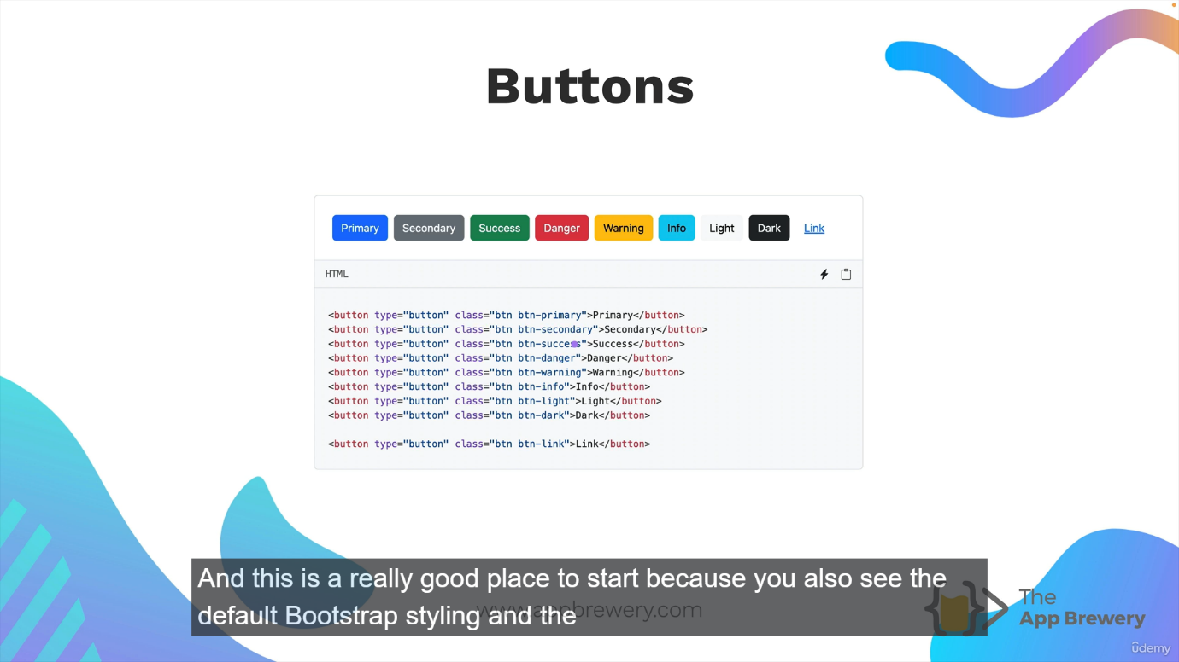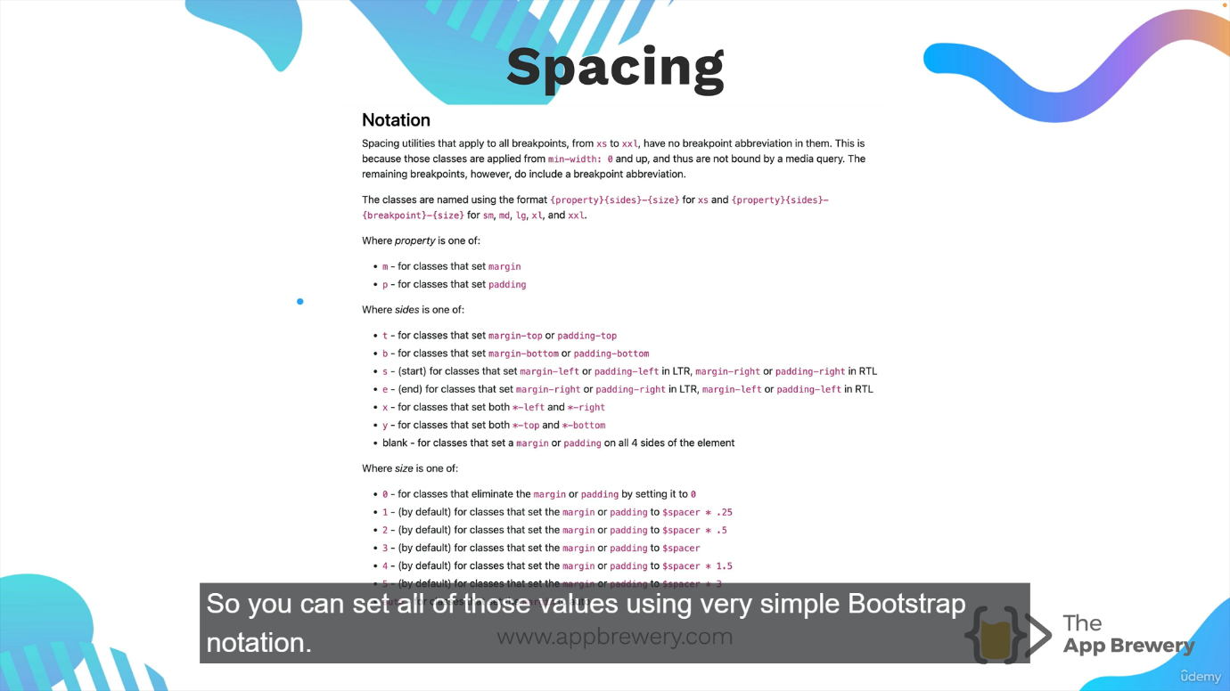

**JavaScript:**

**Javascript :**

**HTML is used to develop static web pages**

**HTML focuses on how to display data**

**if we need dynamic effect in a static HTML page, we can**

**embed a script**

**add a row in a table at runtime**

**delete a row from a table at runtime**

**validate an HTML form**

**when you need to have dynamic effects in a static web page,**

**can be embedded in HTML**

**lightweight**

**interpreted by browser**

**Javascript can be embeded in HTML page easily**

**it is a lightweight, interpreted scripting language**

**How to add Javascript in HTML?**

**by using <script>**

**Where can we add Javascript?**

**1. within body tag**

**the script gets executed at the time of web page loading**

**2. within head tag**

**the script that needs to be executed when required**

**3. as external javascript file**

**by using script tag**

**USD - INR**

**1. accept USD value**

**2. multiply USD by the current value**

**3. display INR value**

**10 USD --> INR**

**10 * 75**

**750 INR**

**Variables :**

**Javascript variable a name of storage location**

**First Name , Last Name, User Name, Password, salary, age, designation......**

**how to declare a variable in JS?**

**using var keyword**

**var FirstName**

**var LastName**

**var age**

**var salary**

**Rules for variable declaration**

**while declaring a variable following rules must be followed**

**1. name of the variable must start with a letter or an underscore (_)**

**or a dollar sign ($). Can not start with number or any other special**

**characters**

**2. after first letter or _ or $, digits, _, $ can be used**

**3. variable names are case sensitive. firstName & FIRSTNAME are not same**

**variables**

**declare a variable**

**var VARNAME = value**

**types of variables:**

**1. Local variable**

**if a variable is declared inside a block of code, it is**

**called as local variable**

**it is declared and used within the block of code and**

**can not be accessed from outside the block**

**2. global variable**

**if a variable is declared outside all blocks of code, it is**

**called as global variable**

**Data types :**

**JS is dynamic type language. you dont specify data type at the time of variable**

**declaration. the data type of a variable is decided dynamically (at runtime)**

**depending on what data is stored in the variable**

**1. Primitive (Basic) data types**

**number - decimal & non decimal**

**boolean - true false**

**string - alphanumeric data**

**undefined - when a variable is not defined**

**null - variable is defined and its value is set to null**

**2. Non primitive (reference) data types**

**object**

**array**

**regex**

**constants in javascript:**

**keyword used is constants**

**const PI = 3.14**

**const INTEREST_RATE = 7.5**

**Control structure**

**when we need to decide the flow of program based on certain**

**conditions, we can use control structure**

**decision making**

**if**

**if(expression){**

**// code to be executed if expression evaluates to true**

**}**

**switch**

**switch(expression){**

**case val1:**

**code**

**break**

**case val2:**

**code**

**break**

**}**

**loops**

**for**

**for(initialization; condition; increment){**

**code to execute**

**}**

**while**

**while(condition){**

**code to be executed till condition evaluates to true**

**}**

**do-while**

**do{**

**code to be executed**

**} while(condition)**

**JS output:**

* Writing into the HTML output using document.write().
* Writing into an alert box, using window.alert().
* Writing into the browser console, using console.log().

### **Variables are Containers for Storing Data**

JavaScript Variables can be declared in 4 ways:

* Automatically
* Using var
* Using let
* Using const

## When to Use var, let, or const?

1. Always declare variables

2. Always use const if the value should not be changed

3. Always use const if the type should not be changed (Arrays and Objects)

4. Only use let if you can't use const

5. Only use var if you MUST support old browsers.

## Re-Declaring JavaScript Variables

If you re-declare a JavaScript variable declared with var, it will not lose its value.

The variable carName will still have the value "Volvo" after the execution of these statements:

### **Example**

var carName = "Volvo";  
var carName;

## Block Scope

Before ES6 (2015), JavaScript did not have **Block Scope**.

JavaScript had **Global Scope** and **Function Scope**.

ES6 introduced the two new JavaScript keywords: let and const.

These two keywords provided **Block Scope** in JavaScript:

### **Example**

Variables declared inside a { } block cannot be accessed from outside the block:

{  
  let x = 2;  
}  
// x can NOT be used here

## Global Scope

Variables declared with the var always have **Global Scope**.

Variables declared with the var keyword can NOT have block scope:

### **Example**

Variables declared with varinside a { } block can be accessed from outside the block:

{  
  var x = 2;  
}  
// x CAN be used here

## Cannot be Redeclared

Variables defined with let **can not** be redeclared.

You can not accidentally redeclare a variable declared with let.

With let you **can not** do this:

let x = "John Doe";  
  
let x = 0;

Variables defined with var **can** be redeclared.

With var you **can** do this:

var x = "John Doe";  
  
var x = 0;

## Redeclaring Variables

Redeclaring a variable using the var keyword can impose problems.

Redeclaring a variable inside a block will also redeclare the variable outside the block:

### **Example**

var x = 10;  
// Here x is 10  
  
{  
var x = 2;  
// Here x is 2  
}  
  
// Here x is 2

Redeclaring a variable using the let keyword can solve this problem.

Redeclaring a variable inside a block will not redeclare the variable outside the block:

### **Example**

let x = 10;  
// Here x is 10  
  
{  
let x = 2;  
// Here x is 2  
}  
  
// Here x is 10

### **JavaScript has 8 Datatypes**

1. String  
2. Number  
3. Bigint  
4. Boolean  
5. Undefined  
6. Null  
7. Symbol  
8. Object

### **The Object Datatype**

The object data type can contain:

1. An object  
2. An array  
3. A date

### **Examples**

// Numbers:  
let length = 16;  
let weight = 7.5;  
  
// Strings:  
let color = "Yellow";  
let lastName = "Johnson";  
  
// Booleans  
let x = true;  
let y = false;  
  
// Object:  
const person = {firstName:"John", lastName:"Doe"};  
  
// Array object:  
const cars = ["Saab", "Volvo", "BMW"];  
  
// Date object:  
const date = new Date("2022-03-25");

let y = 123e5;    // 12300000  
let z = 123e-5;   // 0.00123

# **JavaScript Functions**

**JavaScript functions** are used to perform operations. We can call JavaScript function many times to reuse the code.

#### **Advantage of JavaScript function**

There are mainly two advantages of JavaScript functions.

1. **Code reusability**: We can call a function several times so it save coding.
2. **Less coding**: It makes our program compact. We don’t need to write many lines of code each time to perform a common task.

**Type1)**

<!DOCTYPE html>

<html lang="en">

<head>

    <meta charset="UTF-8">

    <meta name="viewport" content="width=device-width, initial-scale=1.0">

    <title>Document</title>

</head>

<body>

    <script>

        function emp(empid,empname,designation){

            this.empid=empid

            this.empname=empname

            this.designation=designation

        }

        var emp1=new emp(123,"ram","software")

       document.write("employee id "+emp1.empid+" empname "+emp1.empname+" designation "+emp1.designation)

   </script>

</body>

</html>

**Type2)**

<!DOCTYPE html>

<html lang="en">

<head>

    <meta charset="UTF-8">

    <meta name="viewport" content="width=device-width, initial-scale=1.0">

    <title>Document</title>

</head>

<body>

    <script>

        var student={

            studentName:"Geeta",

            standard:10,

            getStudentInfo(){

                return this.studentName+" "+this.standard

            },

            getStudentInfoByobj(){

                return this

            }

        }

        var stud=student.getStudentInfoByobj()

        document.write(stud.studentName+" "+stud.standard+"<br>")

        document.write(student.getStudentInfo())

    </script>

</body>

</html>

**Type3)**

<!DOCTYPE html>

<html lang="en">

<head>

    <meta charset="UTF-8">

    <meta name="viewport" content="width=device-width, initial-scale=1.0">

    <title>Document</title>

</head>

<body>

    <script>

        var sub=new Function("a","b","return a-b")

        document.write(sub(10,20)+"<br>")

        var pow=new Function("a","b","document.write(a**b)")

        pow(10,2)

         document.write("<br>")

        var pow1=new Function("a","b","document.write(a**b)")

        pow1(10,2)

    </script>

</body>

</html>

**Type4)**

**Normal type**

**Arrays in javascript:**

<!DOCTYPE html>

<html lang="en">

<head>

    <meta charset="UTF-8">

    <meta name="viewport" content="width=device-width, initial-scale=1.0">

    <title>Document</title>

</head>

<body>

    <script>

        let a=["a","b","c","d"]

        for(var i=0;i<a.length;i++){

            document.writeln(a[i]+"<br>")

        }

        var b=new Array()

        b[0]=1

        b[1]=2

        for(var i=0;i<b.length;i++){

            document.writeln(b[i]+"<br>")

        }

        var c=new Array("abc","def")

        for(var i=0;i<c.length;i++){

            document.writeln(c[i]+"<br>")

        }

    </script>

</body>

</html>

# **JavaScript Objects**

A javaScript object is an entity having state and behavior (properties and method). For example: car, pen, bike, chair, glass, keyboard, monitor etc.

JavaScript is an object-based language. Everything is an object in JavaScript.

JavaScript is template based not class based. Here, we don't create class to get the object. But, we direct create objects.

## Creating Objects in JavaScript

There are 3 ways to create objects.

1. By object literal
2. By creating instance of Object directly (using new keyword)
3. By using an object constructor (using new keyword)

## 1) JavaScript Object by object literal

The syntax of creating object using object literal is given below:

1. object={property1:value1,property2:value2.....propertyN:valueN}

As you can see, property and value is separated by : (colon).

Let’s see the simple example of creating object in JavaScript.

1. **<script>**
2. emp={id:102,name:"Shyam Kumar",salary:40000}
3. document.write(emp.id+" "+emp.name+" "+emp.salary);
4. **</script>**

## 2) By creating instance of Object

The syntax of creating object directly is given below:

1. var objectname=new Object();

Here, **new keyword** is used to create object.

Let’s see the example of creating object directly.

1. **<script>**
2. var emp=new Object();
3. emp.id=101;
4. emp.name="Ravi Malik";
5. emp.salary=50000;
6. document.write(emp.id+" "+emp.name+" "+emp.salary);
7. **</script>**

3) By using an Object constructor

Here, you need to create function with arguments. Each argument value can be assigned in the current object by using this keyword.

The **this keyword** refers to the current object.

The example of creating object by object constructor is given below.

1. **<script>**
2. function emp(id,name,salary){
3. this.id=id;
4. this.name=name;
5. this.salary=salary;
6. }
7. e=new emp(103,"Vimal Jaiswal",30000);
9. document.write(e.id+" "+e.name+" "+e.salary);
10. **</script>**

**Array methods:**

## JavaScript Array concat() Method Example

Let's see some examples of concat() method.

### **Example 1**

Here, we will print the combination of two arrays.

1. <script>
2. var arr1=["C","C++","Python"];
3. var arr2=["Java","JavaScript","Android"];
4. var result=arr1.concat(arr2);
5. document.writeln(result);
6. </script>

### **Example 2**

Here, we will print the combination of three arrays.

1. <script>
2. var arr1=["C","C++","Python"];
3. var arr2=["Java","JavaScript","Android"];
4. var arr3=["Ruby","Kotlin"];
5. var result=arr1.concat(arr2,arr3);
6. document.writeln(result);
7. </script>

### **Example 3**

In this example, we will concat the elements directly.

1. <script>
2. var arr=["C","C++","Python"];
3. var result= arr.concat("Java","JavaScript","Android");
4. document.writeln(result);
5. </script>

**Entries:**

1. <html>
2. <head> <h5> Array Methods </h5>
3. <body>
4. <script>
5. var arr=['John','Michael','Embrose','Herry','Lewis']; // array elements
6. var itr=arr.entries();
7. document.write("After applying the entries method:"+"<br>");
9. **for**(let e of itr) // let declares a variable, but its scope is within the block.
10. {
11. document.write(e+"</br>");
12. }
13. </script>
14. </body>
15. </head>
16. </html>

**o/p**

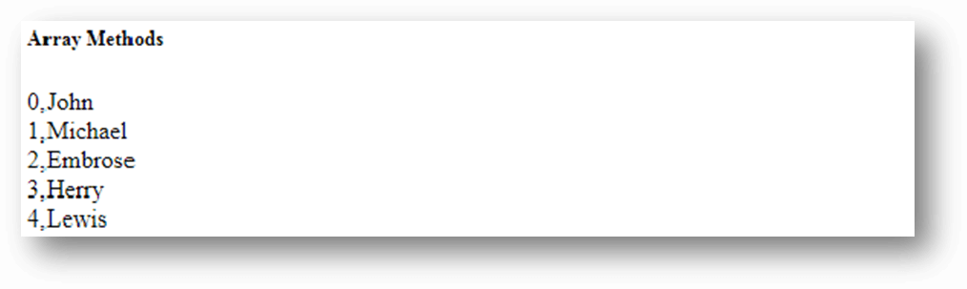

**Flat:**

Testing a multidimensional array with flat() method.

1. <html>
2. <head> <h5> Array Methods </h5> </head>
3. <body>
4. <script>
5. var arr=[90,18,[89,56],[13,20,[67,17]]]; //given multidimensional array
6. var newArr=arr.flat(); //using flat() method
7. document.write("After flattening the array:  "+newArr);
8. </script>
9. </body>
10. </html>

**o/p**

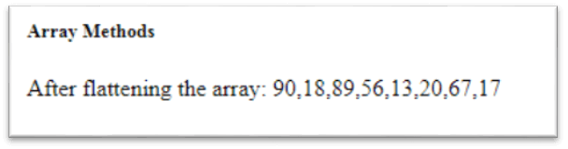

**Fill:**

# **JavaScript Array fill() method**

The JavaScript array fill() method fills the elements of the given array with the specified static values. This method modifies the original array. It returns undefined, if no element satisfies the condition.

## Syntax

The fill() method is represented by the following syntax:

1. arr.fill(value[, start[, end]])

## Parameter

**value** - The static value to be filled.

**start** - It is optional. It represents the index from where the value starts filling. By default, it is 0.

Backward Skip 10sPlay VideoForward Skip 10s

**end** - It is optional. It represents the index where the value stops filling. By default, it is length-1.

## Return

The modified array.

## JavaScript Array fill() method example

Let's see some examples of fill() method.

### **Example 1**

Here, we will provide only the value to be filled.

1. <script>
2. var arr=["AngularJS","Node.js","JQuery"];
3. var result=arr.fill("Bootstrap");
4. document.writeln(arr);
5. </script>

[**Test it Now**](https://www.javatpoint.com/oprweb/test.jsp?filename=JavaScriptArrayfillExample1)

**Output:**

Bootstrap,Bootstrap,Bootstrap

### **Example 2**

In this example, we will also provide the starting index.

1. <script>
2. var arr=["AngularJS","Node.js","JQuery"];
3. var result=arr.fill("Bootstrap",1);
4. document.writeln(arr);
5. </script>

[**Test it Now**](https://www.javatpoint.com/oprweb/test.jsp?filename=JavaScriptArrayfillExample2)

**Output:**

AngularJS,Bootstrap,Bootstrap

### **Example 3**

In this example, we will also provide start and end index.

1. <script>
2. var arr=["AngularJS","Node.js","JQuery"];
3. var result=arr.fill("Bootstrap",0,2);
4. document.writeln(arr);
5. </script>

[**Test it Now**](https://www.javatpoint.com/oprweb/test.jsp?filename=JavaScriptArrayfillExample3)

**Output:**

Bootstrap,Bootstrap,JQuery

## JavaScript Array filter() method example

Let's see some examples of filter() method.

### **Example 1**

Let's see a simple filter() example to filter the marks of a student.

1. <script>
2. var marks=[50,40,45,37,20];
4. function check(value)
5. {
6. **return** value>30;
7. }
9. document.writeln(marks.filter(check));
10. </script>

**Output:**

50,40,45,37

**forEach:**

Here, we will print the Fibonacci series with the help of forEach() method.

1. <script>
2. var sum = 0;
3. var arr = [10,18,12,20];
5. arr.forEach(function myFunction(element) {
6. sum= sum+element;
7. document.writeln(sum);
8. });
9. </script>

[**Test it Now**](https://www.javatpoint.com/oprweb/test.jsp?filename=JavaScriptArrayforEachExample1)

**Output:**

10 28 40 60

# **JavaScript Array includes() method**

The JavaScript array includes() method checks whether the given array contains the specified element. It returns true if an array contains the element, otherwise false.

## Syntax

The includes() method is represented by the following syntax:

1. array.includes(element,start)

## Parameter

**element** - The value to be searched.

**start** - It is optional. It represents the index from where the method starts search.

Backward Skip 10sPlay VideoForward Skip 10s

## Return

A Boolean value.

## JavaScript Array includes() method example

Here, we will understand includes() method through various examples.

### **Example 1**

Let's see a simple example to determine whether the given array contains the specified element.

1. <script>
2. var arr=["AngularJS","Node.js","JQuery"]
3. var result=arr.includes("AngularJS");
4. document.writeln(result);
5. </script>

[**Test it Now**](https://www.javatpoint.com/oprweb/test.jsp?filename=JavaScriptArrayincludesMethodExample1)

**Output:**

true

### **Example 2**

In this example, we will provide the index from where the search starts.

1. <script>
2. var arr=["AngularJS","Node.js","JQuery"]
3. var result=arr.includes("AngularJS",1); //returns false, as "AngularJS" is not present after index 1.
4. document.writeln(result);
5. </script>

[**Test it Now**](https://www.javatpoint.com/oprweb/test.jsp?filename=JavaScriptArrayincludesMethodExample2)

**Output:**

false

### **Example 3**

Let's see one more example to determine whether the includes() method is case-sensitive.

1. <script>
2. var arr=["AngularJS","Node.js","JQuery"]
3. var result=arr.includes("angularjs");
4. document.writeln(result);
5. </script>

[**Test it Now**](https://www.javatpoint.com/oprweb/test.jsp?filename=JavaScriptArrayincludesMethodExample3)

**Output:**

false

# **JavaScript Array indexOf() method**

The JavaScript array indexOf() method is used to search the position of a particular element in a given array. This method is case-sensitive.

The index position of first element in an array is always start with zero. If an element is not present in an array, it returns -1.

## Syntax

The indexOf() method is represented by the following syntax:

1. array.indexOf(element,index)

## Parameter

**element** - It represent the element to be searched.

Backward Skip 10sPlay VideoForward Skip 10s

<p.**index - It represent the index position from where search starts. It is optional.**

## Return

An index of a particular element.

## JavaScript Array indexOf() method example

Let's see some simple examples of indexOf() method.

### **Example 1**

Here, we will print the position of an element.

1. <script>
2. var arr=["C","C++","Python","C++","Java"];
3. var result= arr.indexOf("C++");
4. document.writeln(result);
5. </script>

[**Test it Now**](https://www.javatpoint.com/oprweb/test.jsp?filename=JavaScriptArrayindexOfExample1)

**Output:**

1

### **Example 2**

In this example, we will provide the index value from where the search starts.

1. <script>
2. var arr=["C","C++","Python","C++","Java"];
3. var result= arr.indexOf("C++",2);
4. document.writeln(result);
5. </script>

[**Test it Now**](https://www.javatpoint.com/oprweb/test.jsp?filename=JavaScriptArrayindexOfExample2)

**Output:**

3

### **Example 3**

Here, we will search an element which is not present in an array.

1. <script>
2. var arr=["C","C++","Python","C++","Java"];
3. var result= arr.indexOf("JavaScript");
4. document.writeln(result);
5. </script>

[**Test it Now**](https://www.javatpoint.com/oprweb/test.jsp?filename=JavaScriptArrayindexOfExample3)

**Output:**

-1

**Join:**

In this example, we will separate the array elements using '-' separator.

1. <script>
2. var arr=["AngularJs","Node.js","JQuery"]
3. var result=arr.join('-')
4. document.write(result);
5. </script>

[**Test it Now**](https://www.javatpoint.com/oprweb/test.jsp?filename=JavaScriptArrayjoinExample2)

**Output:**

AngularJs-Node.js-JQuery

**Reverse:**

1. <script>
2. var arr=["AngulaJS","Node.js","JQuery"];
3. var rev=arr.reverse();
4. document.writeln(rev);
5. </script>

[**Test it Now**](https://www.javatpoint.com/oprweb/test.jsp?filename=JavaScriptArrayreverseExample)

**Output:**

JQuery,Node.js,AngulaJS

**Push:**

## JavaScript Array push() method example

Let's see some examples of push() method

### **Example 1**

Here, we will add an element in the given array.

1. <script>
2. var arr=["AngularJS","Node.js"];
3. arr.push("JQuery");
4. document.writeln(arr);
5. </script>

[**Test it Now**](https://www.javatpoint.com/oprweb/test.jsp?filename=JavaScriptArraypushExample1)

**Output:**

AngularJS,Node.js,JQuery

### **Example 2**

Let's see an example to add more than one elements in the given array.

1. <script>
2. var arr=["AngularJS","Node.js"];
3. document.writeln("Length before invoking push(): "+arr.length+"<br>");
4. arr.push("JQuery","Bootstrap");
5. document.writeln("Length after invoking push(): "+arr.length+"<br>");
6. document.writeln("Update array: "+arr);
7. </script>

[**Test it Now**](https://www.javatpoint.com/oprweb/test.jsp?filename=JavaScriptArraypushExample2)

**Output:**

Length before invoking push(): 2

Length after invoking push(): 4

Update array: AngularJS,Node.js,JQuery,Bootstrap

**Pop:**

# **JavaScript Array pop() method**

The JavaScript array pop() method removes the last element from the given array and return that element. This method changes the length of the original array.

## Syntax

The pop() method is represented by the following syntax:

1. array.pop()

## Return

The last element of given array.

## JavaScript Array pop() method example

Let's see some examples of pop() method.

Backward Skip 10sPlay VideoForward Skip 10s

ADVERTISEMENT

### **Example 1**

Here, we will pop an element from the given array.

1. <script>
2. var arr=["AngularJS","Node.js","JQuery"];
3. document.writeln("Orginal array: "+arr+"<br>");
4. document.writeln("Extracted element: "+arr.pop()+"<br>");
5. document.writeln("Remaining elements: "+ arr);
6. </script>

[**Test it Now**](https://www.javatpoint.com/oprweb/test.jsp?filename=JavaScriptArraypopExample1)

**Output:**

Orginal array: AngularJS,Node.js,JQuery

Extracted element: JQuery

Remaining elements: AngulaJS,Node.js

### **Example 2**

In this example, we will pop all the elements from the given array.

1. <script>
2. var arr=["AngulaJS","Node.js","JQuery"];
3. var len=arr.length;
5. **for**(var x=1;x<=len;x++)
6. {
7. document.writeln("Extracted element: "+arr.pop()+"<br>");
8. }
9. </script>

[**Test it Now**](https://www.javatpoint.com/oprweb/test.jsp?filename=JavaScriptArraypopExample2)

**Output:**

Extracted element: JQuery

Extracted element: Node.js

Extracted element: AngulaJS

## JavaScript Array map() method example

Let's see some examples of map() method.

### **Example 1**

Here, map() method returns the round of given elements to the nearest integer.

1. <script>
2. var arr=[2.1,3.5,4.7];
3. var result=arr.map(Math.round);
4. document.writeln(result);
5. </script>

[**Test it Now**](https://www.javatpoint.com/oprweb/test.jsp?filename=JavaScriptArraymapExample1)

**Output:**

2,4,5

### **Example 2**

Here, map() method returns every element of given array by multiplying it by 3.

1. <script>
2. var arr=[2,4,6];
3. var result=arr.map(x=>x*3);
4. document.writeln(result);
5. </script>

[**Test it Now**](https://www.javatpoint.com/oprweb/test.jsp?filename=JavaScriptArraymapExample2)

**Output:**

6,12,18

# **JavaScript Array reduce() Method**

The reduce() method reduces the given array into a single value by executing a reducer function. The user implements the reducer function that works on every element present in the array.

## Reducer Function

The reducer function is the user implemented code. It uses the following four arguments to perform its task:

1. **Accumulator:** It accumulates the return values of the array.
2. **Current Value:** Current element is the current value.
3. **Current Index:** The index of the current element is the value of the current index.
4. **Source array:** The array defined by the user for implementing reduce() method.

## Syntax

1. arr.reduce(callback(accumulator, currentValue, currentIndex, array), initialValue)

## Parameter

**callback:** The main is the callback function that executes for each element, excluding the first, if no initialValue is specified.

The callback function undertakes the following four arguments:

1. **accumulator:** It accumulates the return values of the callback function, returned in the last calling of the function.
2. **currentValue:** It is the value of the current element, which is being processing.
3. **currentIndex:** It is an optional argument that holds the index value of the current element which is being processed. If we provide the initial value, indexing will begin from 0. Else from 1.
4. **array:** It is also optional, which carries the elements on which the reduce() will work.

**initialValue:** It is the first argument value used in the first invocation of the callback function.

## Return

It returns a single value as an output.

## Points to note:

1. If we do not provide the initial value, the callback function will start its execution with index as 1, where it will skip the first index. Although, if intialValue is provided, execution will begin from 0.
2. In case of an empty array with no initialValue is supplied, it will throw a TypeError.
3. If the array is empty, but initialValue is provided, or if the array contains one element, but no initialValue is supplied, that element will return without invoking the callback function.

Thus, it is safe and good to provide the initial value.

## JavaScript Array reduce() Method Example

Let's implement some examples to understand better:

**Example1**

Here's a simple example to sum up the array elements and display the output.

1. <html>
2. <head> <h5> Javascript Array Methods </h5> </head>
3. <body>
4. <script>
5. var arr=[2,3,1,5];
6. var a=arr.reduce(function (accumulator,currentValue) {
7. **return** accumulator+currentValue;
8. },0);
9. document.write("The sum of the array elements is: "+a);
10. </script>
11. </body>
12. </html>

[**Test it Now**](https://www.javatpoint.com/oprweb/test.jsp?filename=JavaScriptArrayreduceMethodExample1)

**Output:**

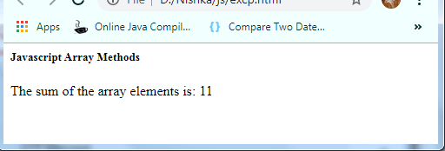

**Example2**

Here's an example to display the difference of the array elements using reduce() method.

1. <html>
2. <head> <h5> Javascript Array Methods </h5> </head>
3. <body>
4. <script>
5. var a=[30,15,5];
6. document.write("The difference of the array elements is: ");
7. document.write(a.reduce(reducer_func));
8. function reducer_func(net,n){
9. **return** net-n;
10. }
11. </script>
12. </body>
13. </html>

[**Test it Now**](https://www.javatpoint.com/oprweb/test.jsp?filename=JavaScriptArrayreduceMethodExample2)

**Output:**

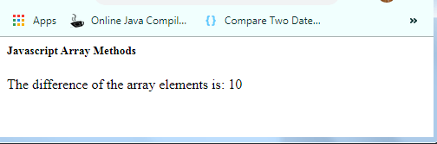

**Example3**

Here's an example to total the array elements using the arrow function.

1. <html>
2. <head> <h5> Javascript Array Methods </h5> </head>
3. <body>
4. <script>
5. var net=[3,2,5,1,7];
6. var calc=net.reduce(
7. (accumulator,currentValue)=>accumulator+currentValue,0);
8. document.write("The total of the array elements comes out to be: "+calc);
9. </script>
10. </body>
11. </html>

[**Test it Now**](https://www.javatpoint.com/oprweb/test.jsp?filename=JavaScriptArrayreduceMethodExample3)

**Output:**

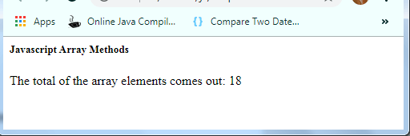

**Example4**

When the array contain a single value only.

1. <html>
2. <head> <h5> Javascript Array Methods </h5> </head>
3. <body>
4. <script>
5. var net=[3]; //Array with one element.
6. var calc=net.reduce(
7. (accumulator,currentValue)=>accumulator+currentValue);
8. document.write("The total of the array element comes out to be: "+calc);
9. </script>
10. </body>
11. </html>

[**Test it Now**](https://www.javatpoint.com/oprweb/test.jsp?filename=JavaScriptArrayreduceMethodExample4)

**Output:**

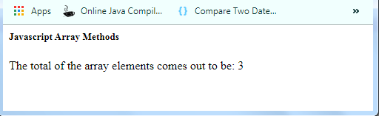

Thus, in presence of a single array element, there is no need to create a callback function. Also, because when an array contain a single element, the callback is not invoked.

We can perform several examples using the array reduce() method.

# **JavaScript Array slice() method**

The JavaScript array slice() method extracts the part of the given array and returns it. This method doesn't change the original array.

## Syntax

The slice() method is represented by the following syntax:

1. array.slice(start,end)

## Parameter

**start** - It is optional. It represents the index from where the method starts to extract the elements.

**end** - It is optional. It represents the index at where the method stops extracting elements.

Backward Skip 10sPlay VideoForward Skip 10s

## Return

A new array contains the extracted elements.

## JavaScript Array slice() method example

Here, we will understand slice() method through various examples.

### **Example 1**

Let's see a simple example to extract an element from the given array.

1. <script>
2. var arr=["AngularJS","Node.js","JQuery","Bootstrap"]
3. var result=arr.slice(1,2);
4. document.writeln(result);
5. </script>

[**Test it Now**](https://www.javatpoint.com/oprweb/test.jsp?filename=JavaScriptArraysliceMethodExample1)

**Output:**

Node.js

### **Example 2**

Let's see one more example to extract various element from the given array.

1. <script>
2. var arr=["AngularJS","Node.js","JQuery","Bootstrap"]
3. var result=arr.slice(0,3);
4. document.writeln(result);
5. </script>

[**Test it Now**](https://www.javatpoint.com/oprweb/test.jsp?filename=JavaScriptArraysliceMethodExample2)

**Output:**

ADVERTISEMENT

AngularJS,Node.js,JQuery

### **Example 3**

In this example, we will provide the negative values as index to extract elements.

1. <script>
2. var arr=["AngularJS","Node.js","JQuery","Bootstrap"]
3. var result=arr.slice(-4,-1);
4. document.writeln(result);
5. </script>

[**Test it Now**](https://www.javatpoint.com/oprweb/test.jsp?filename=JavaScriptArraysliceMethodExample3)

**Output:**

AngularJS,Node.js,JQuery

**String:**

1. String.charAt(index)

# **JavaScript String charCodeAt() Method**

The JavaScript string **charCodeAt()** method is used to find out the Unicode value of a character at the specific index in a string.

The index number starts from 0 and goes to n-1, where n is the length of the string. It returns **NaN** if the given index number is either a negative number or it is greater than or equal to the length of the string.

## Syntax

The charCodeAt() method is represented by the following syntax:

1. string.charCodeAt(index)

## Parameter

index - It represent the position of a character.

## Return

A Unicode value

## JavaScript String charCodeAt() Method Example

Let's see some simple examples of charCodeAt() method.

### **Example 1**

Here, we will print the Unicode value of a character by passing its specific index.

1. <script>
2. var x="Javatpoint";
3. document.writeln(x.charCodeAt(3));
4. </script>

# **JavaScript String concat() Method**

The JavaScript string concat() method combines two or more strings and returns a new string. This method doesn't make any change in the original string.

## Syntax

The concat() method is represented by the following syntax:

1. string.concat(str1,str2,...,strn)

## Parameter

**str1,str2,...,strn** - It represent the strings to be combined.

## Return

Combination of strings.

Backward Skip 10sPlay VideoForward Skip 10s

## JavaScript String concat() Method Example

Let's see some simple examples of concat() method.

### **Example 1**

Here, we will print the combination of two strings.

1. <script>
2. var x="Javatpoint";
3. var y=".com";
4. document.writeln(x.concat(y));
5. </script>

[**Test it Now**](https://www.javatpoint.com/oprweb/test.jsp?filename=concatExample1)

**Output:**

Javatpoint.com

### **Example 2**

Here, we will print the combination of three strings.

1. <script>
2. var x="Javatpoint";
3. var y=".com";
4. var z=" Tutorials";
5. document.writeln(x.concat(y,z));
6. </script>

[**Test it Now**](https://www.javatpoint.com/oprweb/test.jsp?filename=concatExample2)

**Output:**

Javatpoint.com Tutorials

### **Example 3**

In the last example, we provided the space between the strings while initializing it. Here, we will perform the similar task through the method.

1. <script>
2. var x="Javatpoint";
3. var y=".com";
4. var z="Tutorials";
5. document.writeln(x.concat(y+" "+z));
6. </script>

[**Test it Now**](https://www.javatpoint.com/oprweb/test.jsp?filename=concatExample3)

**Output:**

Javatpoint.com Tutorials

## 3) JavaScript String indexOf(str) Method

The JavaScript String indexOf(str) method returns the index position of the given string.

1. **<script>**
2. var s1="javascript from javatpoint indexof";
3. var n=s1.indexOf("from");
4. document.write(n);
5. **</script>**

[**Test it Now**](https://www.javatpoint.com/oprweb/test.jsp?filename=jsstringmethod3)

**Output:**

11

## 4) JavaScript String lastIndexOf(str) Method

The JavaScript String lastIndexOf(str) method returns the last index position of the given string.

1. **<script>**
2. var s1="javascript from javatpoint indexof";
3. var n=s1.lastIndexOf("java");
4. document.write(n);
5. **</script>**

[**Test it Now**](https://www.javatpoint.com/oprweb/test.jsp?filename=jsstringmethod4)

**Output:**

16

## 5) JavaScript String toLowerCase() Method

The JavaScript String toLowerCase() method returns the given string in lowercase letters.

1. **<script>**
2. var s1="JavaScript toLowerCase Example";
3. var s2=s1.toLowerCase();
4. document.write(s2);
5. **</script>**

[**Test it Now**](https://www.javatpoint.com/oprweb/test.jsp?filename=jsstringmethod5)

**Output:**

javascript tolowercase example

## 6) JavaScript String toUpperCase() Method

The JavaScript String toUpperCase() method returns the given string in uppercase letters.

1. **<script>**
2. var s1="JavaScript toUpperCase Example";
3. var s2=s1.toUpperCase();
4. document.write(s2);
5. **</script>**

[**Test it Now**](https://www.javatpoint.com/oprweb/test.jsp?filename=jsstringmethod6)

**Output:**

JAVASCRIPT TOUPPERCASE EXAMPLE

## 7) JavaScript String slice(beginIndex, endIndex) Method

ADVERTISEMENT

ADVERTISEMENT

The JavaScript String slice(beginIndex, endIndex) method returns the parts of string from given beginIndex to endIndex. In slice() method, beginIndex is inclusive and endIndex is exclusive.

1. **<script>**
2. var s1="abcdefgh";
3. var s2=s1.slice(2,5);
4. document.write(s2);
5. **</script>**

[**Test it Now**](https://www.javatpoint.com/oprweb/test.jsp?filename=jsstringmethod7)

**Output:**

cde

## 8) JavaScript String trim() Method

The JavaScript String trim() method removes leading and trailing whitespaces from the string.

1. **<script>**
2. var s1="     javascript trim    ";
3. var s2=s1.trim();
4. document.write(s2);
5. **</script>**

[**Test it Now**](https://www.javatpoint.com/oprweb/test.jsp?filename=jsstringmethod8)

**Output:**

javascript trim

### **9) JavaScript String split() Method**

1. **<script>**
2. var str="This is JavaTpoint website";
3. document.write(str.split(" ")); //splits the given string.
4. **</script>**

# **JavaScript String substring() Method**

The JavaScript string substring() method fetch the string on the basis of provided index and returns the new sub string. It works similar to the slice() method with a difference that it doesn't accepts negative indexes. This method doesn't make any change in the original string.

## Syntax

The substring() method is represented by the following syntax:

1. string.substring(start,end)

## Parameter

**start** - It represents the position of the string from where the fetching starts.

**end** - It is optional. It represents the position up to which the string fetches.

Backward Skip 10sPlay VideoForward Skip 10s

## Return

Part of the string.

## JavaScript String substring() Method Example

Let's see some simple examples of substring() method.

### **Example 1**

Let's see a simple example to print the part of the string.

1. <script>
2. var str="Javatpoint";
3. document.writeln(str.substring(0,4));
4. </script>

[**Test it Now**](https://www.javatpoint.com/oprweb/test.jsp?filename=substringExample1)

**Output:**

Java

**Math:**

[abs()](https://www.javatpoint.com/javascript-math-abs-method)

1. document.writeln(Math.cbrt(-64));

[exp()](https://www.javatpoint.com/javascript-math-exp-method)

[ceil()](https://www.javatpoint.com/javascript-math-ceil-method)

[floor()](https://www.javatpoint.com/javascript-math-floor-method)

[max()](https://www.javatpoint.com/javascript-math-max-method)

1. document.writeln(Math.max(-10,-24,-12,-20));

[min()](https://www.javatpoint.com/javascript-math-min-method)

[pow()](https://www.javatpoint.com/javascript-math-pow-method)

1. Math.random()
2. Math.round(num)